**THE KNOCKS ANNOUNCE NEW ALBUM *NEW YORK NARCOTIC* OUT SEPTEMBER 28TH + SHARE NEW VIDEO FOR “GOODBYES” (FT. METHOD MAN)**

**PRE-ORDER *NEW YORK NARCOTIC*** [HERE](https://bigbeat.lnk.to/NYNPR)

OUT 9/28 ON NEON GOLD/BIG BEAT RECORDS

**WATCH/POST:** <https://bigbeat.lnk.to/NYNPR/youtube>

**BUY/STREAM:**<https://BigBeat.lnk.to/NYNPR>

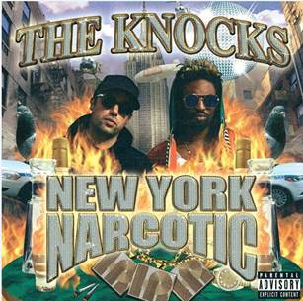

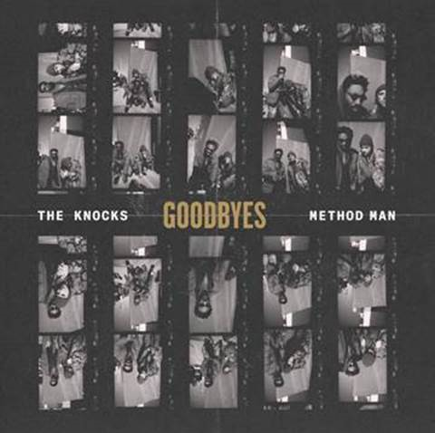 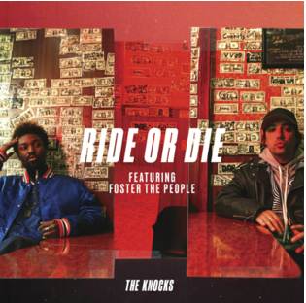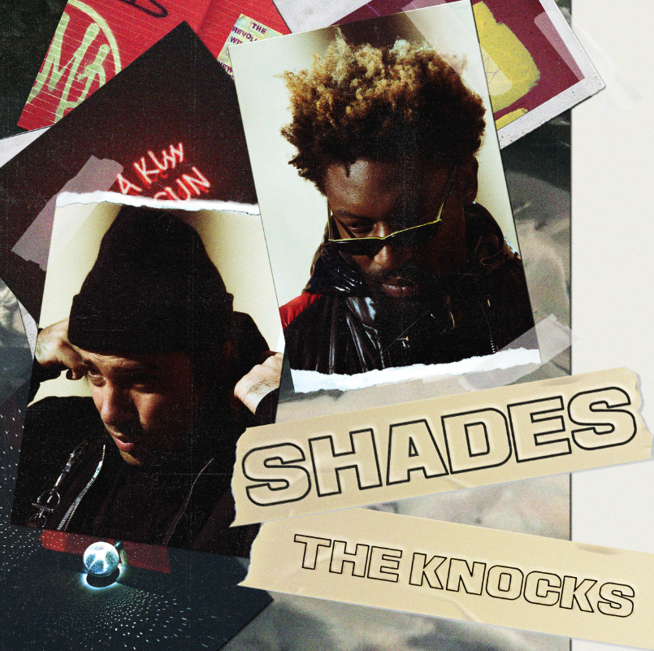

New York City’s acclaimed downtown electronic duo**The Knocks** have been on a roll all summer and now the boys are upping the ante by delivering the pre-order today for their much-anticipated sophomore full-length ***New York Narcotic***arriving on **September 28th** via**Neon Gold**/**Big Beat Records**.

The Knocks also deliver a wavy track **“Goodbyes”**whichfeatures no other than**Method Man**of the legendary**Wu Tang Clan** and The Knocks’ own **JPatt** trading hard-hitting verses throughout! Filmed on VHS, the official video shows Keith Haring and Basquiat-inspired animationtransposed overvintage-looking footage of The Knocks and friends in their favorite LES haunts—watch [HERE!](https://bigbeat.lnk.to/NYNPR/youtube)

In **The Knocks**’ words,*“We wanted this video to be a nod to some of our favorite style videos we grew up watching. 90’s rap videos usually didn’t need more than a good stoop and a bunch of people having a good time, so we got some friends together and shot this in Brooklyn on an old VHS camera.  We love how much it captures the essence of NYC & how it’s a futuristic touch on classic hip-hop imagery; something we hoped to similarly achieve sonically with the song.”*

**“Goodbyes” (ft. Method Man)**is the third song **The Knocks**has shared from ***New York Narcotic*** which will surely follow their pattern of releasing hit after hit. The duo previously released their recent chart-topping collaboration[“Ride or Die”](https://protect-us.mimecast.com/s/oO4kC5y1L6Fq8K0EHOC4Yj)ft.**Foster The People,**which has now eclipsed **22 *million***global streams, hit **#1** on **iTunes dance**, and has sat **16+** weeks on **Billboard Dance** and **11** weeks on the **Billboard Alternative** charts, reaching **Top 20** on both charts. It’s also currently placed at **#15**at**Alternative Radio**, and rising more and more every day. Another recent single,[“Shades”](https://protect-us.mimecast.com/s/9Gl8C68z9gFQk9ozimMcL4), soundtracks**Hyundai’s**current summer sales event([watch](https://protect-us.mimecast.com/s/pO01C73WXju3M6mliNohTX))**,**spanning the gamut of radio, tv and internet.

Fun fact: despite gaining notoriety in recent years for their signature electronic production,**The Knocks**actually got their start as hip-hop producers. In the early-mid 2000's, they worked with **AZ, Cormega, Dipset, G Unit, The Lox, MOP, The Game, Bun B, Doggpound Gang, Nicki Minaj, N.O.R.E, Mobb Deep, Lil Wayne**& more. Hip-hop continues to remain an influence on**The Knocks' sound**and has since featured iconic rappers in their music, including **Cam'ron, Wyclef,**and more to come.

Recently, the electronic music duo comprised of Ben “Broc” Ruttner and James “JPatt” Patterson have performed on [The Tonight Show w/ Jimmy Fallon](https://protect-us.mimecast.com/s/9qciC0RXL1F6vW2VfLgqf3) and[TRL](https://protect-us.mimecast.com/s/y7zGCgJQ2rsV6Wl9tK2vcY) for their smash collaboration with **Sofi Tukker**, NERVO, and Alisa Ueno, “[Best Friend](https://protect-us.mimecast.com/s/pOg7CjRO8xFpEJj8fM3AH1)” – which peaked at **#**1 on the**iTunes Dance**, US Dance Radio, Billboard Commercial, Billboard Dance/Mix Show, and Shazam Dance Charts, and also peaking at**#3**on the**Shazam Worldwide**Main Charts, after debuting during **Apple’s Keynote** address. The track was also prominently featured in advertisements for the **iPhone X** ([watch here](https://protect-us.mimecast.com/s/JFfoCkRO7yFml0n9fDAiAV)).

The Knocks are also curating a monthly ***The Knocks & Friends***residency at **PUBLIC Arts in New York City** which is bringing back the anything-goes Manhattan party-scene. You can catch The Knocks live at **Billboard Hot 100 Music Festival**on Sunday, August 20th in Jones Beach, New York. They are also headlining the **Neon Gold X: 10 Year Anniversary** show on Saturday, September 29th at The Knockdown Center in New York City. The show also includes performances from Marina & The Diamonds, Matt Maeson and others.

**Connect with The Knocks:**

[https://www.facebook.com/theknocksnyc](https://protect-us.mimecast.com/s/HhgQClYM7zcgGKoxiLSkHP)

[https://soundcloud.com/theknocks](https://protect-us.mimecast.com/s/VJe6CmZMyAsEXY5ziVc9nl)

[https://twitter.com/theknocks](https://protect-us.mimecast.com/s/Zpd0Cn5NOBtMwLGvi4Bvtc)

[https://instagram.com/the_knocks](https://protect-us.mimecast.com/s/pgmICo26yDcx9GXEtJ8xOm)

[http://theknocks.com](https://protect-us.mimecast.com/s/4tptCpYX2EcXkLzmIq0wv7)

For Press Assets: [http://press.wearebigbeat.com/artists/the-knocks/](https://protect-us.mimecast.com/s/XYdkCqxMZGcmBrOZf7PtnI)

**Press inquiries:**

Jordan Danielle Frazes

Head of Publicity, Big Beat Records

[Jordan.Frazes@atlanticrecords.com](mailto:Jordan.Frazes@atlanticrecords.com)