THE KNOCKS RELEASE ELECTRIFYING NEW SINGLE “EXIT SIGN” (FT. GALLANT)

ANNOUNCE FALL US TOUR DATES WITH GRYFFIN

LISTEN HERE: https://BigBeat.lnk.to/exitsignPR

OUT TODAY VIA BIG BEAT RECORDS!

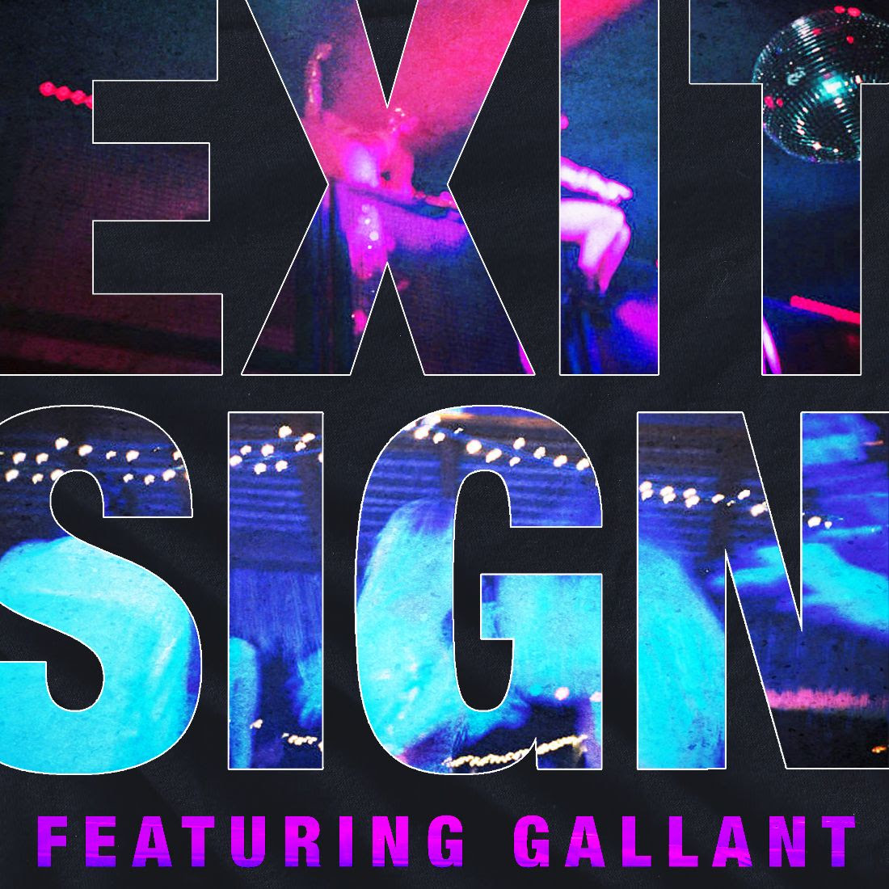
DOWNLOAD ARTWORK HERE

Following a massive sync of their single “New York Luau” in the nationwide US Open TV commercial, NYC’s reigning feel-good dance champions The Knocks are back with the seductive “Exit Sign”, featuring vocals from unparalleled R&B artist Gallant. Gallant’s effortlessly-smooth, crooning voice floats above The Knocks’ signature genre-smashing production that drives the track home. LISTEN HERE!

The Knocks have also announced they will be joining the rising melodic house producer Gryffin on his Fall US tour, taking their critically acclaimed DJ set on the road to select cities.

So far this summer, The Knocks have had a streak of dance releases ranging from “Awa Ni” (with Kah-Lo), to “New York Luau,” “No Requests,” “Colors,” and “Summer Luv” (with Whethan, feat. Crystal Fighters). “Awa Ni” is featured on the FIFA 2020 soundtrack and the track’s accompanying music video is out now. The Knocks also recently appeared on Late Night with Seth Meyers, performing “Marina Del Rey”, which the duo wrote for IFC’s hilarious new show Sherman’s Showcase.

B-Roc and Jpatt have been grinding as The Knocks for over a decade, making music for themselves and others in their HeavyRoc studio in New York City. In 2018, the duo released their most recent LP, New York Narcotic, charted in the Top 50 on Billboard’s Dance/Electronic Albums 2018 Year-end chart, launched a monthly curated party called The Knocks & Friends residency at PUBLIC Arts in New York City, and wrapped the US headline New York Narcotic tour in February, hitting all major markets. New York Narcotic has been celebrated for the duo’s ability to continually bridge sonic barriers, salute multiple genres, and seamlessly fuse electronic, alternative and urban music. The album includes their smash single “Ride or Die” ft. Foster the People which has garnered over 64 Million streams, hitting #1 on iTunes Dance, 22+ weeks on Billboard Dance chart and 20 weeks on the Billboard Alternative chart.

The guys have also performed on The Tonight Show w/ Jimmy Fallon and TRL for their smash collaboration with Sofi Tukker, NERVO, and Alisa Ueno, “Best Friend” – which peaked at #1 on the iTunes Dance, US Dance Radio, Billboard Commercial, Billboard Dance/Mix Show, and Shazam Dance Charts, and also peaked at #3 on the Shazam Worldwide Main Charts, after debuting during Apple’s Keynote address. The track was also prominently featured in advertisements for the iPhone X.

Gallant widens the scope of R&B with relatable confessions and thought-provoking cinematic concepts. The GRAMMY® Award-nominated iconoclast and innovator strikes a balance between bedroom-ready throwback production and nuanced narratives. This approach notched a GRAMMY® Award nomination in the category of "Best Urban Contemporary Album" for his breakout debut Ology. Additionally, the record debuted in the Top 25 of the Billboard Top 200, emerged on Entertainment Weekly's "25 Best Albums of 2016 (So Far)," and attracted acclaim from The Guardian, Pitchfork, The FADER, and more. Not to mention, he drummed up over 100 million-plus streams to date. He brought those songs on the road alongside John Legend, entranced audiences at Coachella, and performed on The Tonight Show Starring Jimmy Fallon, Later... with Jools Holland, and NBC's Today. Plus, he made his acting debut on HBO's Insecure. Now, he projects his vision like never before on 2019’s Sweet Insomnia [Mind of a Genius/Warner Records] introduced by singles “Sharpest Edges,” “Crimes,” and “Sleep On It.”

THE KNOCKS LIVE 2019
More info here: https://theknocks.com/tour/
Oct 26- The Truman- Kansas City, MO
Oct 27- Slowdown- Omaha, NE
Oct 29- Pop's- St Louis, MO
Oct 30- Bluebird- Bloomington, IN
Oct 31- Royal Oak Music Theatre- Royal Oak, MI
Nov 01- Stage Ae- Pittsburgh, PA
Nov 02- Agora Theatre- Cleveland, OH
Nov 05- Deluxe, Old National Centre- Indianapolis, IN
Nov 06- Bogart's- Cincinnati, OH
Nov 07- Mercury Ballroom- Louisville, KY
Nov 09- Express Live!- Columbus, OH
Nov 12- The Norva- Norfolk, VA
Nov 13- The National- Richmond, VA
Nov 14- Marathon Music Works- Nashville, TN
Nov 15- Tabernacle Presented By Cricket Wireless- Atlanta, GA
Nov 16- The Fillmore Charlotte- Charlotte, NC
Nov 17- The Ritz- Raleigh, NC
Nov 19- The Firmament- Greenville, SC
Nov 20- The Senate- Columbia, SC
Nov 21- The Moon- Tallahassee, FL
Nov 22- The Plaza Live- Orlando, FL
*Nov 23- Wonderfront Festival 2019- Waterfront Park- San Diego, CA
Nov 26- Joy Theater- New Orleans, LA
Nov 27- Southside Ballroom- Dallas, TX
Nov 29- Emo's Austin- Austin, TX
Nov 30- House Of Blues – Houston- Houston, TX
Dec 01- Tower Theatre- Oklahoma City, OK
Dec 03- The Rialto Theatre- Tucson, AZ
Dec 04- The Van Buren- Phoenix, AZ
*Live with band. Not Gryffin tour

CONNECT WITH THE KNOCKS:
Instagram | Facebook | Twitter | Spotify

Press Assets: http://press.wearebigbeat.com/artists/the-knocks/

Press inquiries:
Paige Rosoff
Publicity, Big Beat Records
Paige.Rosoff@atlanticrecords.com

