The Summer of The Knocks Continues With
New Single “Colors”

LISTEN HERE: https://BigBeat.lnk.to/colors

OUT NOW VIA BIG BEAT RECORDS

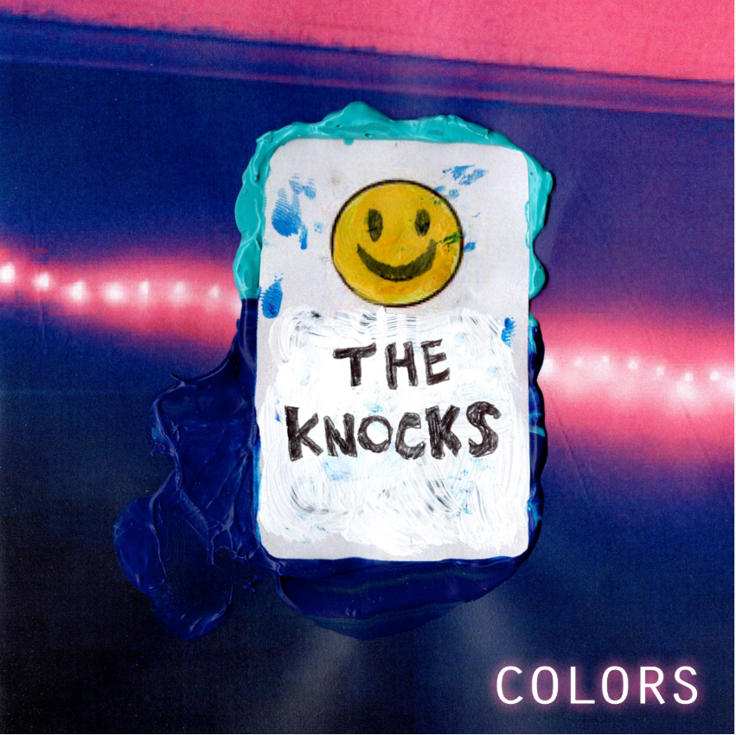
DOWNLOAD ARTWORK HERE

The summer of The Knocks has only just begun, and the beloved electronic music duo are dropping a new single called “Colors,” officially out today through Big Beat/Neon Gold – listen HERE! The effortlessly cool pair keep churning out hit after sweltering hit; July saw the release of two new singles called “New York Luau” and “No Requests,” both of which you can check out here, which was preceded by their other latest single “Awa Ni”, with the Nigerian singer Kah-Lo.

“Colors” is no exception, leaning on ethereal synths and disco-tinged guitars, before the house track erupts, blurring multiple genre lines (in true Knocks fashion), proving once again why JPatt and B-Roc reign supreme as some of the most forward-thinking artists in music.

The Knocks most recent LP New York Narcotic is celebrated for the duo’s ability to continue crossing barriers, interlacing electronic, alternative, and urban sonics. The album includes their smash single “Ride or Die” ft. Foster the People which has garnered over 55 Million streams, hitting #1 on iTunes Dance, 22+ weeks on Billboard Dance chart and 20 weeks on the Billboard Alternative chart. The song also saw an appearance on Late Night w/ Stephen Colbert (WATCH) and an official music video that satires classic 90’s cult films. The LP also features a slew of incredible guest vocalists including Method Man, Big Boi, Sir Sly, Alexis Krauss from Sleigh Bells and Sofi Tukker to name a few.

B-Roc and Jpatt have been grinding as The Knocks for a decade, making music for themselves and others in their HeavyRoc studio in New York City. In 2018, the duo charted in the Top 50 on Billboard’s Dance/Electronic Albums 2018 Year-end chart, launched a monthly curated party called The Knocks & Friends residency at PUBLIC Arts in New York City, and wrapped the US headline New York Narcotic tour in February, hitting all major markets. Additionally, the guys performed on The Tonight Show w/ Jimmy Fallon and TRL for their smash collaboration with Sofi Tukker, NERVO, and Alisa Ueno, “Best Friend” – which peaked at #1 on the iTunes Dance, US Dance Radio, Billboard Commercial, Billboard Dance/Mix Show, and Shazam Dance Charts, and also peaked at #3 on the Shazam Worldwide Main Charts, after debuting during Apple’s Keynote address. The track was also prominently featured in advertisements for the iPhone X.

Keep an eye out for more bangers coming this summer!

Remaining North American Live dates:
Sat, Aug 17 - Nomad Vegas Residency - Las Vegas, NV ++
Saturday, Oct 5 - Tecate Residence - Hermosillo, MX ++
Fri, Oct 18 - Tecate Residence - Mexico City, MX ++
Mon, Nov 24 – Wonderfront Festival – San Diego, CA +
+ indicates Live set
++ indicates DJ set

Connect with The Knocks:
https://www.facebook.com/theknocksnyc
https://soundcloud.com/theknocks
https://twitter.com/theknocks
https://instagram.com/the_knocks
http://theknocks.com

Press Assets: http://press.wearebigbeat.com/artists/the-knocks/

FOR MORE INFORMATION:
Paige Rosoff - Big Beat Records
Paige.Rosoff@atlanticrecords.com

