TYCHO CREATES MESMERIZING REMIX OF THE KNOCKS AND MUNA’S SINGLE “BODIES”

OUT TODAY VIA BIG BEAT RECORDS

LISTEN HERE

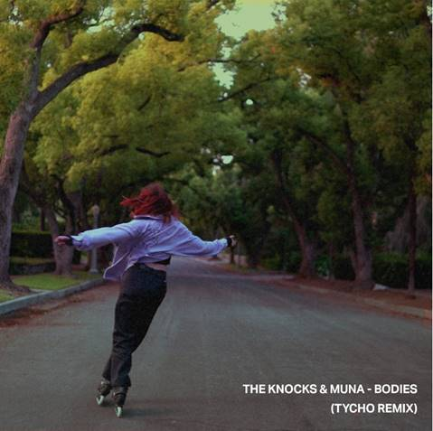

Tycho just took the song of the summer and gave it a celestial sonic touch that truly is otherworldly. The Knocks and MUNA released their anthemic single “Bodies” earlier this summer, which led to its status as one of the most memorable songs of this very strange summer thanks to its easy-going, breezy production from The Knocks and hopeful sentiment from MUNA’s mesmerizing topline. Out today, Tycho has added his trademark ambient spin to the already-spellbinding song, along with its compelling, beautiful visualizer – LISTEN/WATCH HERE!

The Knocks and MUNA’s original version of “Bodies” keeps on growing organically as the seasons change. Thanks to its commercial and streaming success across the board, The Knocks and MUNA recently performed the single on Jimmy Kimmel Live - watch here.

“I've always been interested in the possibilities that arise when combining elements from different styles and genres” said Scott Hansen/Tycho, “with this remix I wanted to create a conversation between the vocal and instrumental passages that intertwined into a kind of duet. It was a really inspiring process.”

A star-studded collaboration from the beginning, “Bodies” was always destined for greatness… and now with an absolutely undeniable remix from Tycho, the sky truly is the limit. Stay tuned for more from The Knocks.

CONNECT WITH THE KNOCKS:
Instagram | Facebook | Twitter | Spotify

CONNECT WITH MUNA:
Instagram | Facebook | Twitter | Spotify

CONNECT WITH TYCHO:
Instagram | Facebook | Twitter | Spotify

Press Assets: http://press.wearebigbeat.com/artists/the-knocks/

Press inquiries:
Paige Rosoff
Publicity, Big Beat/Atlantic Records
Paige.Rosoff@atlanticrecords.com

