THE KNOCKS RETURN WITH DISCO SMASH “BEDROOM EYES”
FT STUDIO KILLERS

FOLLOWING GLOBAL SENSATION “R U HIGH” FT MALLRAT

LISTEN HERE: https://knocks.lnk.to/BedroomEyes
WATCH THE MUSIC VIDEO HERE

OUT TODAY VIA BIG BEAT RECORDS

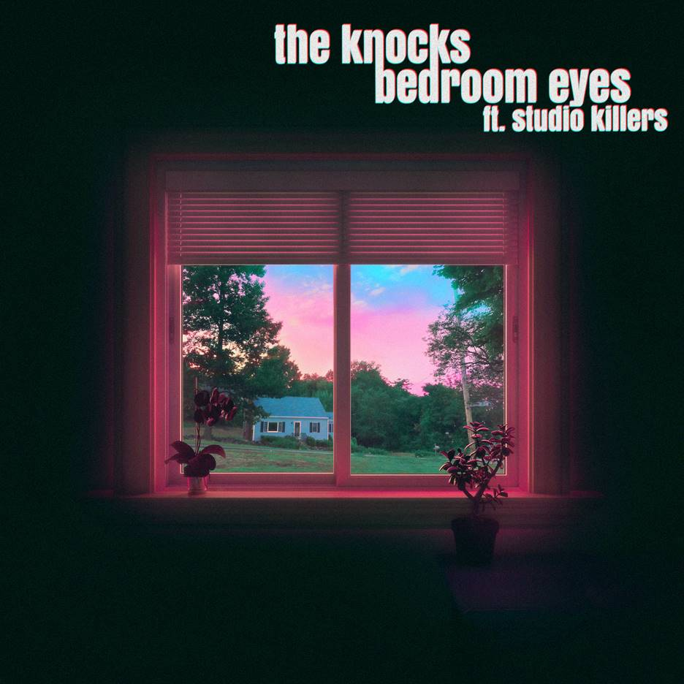
DOWNLOAD ARTWORK HERE

The Knocks follow their last single “R U High” ft Mallrat with melodic disco smash “Bedroom Eyes,” collaborating with international electro-pop group Studio Killers of viral global hit “Jenny.” Listen HERE and watch the official music video HERE.

On the collaboration The Knocks say, "Bedroom Eyes" is a fun, carefree disco song that's a return to our roots. We wanted to capture the feeling of familiarity while also sounding new and fresh. We are big fans of Studio Killers so it was great to finally get to work with them. They remind us of the glory days of electronic music where the music always came first and artists put in the time to craft unique concepts and worlds instead of chasing pop stardom.”

And on the official music video they say, “We love how the music video turned out. It's over the top and ridiculous and reminded us a bit of the classic old school dance videos of the 90's. Everyone involved brought their own unique personalities to the screen so it was great to see them all perform and come together. We worked with the director, Kevin Eis, on our music video for "Trouble" several years ago and knew we had to do it again. We hope this makes you smile as much as it did for us.”

The Knocks’ “R U High” featuring Australian breakthrough talent Mallrat continues to grow globally, with over 5M streams and counting and international radio attention, reaching number 1 on Triple J’s “Most Played” chart. “Bedroom Eyes” also follows The Knocks’ Melody & Silence mixtape with Foster the People, which got the attention of Stereogum, Under The Radar, NME, and more respected music outlets.

The Knocks are a New York City-based electronic music institution who have consistently evolved throughout their successful career and have shown no signs of slowing down this year. Their first single “Bodies” (with MUNA) has been streamed over seventeen million times globally since release, resulting in a brilliant performance on Jimmy Kimmel Live!. The follow up, “All About You” with Foster the People soared up the Alternative Radio charts (#14) and was Tiktok’s “Year End Wrap” ad campaign song. In addition, their collab with Purple Disco Machine, “Fireworks”, has become a global hit, reaching top 20 on the global airplay charts, #1 on the airplay charts in Germany and Italy, has already gone platinum in Italy. Most recently, the single received a big sync with Abercrombie in a campaign that celebrates June pride month. The duo top that off with commanding a lifetime high of 24 million monthly streams on Spotify.

Throughout their career, the duo has collaborated with some of music's biggest names [Carly Rae Jepsen, X Ambassadors, MGMT] and toured around the world with music heavyweights including The 1975, Justin Bieber, and Ellie Goulding. Their hit single, “Ride or Die” featuring Foster the People reached #11 on the alt radio charts and landed them a live performance on The Late Show With Stephen Colbert. In addition, their collaboration with Sofi Tukker "Best Friend" has accumulated more than 200 million streams across platforms to date. They performed the song live on The Tonight Show Starring Jimmy Fallon and was the feature song in Apple's iPhone X campaign and keynote address. The Knocks' hit song "Shades" is currently featured in Pepsi's 2020-2021 national ad campaign.

Studio Killers is an international electro-pop group composed of frontwoman and vocalist Cherry, keytarist Goldie Foxx, and DJ Dyna Mink, who virtually manifest to release new music, usually coupled with brilliantly surreal animated videos. Studio Killers’ breakout single “Jenny” has now found a second life thanks to the extraordinarily unpredictable world of TikTok, with over 3 Billion views, shooting up viral charts worldwide, charting on more than 53 country and global viral charts, 90% of which were the Top 10 (including peaking at #6 on Spotify's Global Viral Chart and #3 on Spotify's US Viral chart), and achieving over 185M global streams and Atlantic Records as a new label home.

CONNECT WITH THE KNOCKS:
Instagram | Facebook | Twitter | Spotify

Press Assets: http://press.wearebigbeat.com/artists/the-knocks/

Press inquiries:
Paige.Rosoff@atlanticrecords.com
Big Beat Records | Atlantic Records

