THE KNOCKS RECRUIT NIGERIAN SINGER KAH-LO FOR NEW SINGLE “AWA NI” OUT TODAY!

+ LIVE DATES, FESTIVAL APPEARANCES & NEW LAS VEGAS RESIDENCY

LISTEN/SHARE: https://youtu.be/hnyk23Koi88
BUY/STREAM: https://BigBeat.lnk.to/AWANIPR

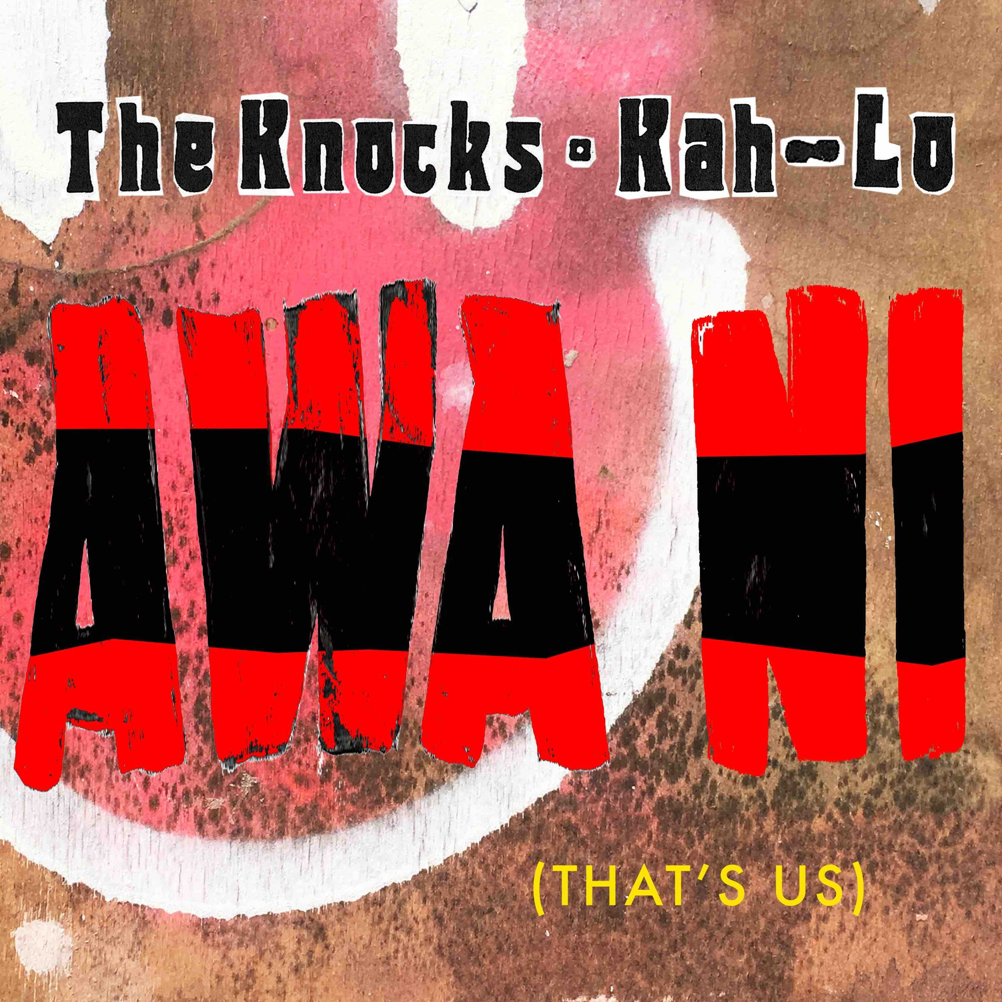

New York City’s effortlessly cool The Knocks debut a worldly new feel-good track “Awa Ni” (the phrase “awa ni” roughly translates to “that’s us” in Yoruba, one of the native languages spoken in the city of Lagos, Nigeria). The new single features Nigerian singer and Lagos native Kah-Lo – LISTEN HERE!

“Awa Ni” arrives ahead of Ben “B-Roc” Ruttner and James “JPatt” Patterson’s forthcoming live dates including an appearance at Firefly Music Festival tonight as well as their newly unveiled residency at JEMAA, the pool party at the Nomad Hotel in Las Vegas – see below for full itinerary and/or head to https://theknocks.com/tour/ for more!

The Knocks most recent LP ‘New York Narcotic’ is celebrated for the duo’s ability to continue crossing barriers, saluting multiple genres, interlacing electronic, alternative, and urban sonics. The album includes their smash single “Ride or Die” ft. Foster the People which has garnered over 55 Million streams, hitting #1 on iTunes Dance, 22+ weeks on Billboard Dance chart and 20 weeks on the Billboard Alternative chart. The song also saw an appearance on Late Night w/ Stephen Colbert (WATCH) and the official music video has over 4.5 Million views. The LP also features a slew of incredible guest vocalists including Method Man, Big Boi, Sir Sly, Alexis Krauss from Sleigh Bells and Sofi Tukker to name a few.

B-Roc and Jpatt have been grinding as The Knocks for over a decade, making music for themselves and others in their HeavyRoc studio in New York City. In 2018, the duo charted in the Top 50 on Billboard’s Dance/Electronic Albums 2018 Year-end chart, launched a monthly curated party called The Knocks & Friends residency at PUBLIC Arts in New York City, and wrapped the US headline New York Narcotic tour in February, hitting all major markets. Additionally, the guys performed on The Tonight Show w/ Jimmy Fallon and TRL for their smash collaboration with Sofi Tukker, NERVO, and Alisa Ueno, “Best Friend” – which peaked at #1 on the iTunes Dance, US Dance Radio, Billboard Commercial, Billboard Dance/Mix Show, and Shazam Dance Charts, and also peaked at #3 on the Shazam Worldwide Main Charts, after debuting during Apple’s Keynote address. The track was also prominently featured in advertisements for the iPhone X.

**

"We've always been huge fans of Kah-Lo and have played a lot of her records in our DJ sets for a while now. We reached out to her on Instagram when we found out she lived in NYC and had her by the studio. We wanted to make something that was different from the more club stuff she had been doing. The instrumental for this song was actually called "Lagos" which turned out to be her hometown (which we didn't know at the time), so she instantly gravitated towards it and wanted to write something anthemic about where she is from. It all happened very fast, which is usually the best sign.” – The Knocks

“I loved working with The Knocks, and they understood exactly where I wanted to take my sound next. They played me this really big beat that seemed like it needed something to be sung in unison, and it really gave me the vibe of rolling around town back home with my friends. ‘Awa ni yen’ is usually used as a response when someone praises you about something. It’s basically an acknowledgement that roughly translates to “That’s us.” I’m always gingered, and I want everyone to feel the same way and be able to say the same thing for themselves." - Kah-Lo

**

The Knocks’ North American Live dates:

Fri, June 21 – Firefly Music Festival – Dover, DE +
Thurs, June 27 – Electric Forest – Rothbury, MI +
Sat, June 29 – Westworld Music Showcase – Denver, CO +
Fri, July 12 – The Knocks & Friends at Q Nightclub – Seattle, WA ++
Sat, July 13 – The Knocks & Friends at Sound Nightclub – Los Angeles, CA ++
Sun, July 14 – High Seas Festival West – San Francisco, CA ++
Thu, July 18 – The Knocks & Friends [location TBD] – New York, NY+
Sat, July 20 – Nomad Vegas Residency – Las Vegas, NV ++
Fri, July 26 – Theatre of Living Arts – Philadelphia, PA +
Fri, Aug 2 – The Knocks & Friends at Sky Bar – Chicago, IL ++
Sat, Aug 17 - Nomad Vegas Residency - Las Vegas, NV ++
Saturday, Oct 5 - Tecate Residence - Hermosillo, MX ++
Fri, Oct 18 - Tecate Residence - Mexico City, MX ++
Mon, Nov 24 – Wonderfront Festival – San Diego, CA +
+ indicates Live set
++ indicates DJ set

Connect with The Knocks:

https://www.facebook.com/theknocksnyc
https://soundcloud.com/theknocks
https://twitter.com/theknocks
https://instagram.com/the_knocks
http://theknocks.com

Press Assets: http://press.wearebigbeat.com/artists/the-knocks/

Press inquiries:

Jordan Danielle Frazes
Head of Publicity, Big Beat Records
Jordan.Frazes@atlanticrecords.com

Paige Rosoff
Tour Press
Paige.Rosoff@atlanticrecords.com

