THE KNOCKS AND FOSTER THE PEOPLE REJOIN FORCES FOR
UNDENIABLE NEW ANTHEM, “ALL ABOUT YOU”

LISTEN HERE: https://lnk.to/AAYID

OUT TODAY VIA BIG BEAT RECORDS

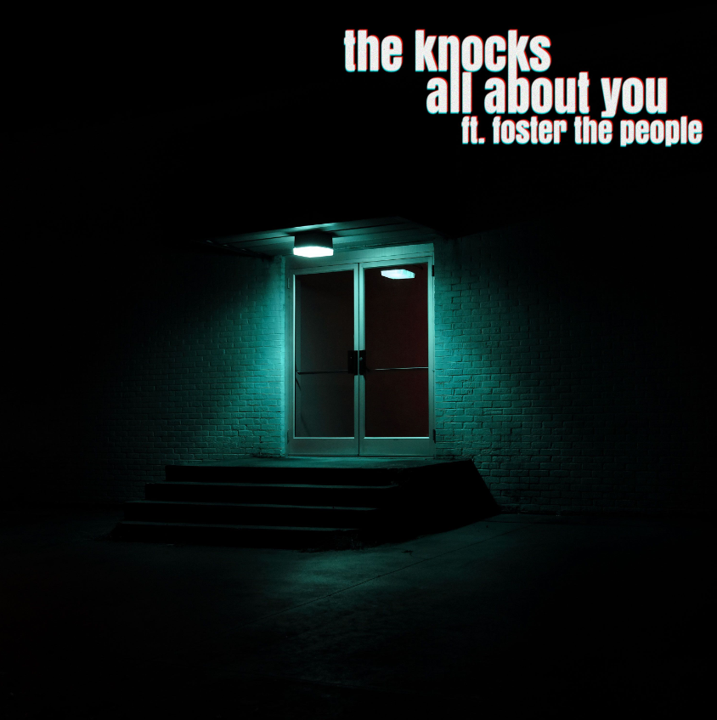

It’s been two years since The Knocks teamed up with Foster the People on “Ride or Die,” their unforgettable first collaboration which wound up being 2018’s undisputed Song of the Summer and streaming over 100 million times. The Knocks are thrilled to follow it up with the release of “All About You” feat. Foster the People, their second single off their yet to be named third full length LP. The single, out today through Big Beat Records, features The Knocks’ warm feel-good production and effortless, sleek vocals from Foster the People’s Mark Foster. “All About You” also utilizes an epic, soulful sample of Pastor T.L. Barrett’s “Like a Ship” in the chorus that takes it over the top to give the track one final divine, ethereal touch for good measure - LISTEN HERE.

In terms of their second collaboration, Ben from The Knocks says “'All About You' was a really natural process. We have always wanted to flip the Pastor T.L Barret sample 'Like a Ship' and I finally made a beat out of it on the tour bus last year... it was a little more basic and was just a breakbeat with the sample and an acid synth line. The beat kinda sat around for a while and we didn't know what to do with it, but we knew we loved it. Fast forward a couple months & Mark texted us saying he was in town... he came by our studio and really liked the idea and helped us come up with the change & the new bass groove. From there, with the help of Luke O'Loughlin, it turned into something special. It feels like a perfect nod to all the different sides of our influences. Late 90s electronica, meets Britpop, mashed with a hip-hop type gospel sample flip, & an indie pop song. We feel it really checks all the Knocks boxes in the perfect most effortless way.”

In Mark Foster’s words “When I was in New York a few months ago, I popped over to say hi to The Knocks guys, as I hadn't caught up with them in a while. We were hanging at their studio, playing various things for each other that we had been working on. One of the tunes Ben played me was the rough instrumental for what would eventually turn into "All About You." The 90’s era breakbeat/early Frankie Knuckles house feel drew me in. I put a bass line and a chord change on it, and was surprised when they sent me a fully realized song a few months later. I cut the vocals and added some textures at my LA studio and we finished the collaboration remotely. It's a beautiful thing when a casual hang with friends produces a piece of art.”

Together for over a decade, The Knocks are a New York City-based electronic music institution. The duo have released 2 LP’s & 5 EP's, collaborated with some of music's biggest names [Foster the People, Carly Rae Jepsen, X Ambassadors, Big Boi, Sir Sly] and toured around the world with music heavyweights including The 1975, Justin Bieber, and Ellie Goulding. Their hit single, “Ride or Die” featuring Foster the People reached #10 on the alt radio charts and landed them a live performance on The Late Show With Stephen Colbert. In addition, their collaboration with Sofi Tukker "Best Friend" has accumulated more than 189 million streams across platforms to date. They performed the song live on The Tonight Show Starring Jimmy Fallon and was the feature song in Apple's iPhone X campaign and keynote address. The Knocks’ latest release “Bodies” (with MUNA) has already been streamed over four million times globally, resulting in a brilliant performance on Jimmy Kimmel Live!, and is still currently sitting at #34 on the US Dance Radio chart. Most recently, The Knocks' hit song "Shades" was featured in Pepsi's summer 2020 ad campaign as well as getting a massive sync for their timeless smash "Classic" (feat. POWERS) on Starbucks national' TV campaign. Cap that with producing several songs for the critically acclaimed IFC show Sherman's Showcase and performing it on the Late Show with Seth Meyers.

ABOUT FOSTER THE PEOPLE
Founded in in 2009, Foster the People achieved success with the 2011 release of their debut album Torches, which has sold over two million albums and over ten million singles worldwide. Torches features the RIAA certified Diamond single “Pumped Up Kicks,” which was recently named one of USA Today’s “100 Absolute Best Songs in History,” and also spawned the chart topping singles “Don’t Stop(Color On The Walls),” “Houdini,” and “Helena Beat.” Foster the People garnered three Grammy nominations for their monumental debut, including Best Alternative Album, Best Pop Duo/Group Performance for “Pumped Up Kicks” and Best Short Form Music Video for “Houdini.” Supermodel was the second full-length record from Foster the People. Influenced by front-man Mark Foster’s world travels and shifting perspective, the album was recorded in studios around the world and features fan favorites including "Coming of Age" and "Best Friend." In 2017, the band followed with their third record, Sacred Hearts Club, which features multi-format, Double-Platinum-certified hit “Sit Next To Me.” The track, described as “pure shimmering pop” by The Associated Press and named one of Billboard’s “Best Songs of 2018,” has accumulated nearly 300 Million global streams to date. At radio, the song hit #3 at Alternative, #19 at Top 40 and reached Top 10 at both AAA and Adult Pop. The track also garnered a 2019 Billboard Music Award nomination for Top Rock Song and a nomination for Choice Rock/Alternative Song at the 2018 Teen Choice Awards. This year, Foster the People have released new singles "It's Ok To Be Human," “Lamb’s Wool” and “The Things We Do” independently, and the band is currently at work finalizing a new EP, to be released toward the end of 2020.

CONNECT WITH THE KNOCKS:
Instagram | Facebook | Twitter | Spotify

Press Assets: http://press.wearebigbeat.com/artists/the-knocks/
Press inquiries:
Paige Rosoff
Publicity, Big Beat/Atlantic Records
Paige.Rosoff@atlanticrecords.com

