The Knocks’ new album “55” is out today!
+ Animated Video Highlighting Their Humble NYC Origins!
WATCH/POST HERE
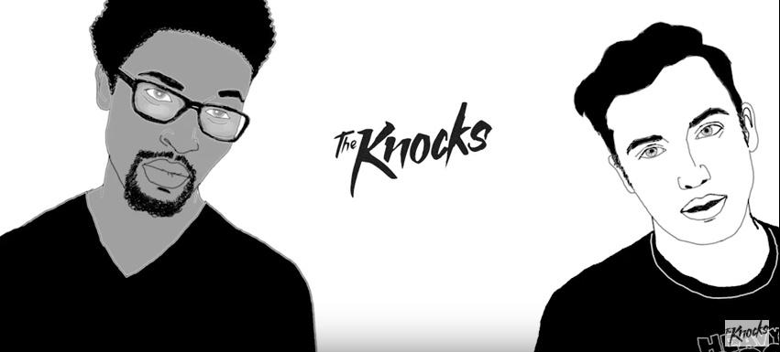
Buy “55” via iTunes + Stream via Spotify
(via Big Beat/Neon Gold Records)

Fresh off a sold-out North American ‘Route 55’ tour, today sees the release of the prodigious Lower East Side production duo The Knocks’ long-awaited debut album “55,” courtesy of Big Beat/Neon Gold Records. To celebrate the momentous occasion, they have shared a comical new animated video that details the origins of how Ben Ruttner [B-Roc] and James Patterson [JPatt] came together to form The Knocks.

1. New York City (feat. Cam’Ron) -
Slow build swirls of piano layered under a vintage Cam’ron verse, capped off with a classic New York City hook!

2. Time –
Feel good funky gospel you’ll come back for over and over!

3. Classic (feat. POWERS) –
The title says it all. Disco, 70’s funk, classic house, all tied together with Powers hypnotizing vocals.

4. Kiss The Sky (feat. Wyclef Jean) –
COMPLEX said it best. This treat of a song kicks into high-gear with a savage intro that throws it back to the '90s before erupting into a percussive beast laced with stellar synths that come into high focus on the party chorus.

5. Dancing With Myself –
Slow-burn, introspective, reminiscent of the French house you know and love. You’ll be hooked!

6. Comfortable Ft. X Ambassadors –
Noisey summarized it as “a stroke of awesome because together they've produced a funked up disco banger to banish the winter blues,” and who are we to disagree?

7. The Knocks & Matthew Koma - I Wish (My Taylor Swift) –
This verse will get stuck in the back of your brain and keep you coming back for years to come.

8. Collect My Love Ft. Alex Newell –
This cut feels straight out of Studio 54!

9. The Key –
Vintage hip-hop intro spliced with sultry disco that’ll keep you coming back
10. Tied To You Ft. Justin Tranter –
Open up new dimensions of your palate with “Tied To You” with vocals from Justin Tranter, whose honeyed, charming vocals recall the best of Passion Pit!

11. Love Me Like That ft. Carly Rae Jepsen –
Carly Rae Jepsen’s vocal addition makes this platter airy and divine, thanks to the retro production vibes, and heartfelt storytelling lyrics of love and longing.

12. Cinderella Ft. Magic Man –
Magic Man brings some uplifting flavor that’s designed perfectly for stadium-size sing-alongs, and is a song that’ll make you forget to be home by midnight!

13. Purple Eyes (Ft. Phoebe Ryan) –
Fresh, atmospheric and blissful all at once.

14. Best For Last Ft. Walk The Moon –
...twists and turns with glitchy production, held together by Walk The Moon’s calming vocals

15. Classic (feat. Fetty Wap & POWERS)
Another take on this imminent throwback funky disco-pop hit, peppered with a tasty verse courtesy of the unmistakable Fetty Wap!

“55” is a resolutely DIY dance album, that features star-studded vocal contributions from Alex Newell, Cam’ron, Carly Rae Jepsen, Fetty Wap, Justin Tranter, Magic Man, Matthew Koma, Phoebe Ryan, POWERS, Walk The Moon, Wyclef Jean, and X Ambassadors.

The Knocks are a New York story through & through, first meeting at age 19 in a studio (at New School). Ben “B-Roc” Ruttner DJed clubs while James “JPatt” Patterson played the organ at a church outside the city. The duo’s already churned out remixes for Katy Perry and Passion Pit (and later remixes for Ellie Goulding and Icona Pop), allowing the Knocks to become synonymous with a certain warm, retro-future, disco-kissed touch. In 2008, JPatt and B-Roc took out a loan and opened the HeavyRoc studio at 55 Chrystie, in the same broken-down building where the Beastie Boys used to rehearse.

55 Tracklisting:
- New York City (feat. Cam'Ron)
- Time
- Classic (feat. POWERS)
- Kiss The Sky (feat. Wyclef Jean)
- Dancing With Myself
- Comfortable (feat. X Ambassadors)
- The Knocks & Matthew Koma - I Wish (My Taylor Swift)
- Collect My Love (feat. Alex Newell)
- The Key
- Tied To You (feat. Justin Tranter)
- Love Me Like That (feat. Carly Rae Jepsen)
- Cinderella (feat. Magic Man)
- Purple Eyes (feat. Phoebe Ryan)
- Best For Last (feat. Walk The Moon)
- Classic (feat. Fetty Wap & POWERS) (Bonus Track)

Connect with The Knocks:
https://www.facebook.com/theknocksnyc
https://soundcloud.com/theknocks
https://twitter.com/theknocks
http://theknocks.com
https://instagram.com/the_knocks

For all press assets, please visit: http://press.wearebigbeat.com/artists/the-knocks/

For press inquiries / Jordan Frazes
Jordan.Frazes@atlanticrecords.com
via Big Beat/Neon Gold Records

For tour requests / Ilana Gold
Ilana.gold@atlanticrecords.com

