RENOWNED PRODUCERS
THE KNOCKS X MAT ZO
TEAM UP FOR BRAND NEW SUPERGROUP
“THE MARY NIXONS”
+

RELEASE EXPLOSIVE DEBUT SINGLE

“ADRIAN”

OUT ON BIG BEAT RECORDS

LISTEN/POST: HERE

BUY / STREAM: HERE

“There's groups, and then there's supergroups. New York duo The Knocks and London born-L.A. based producer Mat Zo have each achieved success on their own. But they've now decided to combine their talents to form a new supergroup called The Mary Nixons. Their debut record, "Adrian", flaunts a cheery tropical sequence and helium-breath vocal chops amid 8-bit elements.” – BILLBOARD

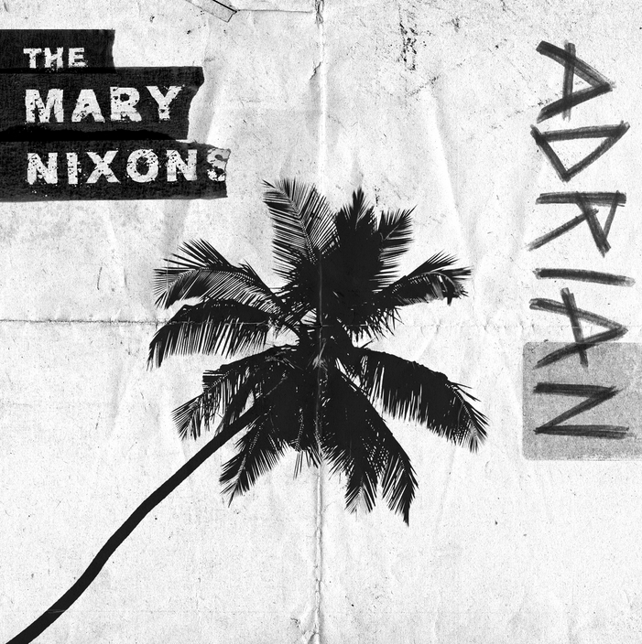

"We wrote this song with our friend Nate Cypthert, who we have known for a minute after meeting him in the Nicaraguan jungle at a writing camp. We wanted to develop something that was a bit of a throwback, like those old classic folk songs about travel and adventure. The original vocal was recorded over an acoustic guitar and then we laid down the melody and lyrics. The song is about one of my best friends who had left his life and corporate job in NYC to travel and see the world." – THE KNOCKS

"Adrian was born when The Knocks and I wanted to make something that was summery and 'tropical' but with a bit of grit, because we were feeling like everything in that vein was sounding a bit too sterile. We had this almost country vocal, and were trying loads of different things over it. Eventually we landed on something really simple and repetitive, but effective. I then used some production techniques I learned from making drum & bass to give it extra character and grit. I think the result is pretty cool, I'm really proud of it." – MAT ZO

New York City bred resident electronic duo, The Knocks and Grammy nominated London born-LA based producer and industry powerhouse Mat Zo team up for the second time under the guise of their new super group The Mary Nixons. Today the world gets a first taste of this incredibly talented trio through the release of their explosive debut single ‘Adrian’ – LISTEN – set to be an anthem for the summer months ahead – out on Big Beat Records.

The name The Mary Nixons was inspired by the legendary ghost singer, Marni Nixon, who sang the vocals in many midcentury iconic Hollywood films including Mary Poppins, The Sound of Music, Westside Story, and My Fair Lady among many others. At the time, several of her performances were uncredited by the studios as was common practice around town. It's a nod to the unsung heroes and the talents that often go under the radar in an industry that is now dominated by a "look at me" attitude.

Centered around a shared love for classic disco/pop/electro-funk, as well as sample-based music, The Mary Nixons personifies this mutual passion, blurring boundaries to exhilarating effect.

The Knocks stay true to form with an already-prolific 2017, which has seen the release of a new Testify EP out now via Neon Gold/Big Beat Records.

Mat Zo, hailed as an innovator in the electronic genre by Rolling Stone, released his debut album, Damage Control, via the Anjunabeats and Astralwerks labels in 2013 which received a Grammy Nomination for Best Dance/Electronic Album. His second studio album, Self-Assemble, was released in March of 2016 under his own Mad Zoo label.

##

More on The Knocks:
The Knocks are a New York story through and through, first meeting at the age of nineteen in a studio at the New School. Ben “B-Roc” Ruttner DJ’d clubs while James “JPatt” Patterson played the organ at a church outside the city. In 2008, JPatt and B-Roc took out a loan and opened the HeavyRoc studio at 55 Chrystie, in the same broken-down building where the Beastie Boys used to rehearse. The Knocks have already become synonymous with warm, retro-future, disco production, and with the “TESTIFY” EP and their new single “Trouble,” the duo certainly aim to expand on that, taking their craft to the next level.

The Knocks have been capitalizing on this increased momentum, selling out headlining show across the country, supporting global superstar artists such as Justin Bieber, Ellie Goulding, and The 1975, and delivering critically acclaimed performances at festivals nationwide and abroad. The duo recently wrapped their Feel Good Feel Great tour, which included support from many of their friends, including Bipolar Sunshine, Mark Johns, Skylar Spence, Lophiile, and Gilligan Moss. Now back in the studio, The Knocks are working on a new body of work that will further solidify their position as one of the leading innovators in the genre-bending electronic space.

“dance-pop masterminds" – SPIN

“The Knocks have displayed an almost encyclopedic understanding of decades of pop. They seamlessly blend that knowledge into their own music, a heady brew of 70’s-era funk, disco, EDM, and hip hop.” –The New York Times

The Knocks upcoming tour dates:
July 15 – Scranton, PA @ Camp Bisco
Aug 12 – Brooklyn, NY @ Elements Brooklyn
Sept 16 – San Diego, CA @ Kaaboo Festival
Sept 17 – San Fran, CA @ The Classic Cruise
Sept 23 – Ithaca, NY @ Cayuga Sound
Oct 7 – Washington D.C.@ All Things Go Festival

More on Mat Zo:
Self-taught in music production and inspired by the likes of Daft Punk and the Chemical Brothers, Zo released his debut single on a:Loud Recordings at age 16 and quickly gained recognition from major players within the trance and house scenes. By 2012 he’d teamed up with Porter Robinson for “Easy” (a #1 hit on the Beatport Top 100 chart) and set to work on his full-length debut. Released in November 2013, Damage Control climbed to #1 on the iTunes Dance chart the very same day of its debut. With “Pyramid Scheme” feat. Chuck D fast reaching #2 on the Billboard Dance/Club Play chart, the album debuted at #1 on the Billboard Heatseekers Albums chart, then landed its nomination for Best Dance/Electronic Album at the 2015 Grammy Awards.

Along with creating Self Assemble, Zo’s spent the last two years self-releasing tracks as free downloads on SoundCloud, overseeing his newly launched record label Mad Zoo, and taking the stage everywhere from Madison Square Garden to major festivals like Electric Daisy Carnival, Ultra Music Festival, and TomorrowLand—not to mention cultivating his skills in painting and drawing with plans of developing the artwork for forthcoming releases.

Mat Zo upcoming tour dates:
July 15 – Santa Ana, CA @ The Observatory
Sept 14 – Washington, DC @ Soundcheck
Sept 15 – Brooklyn, NY @ Output
Sept 23 – London, UK @ Hospitality in the Park

The Mary Nixons press assets: http://press.wearebigbeat.com/artists/the-mary-nixons/

Connect with The Knocks: Facebook | Instagram | Twitter | Soundcloud | The Knocks Website

The Knocks press assets: http://press.wearebigbeat.com/artists/the-knocks/

Connect with Mat Zo: Facebook | Instagram | Twitter | Soundcloud |Mat Zo Website

For press inquiries:
Jordan Danielle Frazes / Head of Publicity, Big Beat Records / Jordan.Frazes@atlanticrecords.com
Catherine Corkery/ Publicity, Big Beat Records/ Catherine.Corkery@atlanticrecords.com
Ilana Gold / Tour Requests / Ilana.Gold@atlanticrecords.com

