THE KNOCKS PRESENT “WALKING ON WATER
(FT. TOTALLY ENORMOUS EXTINCT DINOSAURS)”

MULTI-PLATINUM ELECTRONIC STARS HERALD THIRD STUDIO ALBUM
WITH SOULFUL NEW COLLABORATION

NORTH AMERICAN HEADLINE TOUR BEGINS MARCH 18 IN TEMPE, AZ

LISTEN TO “WALKING ON WATER (FT. TOTALLY ENORMOUS EXTINCT DINOSAURS)” HERE

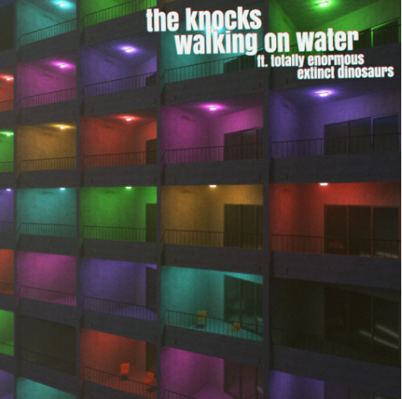
DL press photos

Multi-platinum electronic luminaries The Knocks have announced today’s premiere of a powerfully soulful new single. Listen to “Walking On Water (Ft. Totally Enormous Extinct Dinosaurs)” HERE.

“Walking On Water (Ft. Totally Enormous Extinct Dinosaurs)” heralds The Knocks’ hugely anticipated third studio album, due later this year. Written in Los Angeles with GRAMMY® Award-nominated British electronic artist Totally Enormous Extinct Dinosaurs (a.k.a. Orlando Higginbottom) mere days before the first COVID lockdown in March of 2020, the song instantly stood as one of the new LP’s creative guideposts. Touching on thematic pillars of nostalgia, relationships, and emotional intimacy, “Walking On Water” expertly evinces The Knocks’ knack for bridging eras, genres, and cultures in unexpected ways, with Higginbottom’s smooth vocals interwoven with an indelible sample from Philadelphia soul legend Herb Johnson’s “Unlisted Track” (restored and released in 2001 by the Philly Archives).

The Knocks will further mark the arrival of their upcoming album with an eagerly awaited U.S. headline tour. The high energy NYC-based duo’s first live performances in more than two years, THE HISTORY TOUR – which will see both full-scale live electronic performances and genre-spanning DJ sets – gets underway March 18 at Tempe, AZ’s Sunbar Tempe and then makes stops across the country through a May 1 finale at The Sinclair in Cambridge, MA. Additional North America dates will be announced soon. For complete details and remaining ticket availability, please visit www.theknocks.com/tour.

THE KNOCKS
THE HISTORY TOUR
NORTH AMERICA 2022

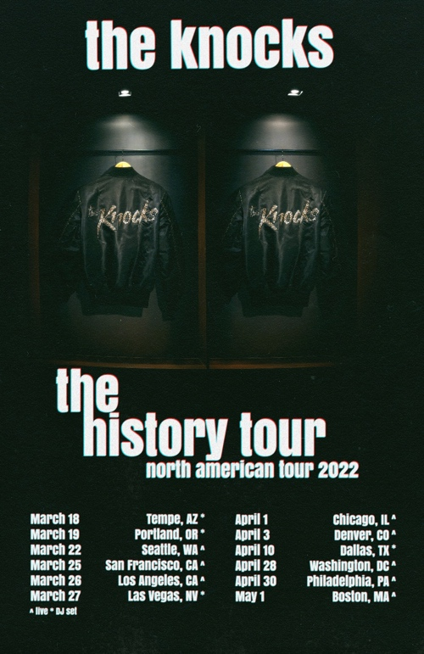

MARCH
18 – Tempe, AZ – Sunbar Tempe *
19 – Portland, OR – 45 East *
22 – Seattle, WA – The Showbox ^
25 – San Francisco, CA – The Regency Ballroom ^
26 – Los Angeles, CA – Fonda Theatre ^
27 – Las Vegas, NV – DISCOPUSSY *

APRIL
1 – Chicago, IL – Concord Music Hall ^
3 – Denver, CO – Bluebird Theatre ^
8 – Dallas, TX – Deep Ellum Art Company *
28 – Washington, DC – 9:30 Club ^
30 – Philadelphia, PA – The Fillmore Philadelphia ^

MAY
1 – Cambridge, MA – The Sinclair ^

* DJ SET
^ LIVE SET

# # #

The Knocks have been hailed worldwide for a carefree electronic sound that freely draws from soul, funk, disco, hip hop, house, and pop. Comprised of James Patterson and Ben Ruttner, the NYC-based duo have unleashed a dizzying array of dance music for more than a decade, spanning two acclaimed albums, multiple EPs, collaborations with artists across the musical spectrum, high profile network TV appearances, and showstopping DJ sets and live performances all over the world.

With touring halted to a standstill during the global lockdown, The Knocks opted to dedicate their time to the studio and began releasing a stunning string of new tracks including “Bodies,” a collaboration with indie pop combo MUNA that saw both acts joining forces for a striking remote performance on ABC’s Jimmy Kimmel Live! (streaming HERE).

The Knocks then reunited with GRAMMY® Award-nominated indie icons Foster The People for “All About You (Ft. Foster the People),” swiftly reaching the top 15 at Alternative radio outlets nationwide. The Knocks’ second alliance with Foster The People following 2018’s breakout hit “Ride Or Die (Ft. Foster The People),” the track was further featured as the official theme to TikTok’s End of Year Wrapped campaign.

Next, The Knocks linked up with Australian indie rapper Mallrat for “R U HIGH (Ft. Mallrat),” scoring a #1 smash on Australian radio’s triple j “Most Played” chart. The hits kept coming through 2021, including “Sound The Alarm (Ft. Rivers Cuomo of Weezer & Royal & The Serpent)“ “Bedroom Eyes (Ft. Studio Killers),” and the emotionally driven LGBTQ+ love story, “River (Ft. Parson James).” As if all that weren’t enough, Purple Disco Machine’s “Fireworks (Ft. Moss Kena & The Knocks)“ proved one of the biggest international hits of summer 2021, racking up more than 120M global streams to date while reaching the top 20 on the airplay charts around the planet.

# # #

CONNECT WITH THE KNOCKS
WEBSITE | INSTAGRAM | FACEBOOK | TWITTER | SPOTIFY | TIKTOK | YOUTUBE

Press Contact:
Paige.Rosoff@atlanticrecords.com
Big Beat Records | Atlantic Records

