**THE KNOCKS SHARE “SLOW SONG” (WITH DRAGONETTE)**

**+ THE OFFICIAL MUSIC VIDEO**

**EAGERLY AWAITED THIRD STUDIO ALBUM DUE APRIL 29TH, 2022**

**WATCH THE MUSIC VIDEO FOR “SLOW SONG” (WITH DRAGONETTE)** [**HERE**](https://www.youtube.com/watch?v=GuhUpKb6DMg&ab_channel=itstheknocks)

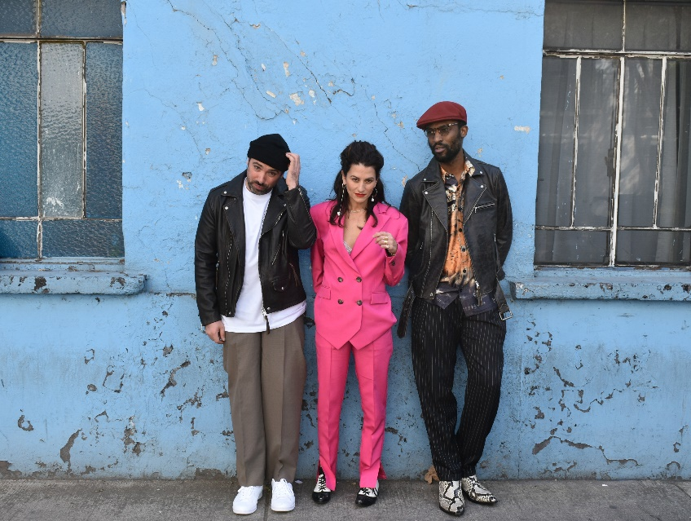

[DL photo here](https://press.wearebigbeat.com/artists/the-knocks/)

Multi-platinum electronic luminaries **The Knocks** have shared a spellbinding new disco single, “**Slow Song” (with Dragonette**). Listen [HERE](https://knocks.lnk.to/SlowSongPR) and watch the official music video, which was shot in Mexico City and stars [Aquaria](https://www.instagram.com/ageofaquaria/?hl=en) from Drag Race and Real Housewives [HERE](https://www.youtube.com/watch?v=GuhUpKb6DMg&ab_channel=itstheknocks). The video was directed by [Austin Peters](https://nam04.safelinks.protection.outlook.com/?url=https%3A%2F%2Fwww.imdb.com%2Fname%2Fnm0676334%2F&data=04%7C01%7CGabrielle.Reese%40atlanticrecords.com%7Cfa960e6fba924aa7956808d9ea7d9cb8%7C8367939002ec4ba1ad3d69da3fdd637e%7C0%7C0%7C637798647482255775%7CUnknown%7CTWFpbGZsb3d8eyJWIjoiMC4wLjAwMDAiLCJQIjoiV2luMzIiLCJBTiI6Ik1haWwiLCJXVCI6Mn0%3D%7C3000&sdata=DZp8CrRsshdh%2FIQCMXBHhRhoCjgr%2BSoolTKgq62XmwM%3D&reserved=0) (HAIM, Major Lazer) and the Director of Photography was [Eric Yu](https://nam04.safelinks.protection.outlook.com/?url=https%3A%2F%2Fdp.ericyue.com%2F&data=04%7C01%7CGabrielle.Reese%40atlanticrecords.com%7Cfa960e6fba924aa7956808d9ea7d9cb8%7C8367939002ec4ba1ad3d69da3fdd637e%7C0%7C0%7C637798647482255775%7CUnknown%7CTWFpbGZsb3d8eyJWIjoiMC4wLjAwMDAiLCJQIjoiV2luMzIiLCJBTiI6Ik1haWwiLCJXVCI6Mn0%3D%7C3000&sdata=Oij7UfnbNmXNZ%2FHgeIKtFd8iXgw6qxVd3sjaBWI3M6s%3D&reserved=0) (Inception, Savages, Warrior, A$AP Rocky).

On the song The Knocks say, *"Slow Song" feels like a great example of how our music has matured, hitting some of our favorite influences from disco to rock to dance. Working with Martina [Dragonette] and doing a record together is full circle, as our first ever tour as The Knocks was with Dragonette.”*

“Slow Song” (with Dragonette) heralds the NYC-based duo’s hugely anticipated third studio album, due April 29th, 2022. The Knocks trumpeted the as-yet-untitled new collection earlier this year with the powerfully soulful “[Walking On Water](https://knocks.lnk.to/WalkingOnWaterID) (Ft. Totally Enormous Extinct Dinosaurs).” Written in Los Angeles with GRAMMY® Award-nominated British electronic artist Totally Enormous Extinct Dinosaurs (a.k.a. Orlando Higginbottom) mere days before the first COVID lockdown in March of 2020, the song instantly stood as one of the new LP’s creative guideposts. Touching on thematic pillars of nostalgia, relationships, and emotional intimacy, “Walking On Water” expertly evinces The Knocks’ knack for bridging eras, genres, and cultures in unexpected ways, with Higginbottom’s smooth vocals interwoven with an indelible sample from Philadelphia soul legend Herb Johnson’s “Unlisted Track” (restored and released in 2001 by the Philly Archives).

The Knocks have been hailed worldwide for a carefree electronic sound that freely draws from soul, funk, disco, hip hop, house, and pop. Comprised of James Patterson and Ben Ruttner, the NYC-based duo have unleashed a dizzying array of dance music for more than a decade, spanning two acclaimed albums, multiple EPs, collaborations with artists across the musical spectrum, high profile network TV appearances, and showstopping DJ sets and live performances all over the world.

With touring halted to a standstill during the global lockdown, The Knocks opted to dedicate their time to the studio and began releasing a stunning string of new tracks including “[Bodies](https://bigbeat.lnk.to/Bodies),” a collaboration with indie pop combo MUNA that saw both acts joining forces for a striking remote performance on ABC’s *Jimmy Kimmel Live!* (streaming [HERE](https://www.facebook.com/JimmyKimmelLive/videos/711729312740620/)).

The Knocks then reunited with GRAMMY® Award-nominated indie icons Foster The People for “[All About You (Ft. Foster the People)](https://lnk.to/AAYAW),” swiftly reaching the top 15 at Alternative radio outlets nationwide. The Knocks’ second alliance with Foster The People following 2018’s breakout hit “Ride Or Die (Ft. Foster The People),” the track was further featured as the official theme to TikTok’s End of Year Wrapped campaign.

Next, The Knocks linked up with Australian indie rapper Mallrat for “[R U HIGH (Ft. Mallrat)](https://knocks.lnk.to/RUHighID),” scoring a #1 smash on Australian radio’s triple j “Most Played” chart. The hits kept coming through 2021, including “[Sound The Alarm (Ft. Rivers Cuomo of Weezer & Royal & The Serpent)](https://knocks.lnk.to/SoundTheAlarmID)“ “[Bedroom Eyes (Ft. Studio Killers)](https://knocks.lnk.to/BedroomEyesID),” and the emotionally driven LGBTQ+ love story, “[River (Ft. Parson James)](https://knocks.lnk.to/RiverID).” The Knocks were featured on "Purple Disco Machine’s platinum smash single “Fireworks," proving to be one of the biggest international hits of summer 2021, racking up more than 150M global streams to date and reaching the top 20 on the Global Airplay Chart.

Martina Sorbara, better known as the electro-pop outfit Dragonette, has lived multiple musical lifetimes over the past 15 years. A Juno-winning artist and sought-after songwriter, Sorbara has scored numerous global hits, including “Pick Up the Phone,” “Let it Go,” and the chart-topping “Hello” with Martin Solveig. She’s collaborated with the world’s biggest DJs (Basement Jaxx, Kaskade, and Galantis, among others) and released four acclaimed albums, including the Juno-nominated Fixin to Thrill (2009) and Bodyparts (2012). Along the way, Dragonette has headlined shows across the globe; supported the likes of Duran Duran, New Order, Ke$ha, and Miike Snow; and played to thousands of fans at Coachella, Electric Daisy Carnival, Glastonbury, and Lollapalooza.

A longtime priority writer with Sony/ATV publishing, the Toronto-based Sorbara also regularly works with acts under UMG, Warner Music, Syco, and Spinnin’. Her musically diverse credits include songs for Keith Urban, Cyndi Lauper, Pretty Sister, Mike Mago, and Carly Rae Jepsen with The Knocks.

Sorbara is currently working on Dragonette’s highly-anticipated follow-up to 2016’s Royal Blues.

CONNECT WITH THE KNOCKS

[WEBSITE](https://www.theknocks.com/) | [INSTAGRAM](https://instagram.com/the_knocks) | [FACEBOOK](https://www.facebook.com/theknocksnyc) | [TWITTER](https://twitter.com/theknocks) | [SPOTIFY](https://open.spotify.com/artist/2x7EATekOPhFGRx3syMGEC?si=gSrxuqY1Rq2jFDq8TjxYUQ) | [TIKTOK](https://www.tiktok.com/@theknocksmusic?lang=en) | [YOUTUBE](https://www.youtube.com/channel/UCFOoRQX5hTgJplXVeGBT-8g)

CONNECT WITH DRAGONETTE

[INSTAGRAM](https://www.instagram.com/dragonette/) |[FACEBOOK](https://www.facebook.com/dragonette) |[TWITTER](https://twitter.com/dragonette) |[SPOTIFY](https://open.spotify.com/artist/4GLJPBj5Cdr9AgLKvLWM4n?si=mtBoQU-gTYKRJaVcZqKBDQ) | [TIKTOK](https://www.tiktok.com/@dragonette) | [YOUTUBE](https://www.youtube.com/user/DragonetteBand)

Press Contact:

Paige.Rosoff@atlanticrecords.com

Big Beat Records | Atlantic Records