**THE KNOCKS DROP *MEMORIAL DAY WEEKEND IN IBIZA* MIX!**

***seventh installment of annual summer kickoff playlist –***

***released today via SoundCloud!***

**STREAM *MEMORIAL DAY WEEKEND IN IBIZA VOL. VII*:** [**HERE**](https://soundcloud.com/theknocks/memorial-day-weekend-in-ibiza-vol-vii?in=theknocks/sets/memorial-day-weekend-in-ibiza)

**STREAM PAST MIXES (*VOL. I – VI*):** [**HERE**](https://soundcloud.com/theknocks/sets/memorial-day-weekend-in-ibiza)

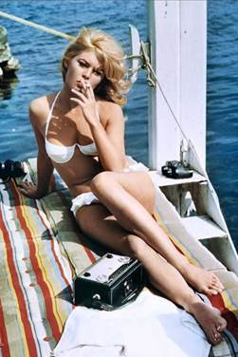

**THE KNOCKS SUMMER TOUR:**

May 27 - Gurney's Montauk (DJ Set)

May 28 - Gurney's Newport (DJ Set)

June 9 - El Rey Theater, Albuquerque (Live)

June 10 - Splash House, Palm Springs (DJ Set)

June 23 - Bonanza, Herber City, UT (Live)

July 15 - Camp Bisco, Scranton, PA (Live)

August 12 - Elements, Brooklyn, NY (Live)

**BUY/STREAM *TESTIFY EP:*** [**HERE**](bbr.ec/testifyay)

**FOLLOW THE KNOCKS:**

[www.theknocks.com](https://protect-us.mimecast.com/s/5JgMB7SnDDWWck)

[www.facebook.com/theknocksnyc](https://protect-us.mimecast.com/s/nKAlB9F8EE66fq)

[www.twitter.com/theknocks](https://protect-us.mimecast.com/s/1dDnBNFaDDnncN)

[www.instagram.com/the_knocks](https://protect-us.mimecast.com/s/VAOEBaUwDDddCK)

[www.snapchat.com/add/Theknocks](https://protect-us.mimecast.com/s/g5akBdUK2288iX)