THE KNOCKS CONTINUE THEIR STREAK OF RELEASES WITH NEW VIDEO FOR “AWA NI”
WITH KAH-LO

WATCH HERE: https://youtu.be/SPb306rz4AM

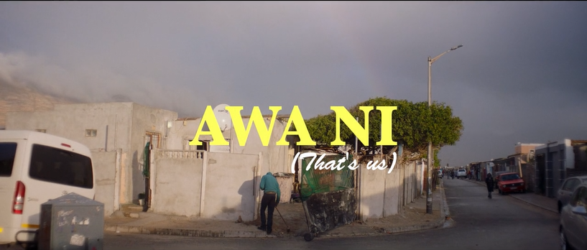

The most effortlessly cool duo in music, The Knocks, debut a new music video for their single “Awa Ni” with Kah-Lo. Watch here.

The visual for “Awa Ni” plunges us into a day in the life of children seeking fun on a budget, escaping their township and heading for the beachside. The chaotic rumble is told from the perspective of the kids as they take us from the playgrounds to the open ocean, ultimately laying claim to the surf.

"We have always set out to create music videos that are a little bit different and go against the standard industry tropes. With Awa Ni, we wanted a video that captured the youthful energy of the song while exploring the incredible beauty of the African landscape. Emile, the cast, and the crew did an amazing of telling the story of friendship and adventure” explain The Knocks.

The film was a collaboration between director Emile Ebrahim Kelly and the kids of the local community, who he met through friend Shuan Solomons, a native who does an immense amount of community work in the township. It was only natural to pair this story with the youthful and wholesome feelings that “Awa Ni” evokes.

The Knocks blessed us with a streak of releases this summer from “Awa Ni” (with Kah-Lo), to “New York Luau” + “No Requests”, “Colors”, and “Summer Luv” (with Whethan, feat. Crystal Fighters), the legendary duo has kept fans on their toes with banger after banger. Their most recent LP “New York Narcotic” is celebrated for the duo’s ability to continue crossing barriers, saluting multiple genres, and interlacing electronic, alternative, and urban sonics. The album includes their smash single “Ride or Die” ft. Foster the People which has garnered over 55 Million streams, hitting #1 on iTunes Dance, 22+ weeks on Billboard Dance chart and 20 weeks on the Billboard Alternative chart.

B-Roc and Jpatt have been grinding as The Knocks for over a decade, making music for themselves and others in their HeavyRoc studio in New York City. In 2018, the duo charted in the Top 50 on Billboard’s Dance/Electronic Albums 2018 Year-end chart, launched a monthly curated party called The Knocks & Friends residency at PUBLIC Arts in New York City, and wrapped the US headline New York Narcotic tour in February, hitting all major markets.

The guys also performed on The Tonight Show w/ Jimmy Fallon and TRL for their smash collaboration with Sofi Tukker, NERVO, and Alisa Ueno, “Best Friend” – which peaked at #1 on the iTunes Dance, US Dance Radio, Billboard Commercial, Billboard Dance/Mix Show, and Shazam Dance Charts, and also peaked at #3 on the Shazam Worldwide Main Charts, after debuting during Apple’s Keynote address. The track was also prominently featured in advertisements for the iPhone X.

**

PRESS ASSETS

CONNECT WITH THE KNOCKS:

Facebook | Soundcloud | Twitter | Instagram | Website

Press inquiries:
Paige Rosoff – Big Beat Records
Paige.Rosoff@atlanticrecords.com

