INCOMPARABLE DANISH ALT-POP SINGER/SONGWRITER
SOLEIMA SHARES NEW SINGLE, “ROSES”

LISTEN/WATCH HERE

OUT TODAY VIA BIG BEAT/ ATLANTIC RECORDS!
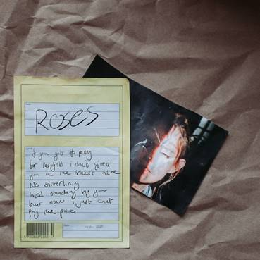
DOWNLOAD PRESS PHOTOS + ART HERE

Over the course of the past few years, Denmark has unleashed a torrent of phenomenal singer-songwriters and artists on the world, but none stick out from the pack more than Soleima. Today sees the release of Soleima’s new single “Roses,” which showcases the unparalleled alternative-pop artists’ unique voice and songwriting style more than ever before. Out today via Big Beat/Atlantic Records, the single treads the line of undeniable singer-songwriter wit in the lyrics and is backed by stellar laid-back production, featuring trap percussion and a whimsical, hook-laden chorus - LISTEN HERE!

“Roses” is the lead single from Soleima’s forthcoming debut album Powerslide, which is officially coming out on March 13th. The song was co-produced by GRAMMY-Nominated Jonny Coffer (Beyoncé, Panic! At The Disco “High Hopes”, Lykke Li) and Bastian Langebaek (Jess Glynne, Jessie Ware). To coincide with the release of her album, Soleima will be embarking on her first-ever US tour with labelmate Electric Guest from January 29 to February 25 (see below for tour stops)!

Producers of her debut album include multiple GRAMMY Award-winning and nominated names such as Jonny Coffer (Panic! At The Disco), Ben Allen (Gnarls Barkley, Walk The Moon, Christina Aguilera), Calvin Valentine (De La Soul, Nas) and Hennedub (Jessie Reyez, Lukas Graham). With one of the most distinctive voices in the alternative-pop world, “Roses” is poised to establish Soleima as a songwriting force to be reckoned with. BBC Radio 1’s Annie Mac has already called her and Artist To Watch, and her breakout single “Low Life” from 2018 was selected as one of Billboard’s “20 Great Pop Songs from 2018” along with being featured on the Spotify US Viral Chart following its release. Soleima continued her streak of critical acclaim in 2019 with Refinery29 nominating her previous single “STFU” for Song of the Year.

Before signing with Atlantic Records, Soleima was nominated for Best New Artist at the Danish GRAMMY, and she’s already drawing sonic comparisons to FKA Twigs, NAO, Lykke Li and Kali Uchis as well. With new music in the works alongside Diplo (!), and previous collaborations with like-minded artists such as Mura Masa, AlunaGeorge, Baauer, Kranium, and more, 2020 is looking mighty bright for Soleima. Stay tuned for more info on her debut album!

FOR MORE INFORMATION:
1/28 - Las Vegas, NV | The Bunkhouse Saloon
1/29 - Albuquerque, NM | Launchpad
1/31 - Austin, TX | Mohawk
2/1 - Houston, TX | White Oak Music Hall
2/2 - Dallas-Ft. Worth, TX | Trees
2/4 - Nashville, TN | Exit / In
2/5 - Charlotte, NC | The Visulite Theatre
2/7 - Washington, DC | 9:30 Club
2/8 - Philadelphia, PA | Union Transfer
2/10 - Boston, MA | The Sinclair
2/11 - New York, NY | Webster Hall
2/12 - New York, NY | Music Hall of Williamsburg
2/16 - Columbus, OH | The Basement
2/17 - Chicago, IL | Metro / Smart Bar
2/18 - Minneapolis-St. Paul, MN | Fine Line Music Cafe
2/19 - Kansas City, KS-MO | Granada Theatre
2/21 - Denver, CO | Summit Music Hall
2/22 - Salt Lake City, UT | Urban Lounge
2/24 - Phoenix, AZ | The Crescent Ballroom
2/25 - San Diego, CA | Music Box

CONNECT WITH SOLEIMA:
Instagram | Facebook | Twitter | Spotify | Website

PRESS ASSETS: https://press.wearebigbeat.com/artists/soleima/

FOR MORE INFORMATION:
Paige Rosoff – Big Beat Records
Paige.Rosoff@atlanticrecords.com

