WELCOMING DANISH MUSICIAN
WITH THE U.S. RELEASE OF ‘NO.14’ VIA BIG BEAT RECORDS

LISTEN/POST: https://www.youtube.com/playlist?list=PLDjZV7YlXh2cVTzC1pE90HO4O1_yI3khs
STREAM/BUY: HERE

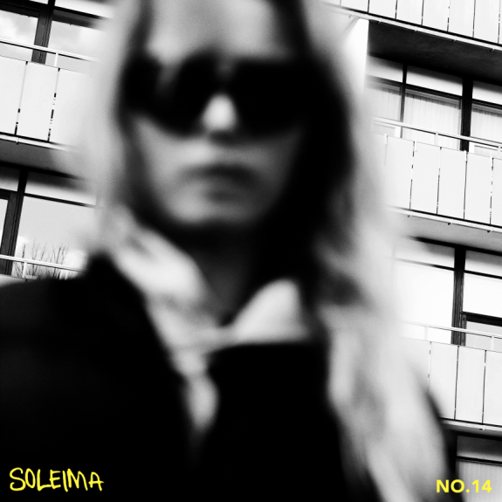

Danish musician Sarah Mariegaard delivers her enigmatic and hypnotic sound within a new solo project under the artist name Soleima, highlighted across a debut mini-album “NO. 14” – LISTEN HERE – arriving officially in the US today via Big Beat Records. “NO. 14” showcases a heady cocktail of pitch-shifted synths, R&B, future bass and an undercurrent of world music. Soleima’s ethereal vocals are childlike in their innocence and sweetly sensual – elevating her individualistic style to another level.

Taking from her past experience in Denmark-based hip-hop septet Flødklinikken, this new direction presents a platform for Soleima to explore societal issues and the very meaning of what it is to be human. Soleima’s lyrics border both hope and melancholy while touching on social issues that are reinforced by cutting-edge production and a relatable pop core. Soleima states, “Political pop is quite unpopular, but I think it’s important to bring it back somehow. The whole challenge is to present it in a way which connects with people.”

Overall, Soleima draws an understated pop universe that magnifies ongoing themes in our world through distinctive vocals that make this release so present. To put it in perspective, Soleima explains, "I've been working on this mini album for some time to find my own sound and vibe. The songs are inspired by hope and dreams for the future and they are all touched by what happens in the world today. I am often hit by a feeling of hopelessness due to the dark times we as a people live in at the moment. Therefore many of the songs deal with the ambiguity in wanting to run away and at the same time the feeling of guilt in having opportunity when not everyone in the world does.
Highlights from “NO.14” includes the electronic, soul and funk inspired single "Cracks" – WATCH HERE -- which hopes to find something good in the future in spite of the darkness; escapism is showcased throughout another track, "Breathe" ft. Hoodboi – WATCH HERE; and the consequence of this is measured on electro/R&B/pop song, "Wasted"—WATCH HERE. Full tracklisting enclosed below!

Soleima ‘No.14’:
- Cracks – > WATCH HERE
- Breathe feat. Hoodboi – > WATCH HERE
- My Love
- Wasted – > WATCH HERE
- Once Was
- Mascarade
- This Life

CONNECT: Facebook | Twitter | Instagram | SoundCloud | YouTube | Press Site

##

For more information please contact:

Jordan Danielle Frazes
Head of Publicity, Big Beat Records
Jordan.Frazes@atlanticrecords.com

