DANISH SINGER-SONGWRITER
SOLEIMA
RELEASES NEW VERSION OF ALBUM TRACK
“BREATHE” FT. KRANIUM & HOODBOI
+ DEBUT MINI-ALBUM “NO.14” OUT NOW VIA BIG BEAT RECORDS

WATCH/POST: HERE
BUY/STREAM “BREATHE”: HERE
BUY/STREAM ‘NO.14’: HERE

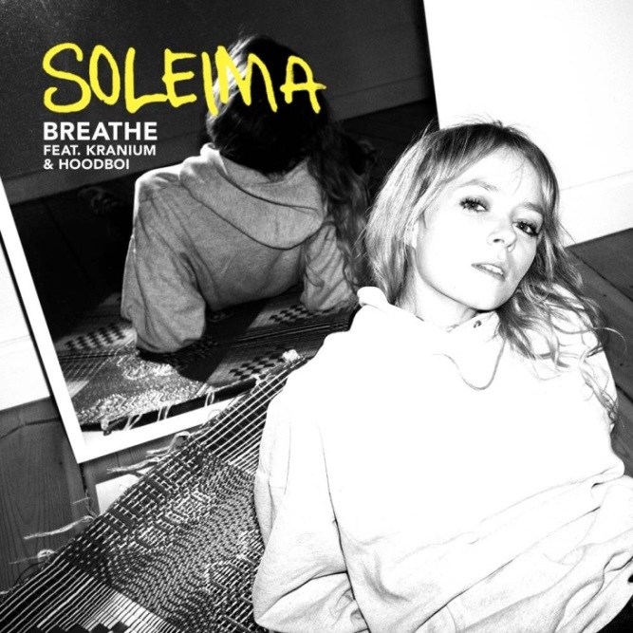

“We’re absolutely mesmerized by Soleima’s vocals and are convinced that
she’s what’s next in the pop world.”
– Milk

“Music that's moody, dancy and garnering quite a few MØ comparisons.” – Noisey

Soleima casts an enigmatic and hypnotic spell with her recent debut mini-album ‘No.14’ and today she brings an intoxicating island vibe to her new version of album track “Breathe” out today via Big Beat Records; featuring Jamaican dancehall artist Kranium and Hoodboi and adding another layer of invention to the track’s modernist alt-pop. Watch the official music video here, premiered today via Milk.

“I feel like Kranium fits into the vibe of the song in a really exceptional way,” Soleima explains of the rework. “I love his mellow melodies in this kind of song. Really clever. It has been a great experience.”

Soleima presents an artist with a singular take on pop that is at once immediately engaging and fascinatingly off-kilter. The Danish musician’s heady cocktail of pitch-shifted synths, R&B, future bass and an undercurrent of world music is already something quite apart from the pack, but her vocal – simultaneously otherworldly, childlike in its innocence and sweetly sensual – elevates her individualistic style to another level.

While her tracks escape easy genre classification, Soleima’s own story is similarly unconventional. Raised in Aarhus – Denmark’s second-largest city – Soleima grew up in a family home soundtracked by classic soul and R&B, notably Aretha Franklin, Stevie Wonder and Otis Redding.

Soleima’s mother took her to an African dance camp which operated as a cultural exchange between Denmark and Sukumaland in Tanzania, and she soon became enamoured with their music – especially with their collection of traditional African drums such as the bunugule. As a young adult, she moved out to Sukumaland for two extended periods, and even organized a grant to allow some of their members to live and teach in Denmark. She subsequently earned a bachelor’s degree in Anthropology, did field work in Nepal and started to create a documentary about migration in Senegal.

That open-mindedness informed Soleima’s first music project Flødeklinikken, a Danish-language hip-hop septet inspired by A Tribe Called Quest and Wu-Tang Clan. Formed as teenagers, the collective released two albums with Soleima on keyboards and – when needed – on vocal hooks too.

“When you’ve been writing with so many people, you reach a point where you want to try flying solo,” she explains. The idea was to write for other artists, but the immediacy of her connection with producers Vera and Vasco convinced her to further “explore the universe” that her organically-infused electro-pop now inhibits. “People have difficulties defining our genre because their background is in rock music, and I come from hip-hop and this African dance environment.”

Ultimately Soleima’s unique trait is in uniting disparate styles – cutting-edge productions with an immediate pop core, and relatable lyrical themes which simultaneously explore societal issues and the very meaning of what it is to be human.

CONNECT: Facebook | Twitter | Instagram | SoundCloud | YouTube | Press Site

##

For more information please contact:

Jordan Danielle Frazes
Head of Publicity, Big Beat Records
Jordan.Frazes@atlanticrecords.com

