SLAYYYTER "DADDY AF"

WATCH/SHARE: https://youtu.be/y6VY9_KvGK0
BUY/STREAM: https://lnk.to/daddyafPR
(BIG BEAT RECORDS)

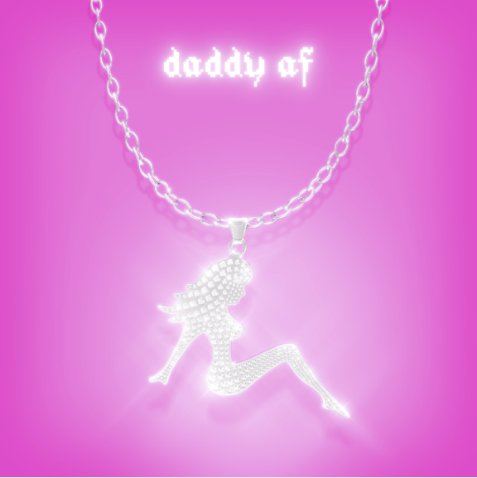

SLAYYYTER GIVES NO F*CKS ON NEW SINGLE "DADDY AF"

Already co-signed by Grimes, Charli XCX and other pop titans, the world is making room for a new voice that you soon won’t be able to ignore. Slayyyter releases a brand new song “Daddy AF” and accompanying video on Big Beat Records today, ahead of a nearly sold-out summer US tour; clearly giving no f*cks, as evidenced by her signature over-the-top lyrics set against experimental pop production – WATCH HERE!

POP STAR SLAYYYTER: F*CKIN' TOO MANY MODELS, POPPIN' TOO MANY BOTTLES?!

Not many artists can get away with the lyrics “I-I-I feel daddy as f*ck, whipping in a pink truck, daddy as f*ck. He wanna get in my guts, licking my cl*t till I nut, daddy as f*ck, I feel daddy as f*ck,” but the world has also never quite met an artist like Slayyyter.

SLAYYYTER FEELS DADDY AF, DOESN'T GIVE AF

The FADER’s already heralding Slayyyter as “the future of pop music,” with Rolling Stone noting “The Internet is a Pop Star’s game, and Slayyyter is winning.”

“Over blaring drill alarms, Slayyyter goes trap-pop and it is outrageous, fun, and incredibly h*rny…” -THE FADER

“So is Slayyyter a robot, or a person?” – PAPER

“….experimental pop sound and distinct MySpace-era aesthetic….” – BILLBOARD

“Pop Is Not A Dirty Word: Trash-pop star Slayyyter has sent queer pop lovers into a spin; now the mainstream awaits” – NME

SLAYYYTER IS ‘MINE’

Slayyyter challenges the confines of experimental synth-pop with her other new track "Mine" which is getting an official re-release today. Listen HERE! The piano and beat-driven track has hooks for days… and the risqué, boundary-pushing lyrics elevate "Mine" into a provocative territory!

SCANDALOUS: SLAYYYTER CAUGHT IN PLAYBOY GROTTO (AGAIN!)

Clearly influenced by the internet and meme culture at large, and with social media posts that harken back to the glory days of MySpace and AIM (crazy how that’s already internet nostalgia), Slayyyter’s music also draws inspiration from early 2000’s reality show personalities like Heidi Montag and Courtney Stodden. The 22-year old artist hails from St. Louis, but her cult following is spreading around the world like a wildfire. Additional dates in Boston, DC, and St. Louis have been added to her sold-out headline tour scheduled for summer. With eight singles released under her belt to date and live dates across the US, Slayyyter is coming for you. We can only hope that you’re ready for Slayyyter.

LOCK UP YOUR KIDS (AND MAYBE YOUR HUSBAND), SLAYYYTER IS COMING TO TOWN

June 24 – Brooklyn, NY: The Hall, Elsewhere - SOLD OUT
June 25 – Brooklyn, NY: The Hall, Elsewhere - SOLD OUT
June 26 – Chicago, IL: Schubas Tavern - SOLD OUT
June 27 – San Francisco, CA: Rickshaw Stop - SOLD OUT
June 29 – Los Angeles, CA: The Echo - SOLD OUT
July 18, 2019 - Boston, MA: Brighton Music Hall
July 20, 2019 - Washington, DC: U Street Music Hall
July 26 – Los Angeles, CA: El Rey
July 27, 2019 - St. Louis, MO: The Ready Room

CONNECT WITH SLAYYYTER:
TWITTER | INSTAGRAM | YOUTUBE | PRESS SITE

PRESS CONTACTS:
Jordan Danielle Frazes: Jordan.Frazes@atlanticrecords.com

Paige Rosoff: Paige.Rosoff@atlanticrecords.com

