FAST-RISING LA DUO SHIP WREK SHARE INFECTIOUS 2ND SINGLE
“BLOODSTREAM” FROM UPCOMING MIRROR MIRROR EP

LISTEN HERE: https://BigBeat.lnk.to/BloodstreamPR

OUT TODAY VIA BIG BEAT RECORDS!

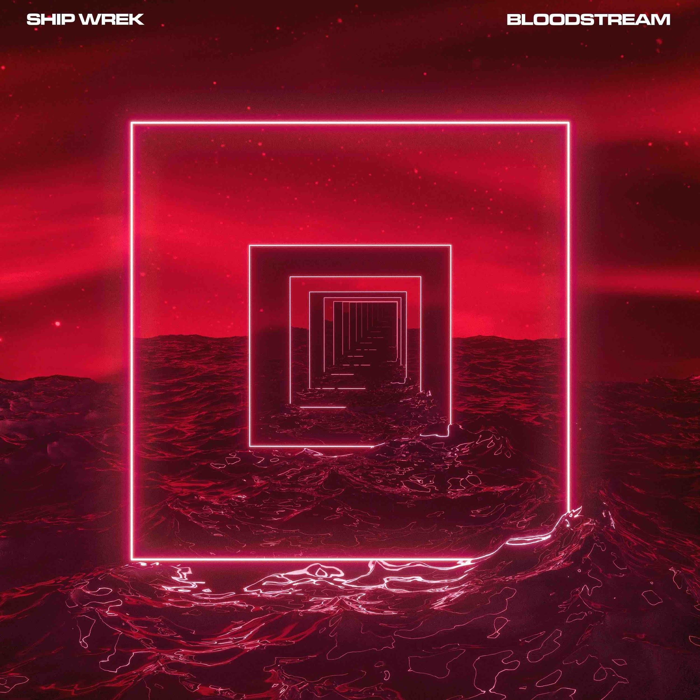

The incredibly fast-rising DJ/production duo Ship Wrek has had a whirlwind year that’s about to culminate with the release of their new Mirror Mirror EP in March (3/13), but first, the prodigious chart-toppers are sharing the second single from the EP called “Bloodstream.” The infectious house track solidifies Ship Wrek as an artist to watch in 2020 (if you haven’t been paying attention already)! The song follows on the heels of the EP’s title track “Mirror, Mirror,” which also featured their trademark sound that embodies rubbery basslines, classic house production and massive drops - LISTEN HERE!

On top of all the original music they’ve been trickling out as of late, Ship Wrek has stayed busy being commissioned for official remixes by DJ Snake, the rock/electro-pop sensation A R I Z O N A, The Chainsmokers, and Dog Blood. They’ve also performed a sold-out show opening for Lost Kings at Webster Hall in NYC, and their recent releases on Big Beat, Spinnin’, Armada, and Jauz’s "Bite This!" have amassed over 7 million combined streams. Their recent single “Wait For You” has also amassed over 100 spins on SIRIUS XM, including their influential dance stations BPM, Diplo’s Revolution, and Pitbull’s Globalization Radio.

The duo recently signed to Paradigm Booking Agency, where they’ll be sharing an agent with the likes of DJ Snake and Porter Robinson, so fans can expect plenty of more live shows and DJ sets in 2020, having recently performed alongside Allison Wonderland, Valentino Khan, and Dillon Francis at Dillon Francis’ “Magic is Real” EP release party. Their bootleg of Skrillex & Boys Noize “Turn Off The Lights” was also just included in Dog Blood’s “Clap Back Vol 1” mix!

With their stock on the rise, Ship Wrek’s numbers keep multiplying tenfold across the board - and not just on the charts. With an EP coming on March 13th, the world is only just getting to know Ship Wrek.

CONNECT WITH SHIP WREK:
Instagram | Facebook | Twitter | Spotify

PRESS ASSETS: https://press.wearebigbeat.com/singles/ship-wrek/

FOR MORE INFORMATION:
Paige Rosoff – Big Beat Records
Paige.Rosoff@atlanticrecords.com

