SWEDISH DUO
GALANTIS
TEAM WITH ONEREPUBLIC ON “BONES”
NEW SONG OUT TODAY!

LISTEN/SHARE: https://BigBeat.lnk.to/GORBPR/youtube
BUY/STREAM: https://BigBeat.lnk.to/GORBPR
(Big Beat Records)

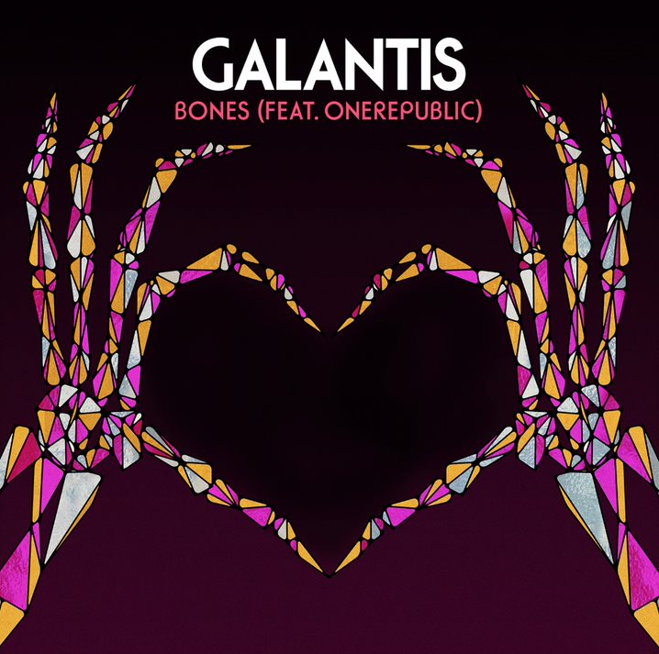

Fresh off two massive, sold-out New Year’s Eve shows at Chicago’s famed venue Aragon Ballroom, the internationally-acclaimed Swedish duo Galantis kicks off 2019 with the release of a new single “Bones” featuring none other than the chart-topping, GRAMMY-nominated band OneRepublic. The track starts to build acoustically before truly taking flight in true Galantis fashion. Maybe that’s OneRepublic’s lead vocalist Ryan Tedder’s collaborative element rubbing off on the duo, but one thing’s for sure: “Bones” is destined to appeal to fans of both artists as it rockets up the charts! The song doesn’t lie when you hear the lyrics, “I feel it in my bones”-- LISTEN HERE!

"It was an incredible experience working with OneRepublic and Ryan on this song. He has such a legendary voice and we've always been big fans of his songwriting, so connecting with him on 'Bones' came so naturally to us. This is the first Galantis music of 2019 and we can't wait to show you what else we've been working on!"- Galantis

“Bones” is the first taste of an eventful 2019 for Galantis. The duo is riding high on a string of recent hits, with their latest “San Francisco” (feat. Sofia Carson) still gaining ground, along with “Emoji”, which was released in November. The tracks’ accompanying music videos have already eclipsed 5 million views each since release! "Satisfied” (feat. MAX), and "Spaceship” (feat. Uffie). Known for their over-the-top live performances, Christian Karlsson (also of Bloodshy & Avant and Miike Snow) and Linus Eklöw (Style of Eye) also have a number of tour dates worldwide already booked in 2019 with many more coming soon.

Galantis’s second album The Aviary debuted as a Top 10 album in 23 countries and received widespread critical praise. The New Yorker proclaimed, “Galantis sends crowds soaring with reliably mammoth melodies,” while NYLON raved, “Everything Galantis touches is gold.” Additionally, their debut album Pharmacy reached No. 1 on the Billboard Dance Chart and spawned hit singles “Peanut Butter Jelly” and “Runaway (U&I),” the latter of which is RIAA certified gold in seven countries and earned GRAMMY nominations for “Best Dance Recording” and “Best Remixed Recording” through Kaskade’s remix of the song.

GRAMMY-nominated OneRepublic, is comprised of singer/songwriter and lead vocalist Ryan Tedder, guitarists Zach Filkins and Drew Brown, bassist and cellist Brent Kutzle, and drummer Eddie Fisher. The band released their debut set Dreaming Out Loud in 2007. The Mosley Music Group/Interscope release included the multi-platinum-selling smash single “Apologize,” which shattered digital sales and airplay records worldwide and received a Grammy Award nomination. The band’s sophomore album, 2009’s Waking Up, produced the hit singles “All the Right Moves,” “Secrets” and “Good Life.” The certified-platinum album Native followed in 2013, featuring the No.1 hit and 10 million plus-selling single “Counting Stars,” along with a worldwide tour. OneRepublic released Oh My My, their fourth full-length album in 2016. This past spring, the band released “Start Again ft. Logic,” a song featured on the soundtrack for the Netflix drama 13 Reasons and “Connection” which was part of FCA’s Summer of Jeep campaign.

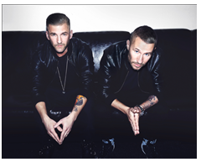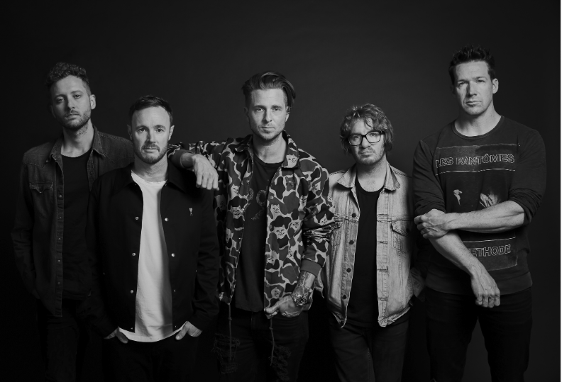
(Galantis photo by Katharina-Næss - DL) (OneRepublic photo by Stewart Gerard - DL)

FOLLOW GALANTIS:
www.wearegalantis.com
www.twitter.com/wearegalantis
www.facebook.com/wearegalantis
www.youtube.com/user/galantistv
www.instagram.com/wearegalantis
Snapchat: @wearegalantis

FOLLOW ONEREPUBLIC:
https://twitter.com/OneRepublic
https://www.facebook.com/OneRepublic/
https://www.instagram.com/onerepublic/

PRESS TOOLS: http://press.wearebigbeat.com/artists/galantis/

CONTACT:
Ted Sullivan | Ted.Sullivan@atlanticrecords.com

