AWARD-WINNING DANISH ARTIST & SONGWRITER
SOLEIMA
SHARES NEW TRACK ‘LOW LIFE’

WATCH/POST: https://www.youtube.com/watch?v=PNiS_agzz3o
BUY/STREAM: https://BigBeat.lnk.to/LLPR

“…modernist pop perfection…” – PAPER MAG

“In her time as a solo artist, Soleima has quietly established herself as a consistent purveyor of prime pop… Soleima's tracks are sly, seductive, and immersive.” – NYLON

“Music that's moody, dancy and garnering quite a few MØ comparisons.” – Noisey

“The Dane creates a unique blend of indie, pop, and dance that she uses as a way to explore the very essence of being human.” – C-Heads Magazine

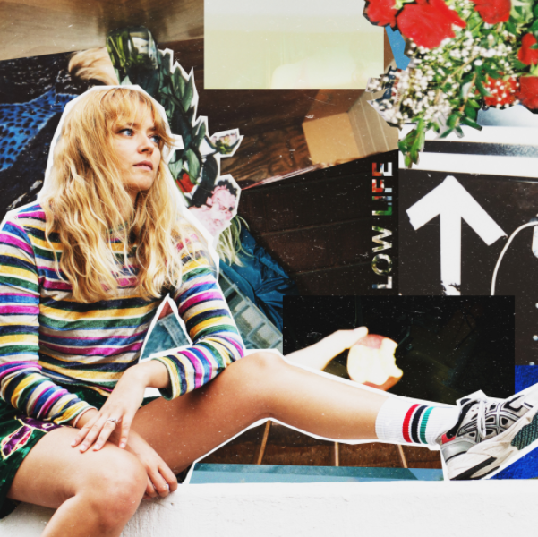

Copenhagen-based artist and songwriter Soleima kicks off 2018 with a brand new track “Low Life” (watch here) arriving today on Big Beat Records – coming off the heels of winning “Talent of the Year” at the major Danish award ceremony P3 Guld and receiving a nomination for “Best Newcomer” at the recent Danish Music Awards.

“Low Life” continues Soleima’s ever-adventurous journey into off-kilter sonics, with a sound that evolves with a confident step into neo-soul. Utilizing layers of looped sounds – bouncing bass, back-to-basics percussion and Soleima’s singular vocal style – the disparate elements combine for a compelling track with a playful sophistication that rewards repeated listens. The Danish artist often describes her music as garage pop and “Low Life” is a clear reflection of this – modernist pop with a hand-crafted sense of character.

“‘Low Life’ is a song about embracing whatever you’ve got in life, and about empowering yourself,” says Soleima. “I had somebody very dear to me in my mind when writing this. They grew up under difficult circumstances and even though they’re still struggling, they’re fighting to get somewhere good. I admire that more than anything.”

The beautifully filmed accompanying visual was directed by Jonas Bang and reflects the song’s theme of struggling to break out of a vicious circle. “We wanted to make something artistic,” explains Bang. “We wanted to follow our urge to create longer scenes rather than pandering to the scroll-after-ten-sounds crowd, or at least demand a little more patience from the viewer. The final scene symbolizes that even though you feel stuck and low, there’s a way through if you’re determined.”

The visual is the second creative project from Soleima and Bang that was made in collaboration with Mercedes-Benz’s culture laboratory Prxjcts, following the video for “Paper” released in September (watch here). Of their experience working with the artists on the visual, the Prxjcts team shares: “Once again Soleima and Jonas Bang have succeeded in creating a visually stunning video. The video also has some interesting underlying themes and Sarah’s ability to unify the mass appeal of pop music with a sparkling creativity and sincere presence is among the reasons why we’re such big fans of her.”

Raised in Denmark, Soleima grew up in a family home soundtracked by classic soul and R&B. Soleima’s mother took her to an African dance camp which operated as a cultural exchange between Denmark and Sukumaland in Tanzania, and she soon became enamored with their music – especially with their collection of traditional African drums such as the Bunungule. As a young adult, she moved to Tanzania for two extended spells and organized a grant to allow some of their members to live and teach in Denmark.

After first coming to attention with Danish-language hip-hop septet Flødeklinikken, Soleima spread her wings and embarked upon a solo project which unites world music rhythms, unconventional R&B and energized electro-pop. Her debut mini-album / EP ‘No. 14’ earned widespread praise from music and fashion media, with BBC Radio 1’s Annie Mac highlighting Soleima as one of her “New Names.”

CONNECT: Facebook | Twitter | Instagram | SoundCloud | YouTube | Press Site

##

For more information please contact:

Jordan Danielle Frazes
Head of Publicity, Big Beat Records
Jordan.Frazes@atlanticrecords.com

