SNBRN & COYOTE KISSES TEAM UP ON NEW SINGLE “SHOW ME” OUT NOW VIA BIG BEAT WHITE LABEL!

BUY/DOWNLOAD: https://BigBeat.lnk.to/showmePR
STREAM: https://soundcloud.com/snbrn/show-me

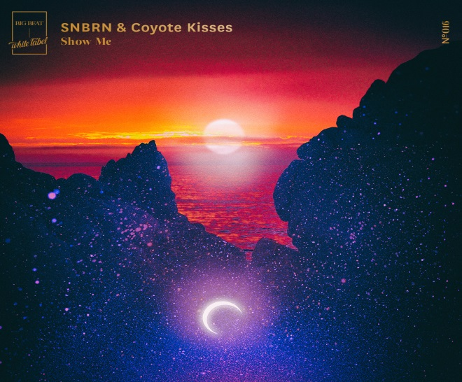

Following the massive success of his single “You Got Me” with BLU J, which hit #1 on the Hype Machine popular charts and has acquired over 1.1 million streams within the first 2 weeks of its release, SNBRN continues the momentum on his latest collaboration with Coyote Kisses, “Show Me,” out now on Big Beat White Label. Sleek instrumentals flow together with rushes of bass and whirling synths to create a dance-floor ready, futuristic anthem.

“Show Me” showcases the forward-thinking sounds of electronic outfit Coyote Kisses. Interweaving sparkling melodies with stylish fanfare, it’s not difficult to see why the duo has captured the hearts of so many listeners. Since 2016, they’ve released a series of viral originals, including their Hype Machine #1 hit "Illusion and their follow up single “Waiting for You” feat. Madison Love, which was released on Big Beat and has gone on to amass over 9 million streams on Spotify.

Kevin Chapman, better known as SNBRN hardly needs an introduction as a leading innovator in today’s electronic music landscape. Tastefully bringing together the worlds of deep house, indie dance, and nu-disco, he’s gone on to acquire over 60 million combined plays and 1.72 million active monthly listeners on Spotify, and over 38 million combined plays on Soundcloud.

Coachella attendees, get ready! SNBRN is slated to play both weekends of the Music & Arts Festival in Indio, California on April 14th and 21st.

“Show Me” is out now and available across all DSP’s!

SNBRN Tour Dates:
April 14 – Coachella Valley Music & Arts Festival
April 21 – Coachella Valley Music & Arts Festival
April 28 – Kingdom – Austin, TX
May 5 – Heartfeldt – Boat Cruise
May 5 – Royale – Boston
May 26 – Skyway – Minneapolis, MN
May 27 – Elements Festival – Lakewood, PA
June 1 – Necto – Ann Arbor, MI
June 2 – Site 1A – Milawukee, WI
June 23 – Paradiso – George, WA
June 24-25 – Electric Forest - Rothbury, MI
June 29 – Electric Forest - Rothbury, MI

Connect with SNBRN:
facebook.com/snbrn
twitter.com/snbrnmusic
instagram.com/snbrnmusic
soundcloud.com/snbrn

Connect with Coyote Kisses:
facebook.com/CoyoteKissesMusic
twitter.com/coyotekissesxo
instagram.com/coyotekissesxo
soundcloud.com/coyotekisses

For more information please contact:
Jordan Danielle Frazes
Head of Publicity, Big beat Records
Jordan.Frazes@atlanticrecords.com

Lindsay Herr
lindsay@thewanderlvst.com

