Belgian Tech-House Producer SIEGE Releases Pulsing New
Single “Thursday Jam”

LISTEN HERE: https://BigBeat.lnk.to/TJPR

Out Today on Big Beat Records!

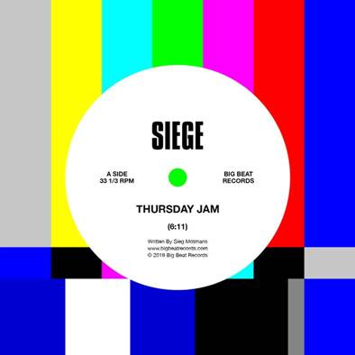
DOWNLOAD PHOTO HERE

Hailing from Belgium, long known for its pioneering rave scene and churning out electronic music legends, comes Siege. The fast-rising tech-house DJ/producer has already released music on iconic dance labels from Toolroom and Toolroom Trax, to Circus Recordings and Strictly Rhythm. Now Big Beat Records is excited to release his pulsing new single, “Thursday Jam”, which is out today! Listen HERE.

Born Sieg Motmans, Siege has been honing his distinctive style of tech-house since before he was old enough to go to a club. The up-and-comer has played festivals around the world, including Belgium’s own legendary, long-running festival Tomorrowland. His singles has been supported by Claptone, Hot Since 82, Paco Osuna, Prok & Fitch, the BBC Radio 1 family (Danny Howard, Pete Tong, Annie Mac), to name a few. He has also produced acclaimed remixes for Weiss, Bob Sinclar & Sharam Jey gaining even more support from the likes of Calvin Harris, Mark Knight, Adam Beyer, Technasia, Sam Paganini, and many more.

Raised in Hasselt, outside of Belgium's best-known clubbing centers, Siege is a beacon for the power of focus and self-determination. From buying his first vinyl turntables as a teen to playing his first major gigs just a year or two later, Siege knew he wanted to similarly inspire others through his own tracks.
Self-taught by his own dedication and the help of Future Music Magazine, when his first remix stopped just shy of the Beatport House Top Ten his reputation was assured. The release of his breakthrough track ‘Crunk’ under Defected Records immediately sealed his fate as one of Belgium’s most revered artistic exports. Having guaranteed his name back home, shored up by his own roving party Bandar, Siege is moving quickly onto the world stage and dance charts worldwide. Catch Belgium's hottest new export near you very soon.

PRESS ASSETS

CONNECT WITH SIEGE:
Instagram | Facebook | Spotify | Apple | Soundcloud

FOR MORE INFORMATION:
Paige Rosoff – Big Beat Records
Paige.Rosoff@atlanticrecords.com

