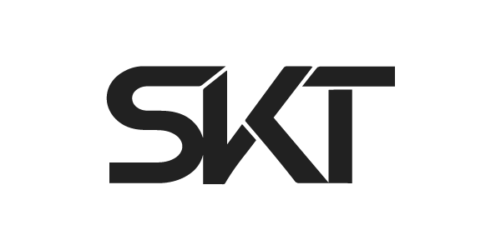
DJ S.K.T is without question one of the hottest talents in the UK club scene. The man behind 2015’s huge “Take Me Away,” 2016’s “Poison” and 2017’s “Jack That Jack,” as well as countless other club anthems, DJ S.K.T is one of the hardest working producers and most in-demand DJs around. With a weekly residency on Kiss FM and a steady stream of hit records, he can count tastemakers such as Annie Mac, Pete Tong, Danny Howard, Mistajam, DJ Target, MK, Roger Sanchez, Amine Edge & Dance, Solardo, Hannah Wants and Idris Elba among his legions of fans.
A producer, DJ, and label manager, DJ S.K.T specialises in all forms of dance music – from deep and soulful house, tech-house, garage & experimental bass, all tied together with that common thread of working a dance floor.
A UK radio favourite, DJ S.K.T has delivered guest mixes for Kiss FM UK, Capital Xtra and Rinse FM. He was a previous resident DJ on BBC 1Xtra Talent’s UKG show and was one of Mistajam’s 60 Minute Mix DJs on BBC 1Xtra.
His first significant productions came at the tail end of 2013 with remixes of Miguel’s “Adorn” and Somore’s “I Refuse,” while 2014 saw him produce the underground anthem “Right Before My Eyes” for Little Nikki on Sony/Deconstruction, which gained him a Top 40 in the UK national singles chart. Following these early successes, his remix of Nightcrawlers’ seminal “Push The Feeling On” was signed to Ministry Of Sound.
Further show-stealing remixes for the likes of Oliver Heldens (“Gecko”), Wilkinson (“Dirty Love”), Becky Hill (“Caution To The Wind”), Clean Bandit & Jess Glynne (“Real Love”) and UK No.1 Philip George’s “Wish You Were Mine” set DJ S.K.T in a league of his own, bringing his unique sound to thousands of new fans around the world and establishing him as a remixer of real renown. This summer, DJ S.K.T gave the remix treatment to “Atheist” by Disciples and appeared live on a BBC Radio 1 takeover to premiere and discuss the release.

DJ S.K.T is arguably best known for his original production - the huge “Take Me Away” with guest vocals from Rae – after initially being signed to house titans Defected/Azuli, it was snapped up for major release by Atlantic Records, eventually breaking into the top 20 of the UK Singles Chart. This was followed by a return to his underground club roots with the “Dirty” EP on Defected, which was heavily supported by the likes of Hannah Wants, Sonny Fodera, Tensnake, Pete Tong and B Traits. This talented producer shows no signs of slowing down and recent highlights include having “Must Be a Reason” included on Defected’s Most Rated 2018 compilation and “Get Up” included in the Defected x Relentless campaign. DJ S.K.T was also asked by New State to mix their 2018 Pure Tech House Album.
Outside of the studio DJ S.K.T has performed extensively across the UK and in Europe and has appeared at the best clubs and festivals around, including Glastonbury, V Festival, EDC, Cream (Ibiza), Sankeys (Ibiza), Amnesia (Ibiza), Ibiza Rocks, Ministry of Sound, We Are FSTVL, Sankeys Manchester, Creamfields, SWG3, Village Underground, Studio 338 and Electric Brixton to name a few.
He has had original releases already on Toolroom (“Dance All. Night”) and Armada (“When She Dances”) this year and with further releases lined up across some of the most credible labels in the game and his radio show on Kiss FM UK going from strength to strength, DJ S.K.T continues to prove not only does he have the staying power but he truly has cemented his place at the top of the game.

###

Big Beat Records, 2018

