**RUDIMENTAL x THE MARTINEZ BROTHERS**

**UNVEIL ‘SITIGAWANA’ FT.**

**MALAWIAN ARTIST FAITH MUSSA**

***(MAJOR TOMS / CUTTIN’ HEADZ)***

**LISTEN HERE:**

[**https://www.youtube.com/watch?v=N4VS2qh6kTg**](https://www.youtube.com/watch?v=N4VS2qh6kTg)

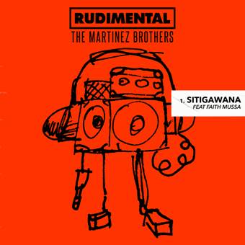****

**Rudimental** have joined forces with **The Martinez Brothers** on fresh new peak-time club track, “**Sitigawana**” – buy/stream [HERE](https://bigbeat.lnk.to/sitigawanaPR).

Taken from a new five-track Rudimental EP due for release in July, “**Sitigawana**” is aimed squarely at the floor, pairing a solid, locked groove with tribal percussion, entrancing vocals – sung in Chichewa by Malawian artist **Faith Mussa** – and slick guitar chords.

Faith was originally invited to **Rudimental**’s studio after **Piers Aggett** (one quarter of the collective) attended one of his shows in London in 2018, where the band recorded a track for Faith’s forthcoming album. The vocals recorded that day proved the perfect addition to a collaboration the band were working on with **The Martinez Brothers** earlier this year – and “**Sitigawana**” was born.

Marking **Rudimental** and **The Martinez Brothers**’ second official release together after 2017’s “[No Fear](https://www.youtube.com/watch?v=MJhAcp0R9Zg)” (ft. **Donna Missal**), “**Sitigawana**” forms an exciting primer to a packed Ibiza season for both acts; **Rudimental** host a residency at **Ibiza Rocks** every Thursday (July 4 – August 29) and **The Martinez Brothers** have just announced a series of **Cuttin’ Headz** label parties at DC10 on June 21, August 2 and September 6.

**For more information please visit:**

[www.rudimental.co.uk](http://www.rudimental.co.uk)

<https://twitter.com/Rudimental>

<https://www.facebook.com/Rudimental>

<https://www.youtube.com/user/RudimentalUk>

Press Tools: <http://press.wearebigbeat.com/artists/rudimental>

**Press Inquiries:**

Libby Kober | [Libby.Kober@atlanticrecords.com](mailto:Libby.Kober@atlanticrecords.com)