RUDIMENTAL



UNVEIL SECOND ALBUM
“WE THE GENERATION”
SET FOR RELEASE SEPTEMBER 18th
(MAJOR TOMS/BIG BEAT)

NEW “NEVER LET YOU GO” VIDEO HERE!
BAND ALSO GEARS UP FOR BONNAROO NEXT WEEK!

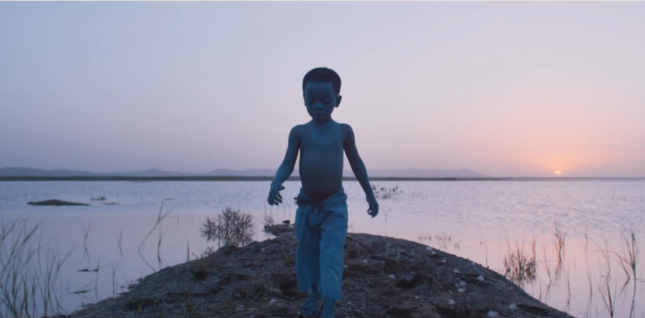
Link: https://youtu.be/0TtA_oP1zoE

Global-platinum selling four-piece RUDIMENTAL are about to take the ‘Made In Hackney’ stamp and make it global. Since unveiling their brand new single ‘Never Let You Go’ to great international acclaim – and a brand new music video – they have also announced their eagerly awaited sophomore album,“WE THE GENERATION,” set for release on September 18th through Major Toms/Big Beat.

The video for the uplifting single “Never Let You Go” shot by director Nez is brought to life in glorious multicolour as we soar across the globe (UK, Morocco, Ukraine and LA), witnessing people of all ages and all cultures painted in vivid hues. Crossing deserts, lush fields, mountains and inner cities, both the good and the bad sides of humanity are exposed, with the ultimate message of unity conveyed in a harmonious melding of colours. These themes have always been key to the Rudimental story and the new video provides the first hint of how “We The Generation” is set to take this message global.

The forthcoming sophomore LP, “WE THE GENERATION” marks a progressive Rudimental, a genre-defying collective that will continue to change the face of dance music not just within the UK music scene but globally. ‘Never Let You Go’ updates the much-loved style fans have come to expect from these musical pioneers; a huge drum and bass euphoric anthem that will undoubtedly be a global smash. The 14-track album follows their 2013 critically-acclaimed debut “Home,” which earned the band a Mercury Prize nomination and landed their first BRIT Award for British Single for ‘Waiting All Night ft. Ella Eyre,’ (an artist also featured on the new record).

Rudimental has become renowned for discovering and nurturing the hottest new up and coming talent and “We The Generation” continues this. On this record we see Rudimental championing incredible new young UK singers such as Mahalia on title track ‘We The Generation’, Anne-Marie (who has signed to the bands brand new record label Major Toms named after Rudimental’s Hackey HQ) and Will Heard. Of course there are also a few household names such as Lianne La Havas who wanted to get in on the act. Rudimental’s extended family is one of the most dynamic musical collectives out there with every vocalist naturally immersing themselves in the melting pot. There are special moments in abundance on “We The Generation,” one particular moment comes in the form of ‘New Day Coming’, a standout future-soul classic in waiting that features vocals by the late Bobby Womack – one of the last tracks he recorded vocals for before he passed away. They have once again struck musical gold: sound-clashing live instruments, progressive beats and soulful voices. This is what sets Rudimental light years ahead of their contemporaries.

Rewinding to the beginning of this amazing journey in 2012, ‘Feel The Love’ had taken its place firmly at the No. 1 spot, selling over 90,000 copies in its first week. They were the name on everyone’s lips…Who were these four guys from Hackney? How did they craft a song so huge it was an instant hit and one that resonated with all sorts of music fans from all walks of life, but also which maintained such a sense of musicality - a rare and exceptional combination these days. And that’s the thing about Rudimental; they are a collective with a strong musical heart. With influences ranging from Sly and the Family Stone to Bobby Womack, George Clinton and Steely Dan, We The Generation exemplifies that message and musicality.

Their talents exceed most hit-makers out there; theirs is a sound that is limitless – collectively they have gone on to sell over 5 million singles worldwide, a true testament to how important and relevant this band is. The upbeat and euphoric feeling that is their trademark permeates everything, whether it’s a huge drum and bass lead track like ‘Never Let You Go’ or a classy house track like ‘Rumour Mill’ (a track the band describe as ‘Spoons Part Two’) - positivity is the key.

Rudimental have never been just a drum and bass or electronic act, there’s always been precision and skill behind everything they do. This has been demonstrated in their award-winning videos that have now racked up an impressive 238.7 million views across their YouTube channel. But their live set up is where they come into their own, taking these huge songs and translating them on stage and making every single person in the audience feel like they are part of something – no easy feat. Their live achievements to date are something pretty spectacular, from supporting Ed Sheeran on his recent US arena tour (which they will do again at his upcoming Wembley Stadium London gig), to major music festivals across the globe, including two upcoming appearances at Governors Ball Music Festival in New York on June 6, and Bonnaroo on June 14th in Manchester, TN.

Fans can also enter here to win a free roundtrip flight, hotel and passes to Rudimental’s show at Lovebox Weekender in London through Beatport Guestlist (sweepstakes ends June 4th).

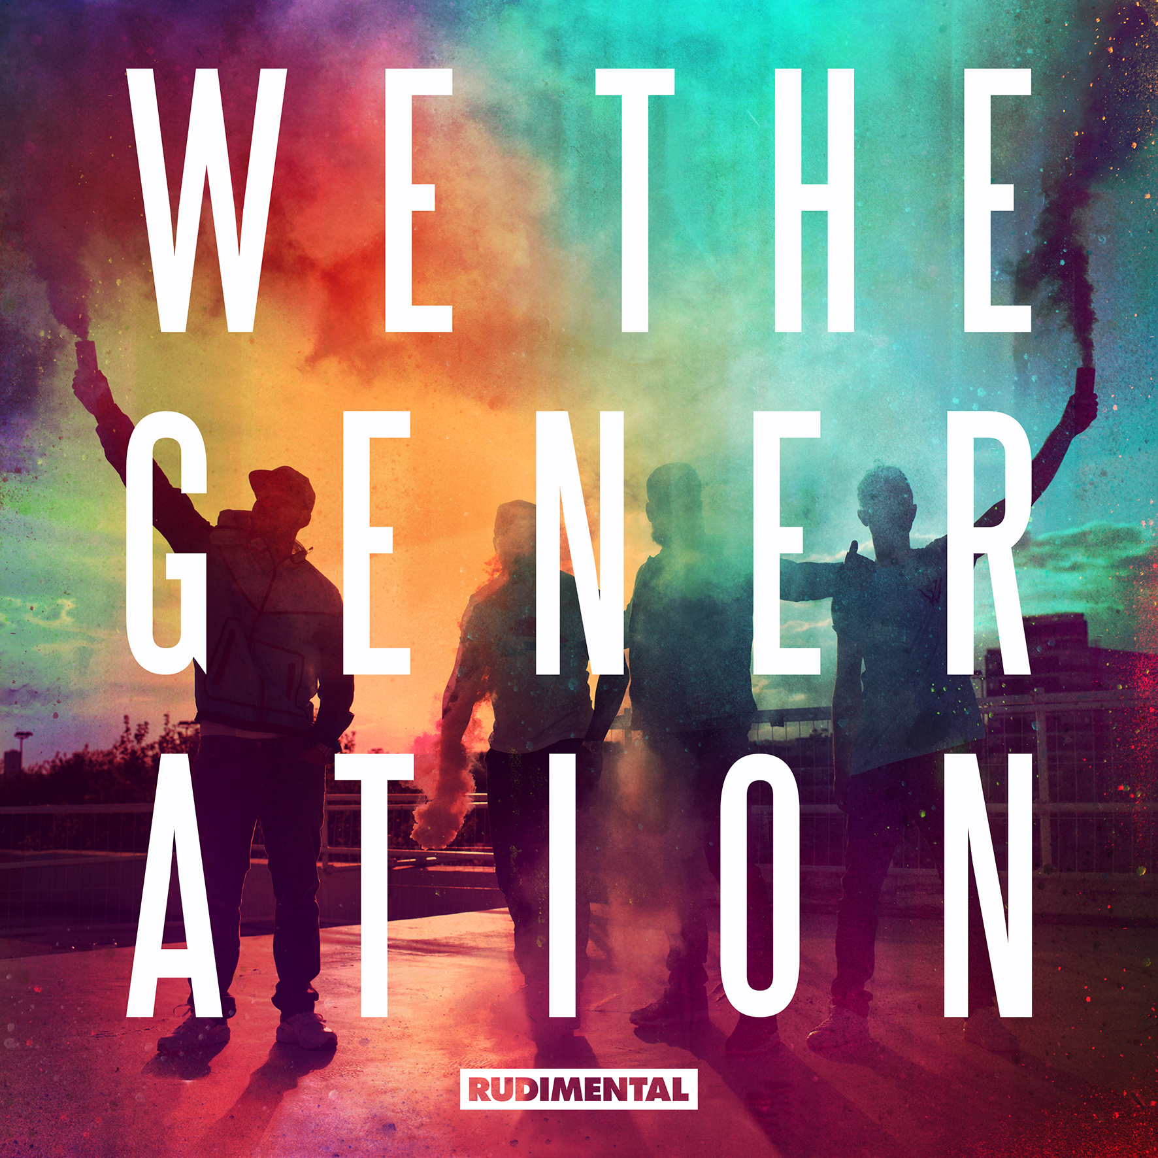

Preorder “We The Generation” on iTunes
Deluxe - http://smarturl.it/WeTheGeneration
Standard - http://smarturl.it/WeTheGeneration.Stnd

Stream the single, “Never Let You Go”
https://www.youtube.com/watch?v=OxjgpZSmUVw
Watch: https://youtu.be/0TtA_oP1zoE

Rudimental / on tour
6/6 – New York, NY @ Governors Ball Music Festival
6/14 – Manchester, TN @ Bonnaroo 2015

For more information / log on
http://www.rudimental.co.uk/
https://twitter.com/RudimentalUk
https://www.facebook.com/RudimentalUK
http://www.youtube.com/artist/rudimental
http://press.wearebigbeat.com/artists/rudimental

For press inquiries / Jordan Frazes
Jordan.Frazes@atlanticrecords.com
via Big Beat Records / 212.707.2022

For tour requests / Jill Segal
Jill.Segal@atlanticrecords.com

