PLATINUM-SELLING UK MUSIC COLLECTIVE
RUDIMENTAL RELEASE NEW SONG ‘SCARED OF LOVE’
FT. RAY BLK & STEFFLON DON
OFF FORTHCOMING THIRD STUDIO LP
‘TOAST TO OUR DIFFERENCES’
ARRIVING JANUARY 25TH
VIA MAJOR TOMS/BIG BEAT RECORDS

LISTEN/SHARE: https://youtu.be/nAI0zGmFOVs
BUY/STREAM: https://atlanti.cr/ScaredOfLove

PRE-ORDER ‘TOAST TO OUR DIFFERENCES’: https://lnk.to/ToastToOurDifferences

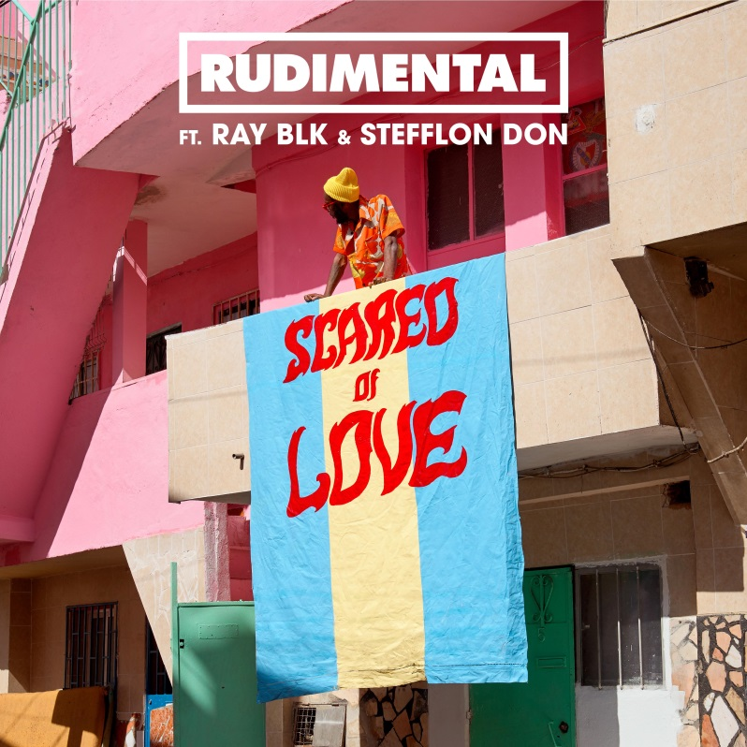

Rudimental tease the British four-piece’s third studio album ‘Toast To Our Differences’ with a new tune presenting a smooth, bubbling groove ‘Scared Of Love’ featuring Ray BLK and Stefflon Don. Bursting with classic house flavors, the track lands as a peak-time, feel good jam, elevated by Ray BLK’s glistening vocal hooks and Stefflon Don’s sharp, rapid-fire verses, spotlighting just how bold, diverse and expansive the Rudimental sound has become. Having already debuted three singles from the new album ‘Toast To Our Differences’ so far– smash hit UK #1 ‘These Days’ ft. Jess Glynne, Macklemore & Dan Caplen, the biggest-selling record of 2018 in the UK, ‘Let Me Live’ (prod. with Major Lazer) ft. Anne Marie & Mr. Eazi and ‘Walk Alone’ ft. Tom Walker – ‘Scared Of Love’ sees Rudimental pair up with Ray BLK and Stefflon Don on a record for the first time – LISTEN HERE!

About ‘Toast To Our Differences’

Written as an emphatic celebration of difference and a coming together of cultures, styles and sounds, ‘Toast To Our Differences’ is the product of the band’s past three years of work and boasts an extraordinary list of collaborators – see full track list below. Tom Walker turns in a stunning vocal on catchy, wholesome ballad, ‘Walk Alone’, emerging vocalists like Maleek Berry and RAYE come together on the sparkling ‘1x1’ and rising singer-songwriter Dan Caplen shines on #1 smash, ‘These Days’, alongside Jess Glynne and Macklemore. ‘Let Me Live’ also features vocals from Ladysmith Black Mambazo, an incomparable x5 time GRAMMY-winning South African male choral group, and hotly-tipped soul singer, Yebba, who has been heavily co-signed by global stars like Ed Sheeran and Sam Smith. Tour de force rapper Stefflon Don and BBC Sound Poll winner Ray BLK make waves on the powerful ‘Scared Of Love’, Rita Ora excels on the sleek, shimmering ‘Summer Love’ and enigmatic rapper Kojey Radical and Kabaka Pyramid spar on ‘No Pain’, further showcasing the breadth and diversity of talent Rudimental showcase right across ‘Toast To Our Differences’. Further features on the album include (in alphabetical order); Chronixx, Eli Ingram, Hak Baker, Maverick Sabre, OLIVIA, Protoje, Shungudzo, Kevin Garrett & Raphaella.

Rudimental – ‘Toast To Our Differences’
Pre-Order: https://lnk.to/ToastToOurDifferences
1. Toast To Our Differences (feat. Protoje, Hak Baker & Shungudzo)
2. Rudimental & Major Lazer: Let Me Live (feat. Anne-Marie & Mr Eazi)
3. Dark Clouds (feat. Jess Glynne & Chronixx)
4. Walk Alone (feat. Tom Walker)
5. Thula Ungakhlai (feat. Ladysmith Black Mambazo)
6. These Days (feat. Jess Glynne, Macklemore & Dan Caplen)
7. Sun Comes Up (feat. James Arthur)
8. 1by1 (feat. Raye & Maleek Berry)
9. Last Time (feat. Raphaella)
10. No Pain (feat. Maverick Sabre, Kojey Radical & Kabaka Pyramid)
11. Scared of Love (feat. Ray BLK & Stefflon Don)
12. Summer Love (feat. Rita Ora)
13. They Don't Care About Us (feat. Maverick Sabre & YEBBA)
14. Do You Remember (feat. Kevin Garrett)
15. Leave It For Tomorrow (feat. Elli Ingram)
16. Adrenaline (feat. OLIVIA)

For more information please visit:
www.rudimental.co.uk
https://twitter.com/Rudimental
https://www.facebook.com/Rudimental
https://www.youtube.com/user/RudimentalUk
Press Tools: http://press.wearebigbeat.com/artists/rudimental

Press Inquiries:
Jordan Danielle Frazes
Head of Publicity, Big Beat Records
Jordan.Frazes@atlanticrecords.com

