ELDERBROOK & RUDIMENTAL RELEASE
‘SOMETHING ABOUT YOU’

HIGHLY-ANTICIPATED COLLABORATION BETWEEN MULTI-PLATINUM + GRAMMY-NOMINATED ARTISTS OUT TODAY VIA BIG BEAT RECORDS

https://www.youtube.com/watch?v=N1EhXF1lskA
BUY/STREAM HERE: https://BigBeat.lnk.to/SAYPR

download hi-res images + artwork here

Platinum-selling UK collective Rudimental and Grammy nominated singer-songwriter, producer, and multi-instrumentalist Elderbrook have unveiled their highly-anticipated collaboration – “Something About You,” out today via Big Beat Records and joined by an inspirational official music video – watch here.

Starring Michael Socha from HBO’s Chernobyl and the film This Is England, the video focuses on the important issue of mental health. Directed by Luke Davies (Rich The Kid, Jax Jones, Mabel) and showcasing an all-male group therapy session, the visual rails against notions of traditional masculinity, showing the beauty that can come from expressing emotions.

Of their experience working with Elderbrook, Rudimental explained: “We have been big fans of Elderbrook’s vocals and production over the past few years so it’s amazing to finally come together on this track!”

Elderbrook echoed this, saying “I’ve always loved the music and energy that Rudimental put out. This song wouldn’t have happened without them and has been amazing collaborating with them!”

“Something About You” comes off Rudimental’s Distinction EP, also out today via Major Tom/Big Beat Records (buy/stream here; track list enclosed). The four-track dance focused EP includes previously released tracks “Sitigawana” ft. The Martinez Brothers and “Mean That Much” with Preditah ft. MORGAN.

The multi-platinum group’s last album “Toast to Our Differences,” was released in January of this year and has gone on to amass over 1.2 Billion streams, marked by the smash hits “Sun Comes Up” ft. James Arthur and “These Days” ft. Jess Glynne, Macklemore & Dan Caplen. They will cap off the summer with a series of UK festival dates and live shows (itinerary below), following their residency earlier this summer in Ibiza.

Elderbrook will also headline shows across Europe from September to October, before heading to North America the following month for a tour which will include stops at iconic venues such as Bowery Ballroom, The Troubadour, and more (full itinerary enclosed). For tickets and additional information, visit his website.

Following his Grammy nomination in 2018 for the global smash “Cola” with Camelphat, Elderbrook has spent the past two years touring the globe (including runs with Rüfüs Du Sol, Jungle + Bonobo) and amassing millions of streams with his unique blend of innovative dance music and catchy leftfield pop. Most recently, he released “How Do You” featuring Diplo & Sofi Tukker, which was featured as BBC Radio 1 Annie Mac’s Hottest Record in the World.

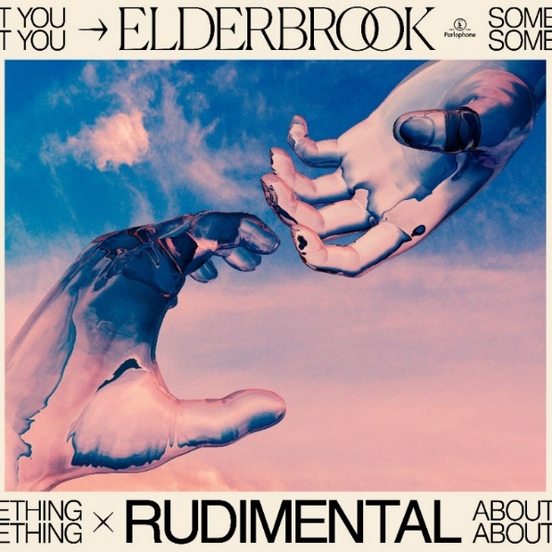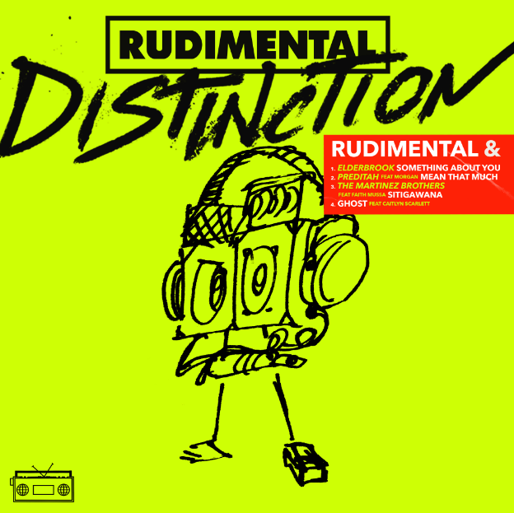
download hi-res images + artwork here

RUDIMENTAL – ‘DISTINCTION’ EP
- ‘Sitigawana’ w/ The Martinez Brothers (ft. Faith Mussa)
- ‘Mean That Much’ w/ Preditah (ft. MORGAN)
- ‘Keeping Me Sober’ ft. Elderbrook
- ‘Ghost’ ft. Caitlyn Scarlett

RUDIMENTAL LIVE DATES
08.23 Cipping Norton, UK The Big Feastival 2019
08.24 Southsea, UK Victorious Festival 2019
09.21 Surrey, UK Wentworth Club

ELDERBROOK LIVE DATES
09.18 Hamburg, Germany Reeperbahn Festival 2019
10.12 London, UK EartH (Hackney Arts Centre)
10.31 Amsterdam, NL Melkweg
11.01 Berlin, DE Saalchen
11.02 Prague, CZ Futurum
11.04 Vienna, AT Ottakringer Braurei
11.05 Zurich, CH Mascotte
11.06 Munch, DE Strom
11.07 Paris, FR Le 1999
11.15 Toronto, ON Velvet Underground
11.16 New York, NY Bowery Ballroom
11.17 Mexico City, MX Autodromo Hermanos Rodriguez
11.20 Boulder, CO Fox Theatre
11.22 San Francisco, CA 1015 Folson
11.23 West Hollywood, CA Troubadour
11.24 San Diego, CA Quartyard

CONNECT WITH RUDIMENTAL
rudimental.co.uk
FB : rudimental
Twitter : rudimental
Instagram : rudimental
Soundcloud : rudimental

CONNECT WITH ELDERBROOK
https://www.elderbrookofficial.com/
FB : elderbrookmusic
Twitter : _elderbrook
Instagram : _elderbrook
Soundcloud : elderbrook

PRESS INQUIRIES:
Libby Kober | Libby.Kober@atlanticrecords.com

