GRAMMY-Nominated Producer Robin Schulz releases “speechless” ft. erika sirola

NEW SINGLE/MUSIC VIDEO OUT TODAY

LISTEN/SHARE: https://youtu.be/wezhufvgo0q
BUY/STREAM: http://wmg.click/robinschulz_speechlessay
(Big Beat Records)

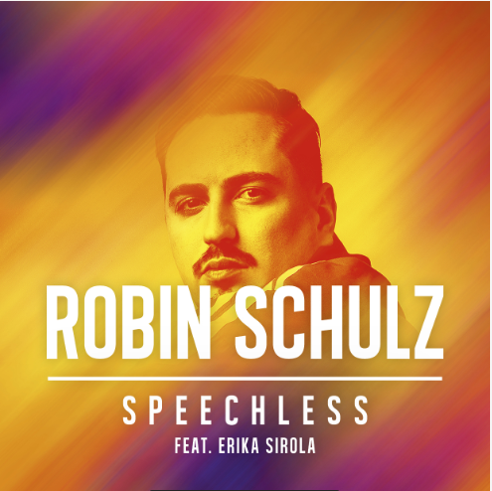

GRAMMY-nominated German DJ and producer Robin Schulz unleashes a “Speechless” new single today featuring up-and-coming Finnish artist Erika Sirola. With its atmospheric production, Robin’s new track will arrest you from the get-go. Vocalist Erika Sirola tells the story of a sizzling encounter that has all the ingredients for a big love story. With so many emotions involved, it’s hardly surprising one is left “Speechless” – LISTEN HERE!

The same goes for the young man in the official music video – WATCH HERE! Set in a street food restaurant in Mumbai, India, where the protagonist works as a cashier, and slowly goes about his chores until he sees the woman of his dreams standing right in front of him. The problem: the whole affair is very much one-sided, but our friend gives his all to catch her attention, completely oblivious to the spectacle unfolding around her. Robin Schulz makes more than one cameo, playing a customer as well as the head chef. In the end, the video takes a turn to the completely unexpected, taking everyone by surprise except the mysterious woman…

Ringing in another successful year since releasing his third studio album “Uncovered,” Robin Schulz broke new records, reaching his ninth #1 radio airplay in Germany – the only male artist ever to do so. 2018 also saw his first collaboration with a Latin American act, “Oh Child” with Piso 21 (80 million streams to date), alongside scoring another RIAA certified Gold record, “Unforgettable.” In total, Robin Schulz has over 250 Gold, Platinum & Diamond awards in 30 territories under his belt. This year, he was also awarded “Dance national” at the ECHO awards (the German GRAMMYs).

Connect with Robin Schulz:
Website | Twitter | Facebook | YouTube
For press assets, visit: http://press.wearebigbeat.com/artists/robin-schulz/

Press Contact:
Jordan Danielle Frazes
Head of Publicity, Big Beat Records
Jordan.Frazes@atlanticrecords.com

