ROBIN SCHULZ & HUGEL RELEASE “I BELIEVE I’M FINE” –
NEW SINGLE OFF SCHULZ’S FORTHCOMING
THIRD STUDIO ALBUM UNCOVERED!

WATCH/POST THE SINGLE: HERE
BUY/STREAM THE SINGLE: HERE
PRE-ORDER THE ALBUM: HERE

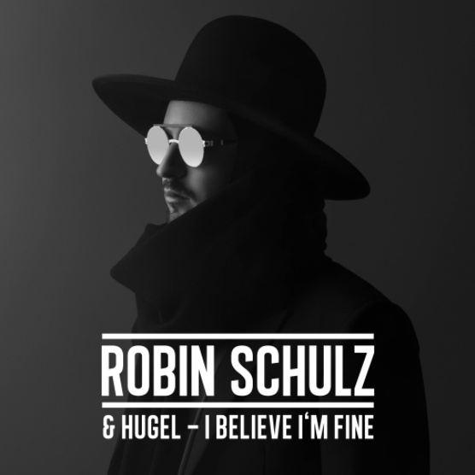

Today, acclaimed German DJ Robin Schulz releases a new single “I Believe I’m Fine” on Big Beat Records, featuring French DJ and producer HUGEL; who instantly made a name for himself as the next European house/pop sensation with his 2015 debut single “Coming Home,“ followed by “Where We Belong (ft. Jasmine Thompson)” and his current single “Baby. ” The official music video features Schulz as the target of a manhunt – narrowly escaping a would-be assassin at every turn – as well as a cameo appearance by HUGEL working at a carnival booth while sporting a bright yellow tracksuit. Watch here: https://www.youtube.com/watch?v=hzp4upS8M8Y.

“HUGEL and I have known each other for some years now and are constantly sharing musical ideas. So this cooperation was quite spontaneous and natural. We are excited to see how ‘I Believe I’m Fine’ is received. This single is a bit different from my prior releases.” –Robin Schulz

“I Believe I’m Fine” - which comes equipped with a catchy, urban R&B hook - is the next single from Schulz’s eagerly awaited third studio album Uncovered, containing 18 tracks and scheduled for a US release on September 29th by Big Beat Records. The following day, Schulz kicks off his “Uncovered” stadium tour with support from fellow German DJ Alle Farben and, of course, HUGEL—see full intinerary below.

The new single “I Believe I’m Fine” details a relationship that has seemingly come to an end, before the chorus takes a confidently upbeat turn. The Track becomes the protagonist’s empowering mantra, as he lets everyone know that he will carry on, despite the heartbreak. The single comes hot off the heels of Robin Schulz‘ summer anthem “OK” featuring acclaimed British superstar James Blunt, which was released before his previous David Guetta collaboration “Shed A Light (ft. Cheat Codes),” now certified Gold and Platinum in several countries, with over 300 million streams internationally.

Schulz also found tremendous success in 2015 with “Sugar (feat. Francesco Yates),” which went on to be streamed over 600 million times worldwide. Perhaps most impressive, his debut track – the record-setting “Prayer in C” – stands as the most successful track internationally of any German act to date. Less than three years in the making, Schulz ranks among the most sought after acts on the globe, as well as one of the most streamed artists worldwide, raking in 2.7 billion plays and counting.

UPCOMING LIVE DATES:

Saturday, September 9th @ Encore Beach Club – Las Vegas, NV
Saturday, September 9th @ Intrigue Nightclub – Las Vegas, NV
Thursday, September 14th @ Pacha (Robin Schulz & Friends) – Ibiza, Spain
Thursday, September 21st @ Pacha (Robin Schulz & Friends) – Ibiza, Spain
Saturday, September 23rd @ Big City Beats – Seoul, Korea
Thursday, September 28th @ Pacha (Robin Schulz & Friends) – Ibiza, Spain
Saturday, September 30th @ Olympiahalle – Munich, Germany
Thursday, October 5th @ F*** Me I’m Famous w/ David Guetta – Ibiza, Spain
Saturday, October 7th @ Velodrome – Berlin, Germany
Friday, October 13th @ Zénith de Paris – Paris, France
Thursday, October 19th @ Barclaycard Arena – Hamburg, Germany
Friday, October 20th @ König Pilsener Arena – Oberhausen, Germany
Saturday, October 21st @ Fabrique – Milan, Italy
Saturday, October 28th – Sunday, October 29th @ Wynwood Fear Factory 2017 – Miami, FL
Friday, November 17th @ Marquee – New York, NY
Wednesday, December 27th – Tuesday, January 2nd @ Pipa Reveillon – Tibau do Sul, Brazil
Tuesday, January 2nd @ P12 Parador Internacional – Florianópolis, Brazil

