FAST-RISING PRODUCER REBUKE UNVEILS
BRAND-NEW TRACK, ‘TAKE THAT BACK’

OUT TODAY VIA BIG BEAT RECORDS
New single follows Irish producer’s recent Beatport #1 track
‘Along Came Polly’ & current top 10 single ‘The Pipe’

LISTEN/SHARE: https://youtu.be/mG_pC-GEkIo
STREAM/BUY: https://BigBeat.lnk.to/RTTBPR
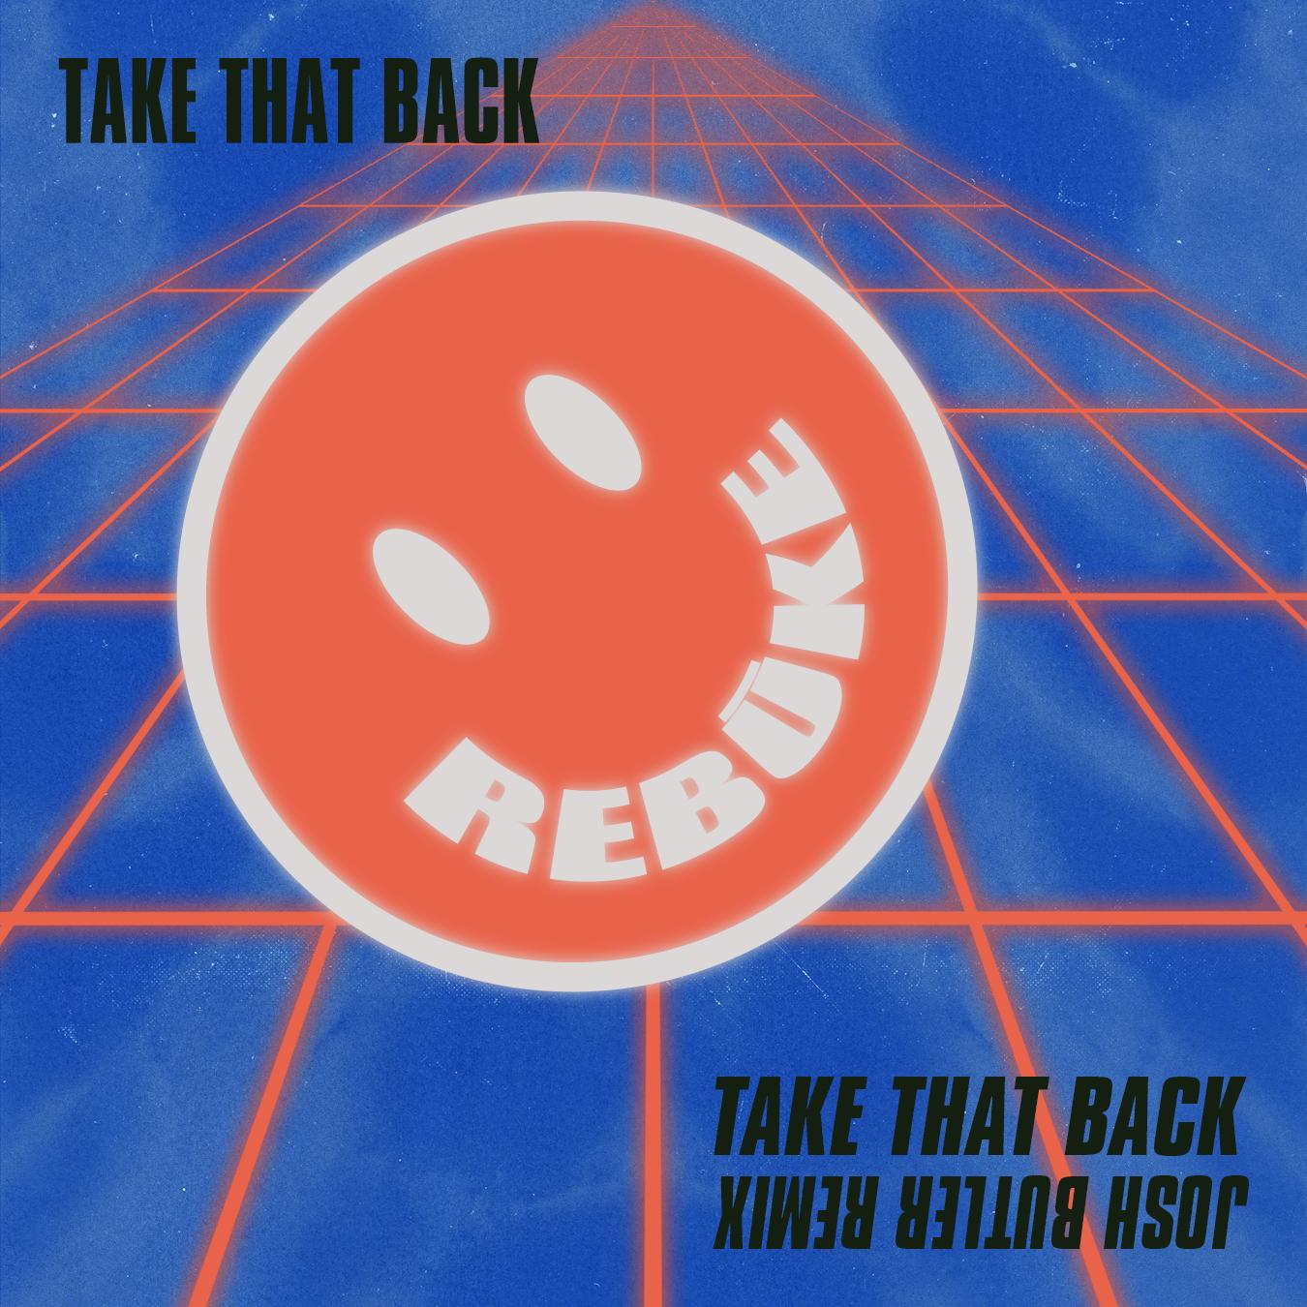

Irish artist and DJ & producer, Rebūke, continues his meteoric rise, delivering an aural embodiment of his raw style in new single ‘Take That Back’ – out today via Big Beat Records – listen HERE! Fusing elements of house, techno and early 90s rave into his unique productions, ‘Take That Back’ serves as an atmospheric and industrial-leaning anthem, led by the producer’s gruff chord patterns and interjecting chimes.

With previous releases including, the all-conquering Beatport #1 ‘Along Came Polly’ (Hot Creations) and the current top ten hit ‘The Pipe’ (Dirtybird), Rebūke continues to shoot to attention after recently performing the Hot Mix for disc jockey Pete Tong.
“I’ve got a deep, almost obsessional interest in the Italian, Belgian and UK records from the early 90s and I try to bring that into my productions,” explains Rebūke. “It is really about capturing the dirt and energy of the records of that time and fusing it with modern house and techno that I love too. That’s definitely what appeals to me.”
With his own distinct sound spreading rapidly through the industry, 2019 marks an exciting chapter in the Irish talent’s burgeoning career, with ‘Take That Back’ preceding Rebūke’s eagerly anticipated performance at Annie Mac’s Lost & Found Festival this May.

On side B of the original track release, Manchester-based DJ, Josh Butler, will be injecting a more tribal feel into his own rework. Listen to the remix HERE! As one of house music’s most revered talents, Butler has picked up multiple industry awards from Beatport and DJ Mag, debuted a mix on the legendary BBC Radio 1 Essential Mix series, and has remixed tracks for Fatboy Slim, Carl Cox and Joris Voorn. Ahead of his annual return to Australia and New Zealand in early 2019, and past releases with Hot Creations, Rejected, 8bit and Kaoz Theory under his belt, it’s clear to see that Josh Butler is showing no signs of slowing down.

# # #
For more information on Rebūke, visit:
Facebook I Twitter I Soundcloud I Instagram

For more information:
Paige Rosoff – Big Beat Records
Paige.Rosoff@atlanticrecords.com

