AMINDI RECRUITS POPCAAN AND KRANIUM TO COLLABORATE ON NEW REMIX OF
“PINE & GINGER”

OUT TODAY VIA BIG BEAT RECORDS

WATCH / POST: https://youtu.be/jWR0BqE537I
BUY/STREAM: https://BigBeat.lnk.to/PGP

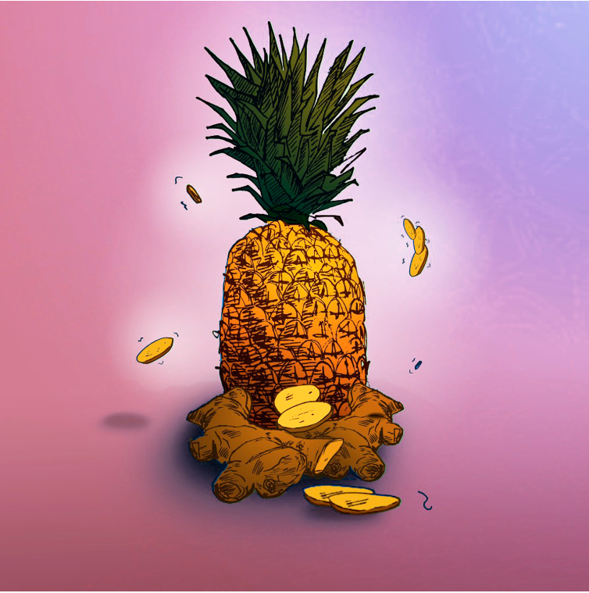
DOWNLOAD IMAGE HERE

Today Big Beat Records releases a new remix from legendary dancehall artists, Popcaan and Kranium, in which they pay their respects to an internationally-acclaimed club favorite “Pine & Ginger”, a track that last year The FADER dubbed “...one of the best pop songs of the past year.” The single was first made popular through the meteoric-rising vocalist Amindi, Jamaican artist Tessellated and producer Valleyz, and now Popcaan & Kranium's versatile sounds take the already laid-back reggae beat next level, ensuring its spot as a true summer jam. Listen HERE!

Ever since he stepped on the scene, Popcaan has been making waves in dancehall music. He has been in the spotlight for more than a decade pumping out dance floor hits such as “Only Man She Want” and “Party Shot”, which helped lift him up in his rise to international success. The Jamaican singer’s artistry transcends genres through being sampled by other groundbreaking musicians such as Drake and Rihanna, and through collaborations like Jamie xx’s 2015 smash, “I Know There’s Gonna Be (Good Times)” and Gorillaz’ 2017 “Saturnz Barz.” 2018 saw milestones such as the triumphant release of Popcaan’s full-length sophomore album, Forever, spawning hits “Silence” and “Wine for Me”, an appearance from Drake and Tory Lanez at his hometown show in St. Thomas, and Popcaan himself serving as Drake’s opening act on a stint in Europe. Based on 2018 alone, we suggest you keep your eyes on this worldwide dancehall superstar for what’s to come.

Kranium is known for his melodic flow, clever wordplay, and ability to break all barriers when it comes to his music. Born in Montego Bay, Jamaica and raised in Jamaica, Queens, NY, he offers the perfect blend of authentic Dancehall vibes with a unique touch of his own. Kranium’s distinct sound can be heard on major collaborations with artists such as Wiz Kid, Major Lazer, Tory Lanez, Rotimi, Bebe Rexha and Ed Sheeran, and Ty Dolla $ign. His collaboration with Ty Dolla $ign is when he emerged onto the music scene in 2013 with “Nobody Has to Know.” The widespread success of this single helped place him at the forefront of the dancehall scene and introduced his influential sound as an undeniable staple the world didn’t know they were missing. Neglecting pen and paper, he’s known for allowing his honest lyrics to flow freely based on the feelings the melodies uncover. You can catch him now headlining his “Hotel Tour” in support of his latest single, “Just The Style” ft Alkaline which is available now at all digital retail outlets.

CONNECT WITH POPCAAN:
SOUNDCLOUD I FACEBOOK I TWITTER | INSTAGRAM

CONNECT WITH KRANIUM:
SOUNDCLOUD I FACEBOOK I TWITTER | INSTAGRAM

CONNECT WITH AMINDI:
SOUNDCLOUD I FACEBOOK I TWITTER | INSTAGRAM

PRESS ASSETS

***
PRESS CONTACTS:
Paige Rosoff - Big Beat Records
Paige.Rosoff@atlanticrecords.com

