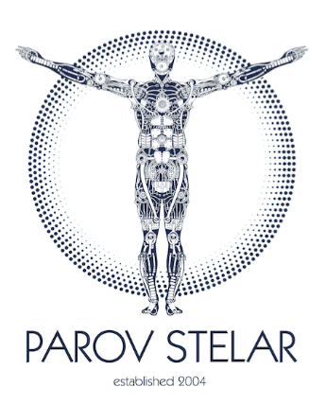

Marcus Fuereder, better known by his stage name Parov Stelar, is Austrias internationally most successful artist. He is called the founder of ‘Electro Swing’ and his band, the Parov Stelar Band, is in heavy request all over the world. His music is the soundtrack for numerous movies, TV shows and ads.

Already his first release, the EP Kiss Kiss, and the following album Rough Cuts in 2004 provided him an immediate breakthrough in the international electronic music scene. His unique sound, his specific approach to music production and the unorthodox combination of musical genres soon made him the star of an uprising scene. With his subsequent albums Seven and Storm (2005), Shine (2007), Coco (2009), The Princess (2012), The Invisible Girl (Parov Stelar Trio, 2013), The Art of Sampling (2013), the No. 1 album The Demon Diaries (2015), Live @ Pukkelpop (2016), the No. 1 album The Burning Spider (2017) and more than 20 EPs he was able to strengthen and even improve his status until today and he became the favorite of a huge fan community.

The Parov Stelar Band played over 1000 live shows all around the world, e.g. sold out shows at Playstation Theater in New York (back to back), Alexandra Palace in London and Zenith in Paris. They played many major festivals like Coachella, Glastonbury, Sziget, Lollapalooza, Pukkelpop, and many more.

Parov Stelar is also in heavy request for collaborations. He worked with Tony Bennett & Lady Gaga, Marvin Gaye, Lana Del Rey, Bryan Ferry, Klingande and many more. Parov Stelar won 7 Amadeus Austrian Music Awards (4x Best Electronic/Dance, 2x Best Live Act and 1x Best Album) and released 9 albums and more than 20 EP's. Next to various top chart positions in Europe the track The Sun reached No. 1 in the electronic US iTunes charts in 2018. The song All Night reached Double Platinum for more than 100,000 tracks sold in Italy and Parov Stelar received Gold Awards For All Night in Germany and The Princess, The Art Of Sampling and The Demon Diaries in Austria.

Parov Stelar has 1 Million facebook fans, more than 500 Million youtube views and more than 500 Million Spotify plays. His tracks have been used on more than 700 compilations worldwide (e.g. Hotel Costes, Buddha Bar, ...) and have been used in numerous TV shows, TV series and movies. There are dozens of TV ads with his music e.g. Audi, Bacardi, Courvoisier, Colgate, Cosmopolitan, Escada, Fiat, Google, Microsoft, Motorola, Nespresso, Paco Rabanne, Target, Telecom Italia and Vodafone to name just a few.

As a hunter and collector of great samples, Parov Stelar has proven his ability to transform raw diamonds into musical gems. After an extremely successful summer ripe with major festivals and inspiration, he has found what he was looking for once again. With lead vocals by US singer Nikki Williams, Parov Stelar will release TROUBLE, a song about the vivid sensibility of relationships on November 16th 2018. The cover artwork is a real masterpiece developed with screenprinting skills and nothing short of 'a real Stelar’. Parov Stelar will soon be on pins and needles again, ready to rock the stages of this world and party with his fans, because once entrenched in the international live circus there is no going back. Expectations are high as to how the music producer and master of sampling will fascinate the fans with his outstanding skills once again.

###

Big Beat Records, 2018

