NATHAN DAWE DROPS INFECTIOUS DEBUT SINGLE “CHEATIN’”

OUT TODAY VIA BIG BEAT RECORDS/ATLANTIC RECORDS UK

LISTEN/POST: https://BigBeat.lnk.to/CheatinPR/youtube
BUY/STREAM: https://BigBeat.lnk.to/CheatinPR

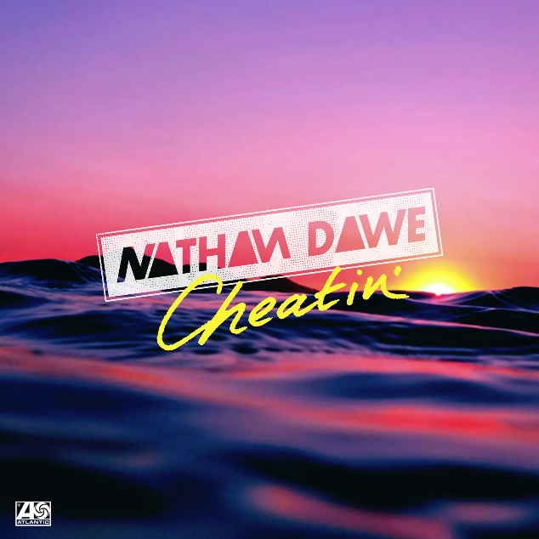

Bouncing off his debut overseas performances at We Are FSTVL and Bestival, rising UK DJ and producer Nathan Dawe delivers his stunningly rhythmic debut single “Cheatin’’’ - Out now via Big Beat Records/Atlantic Records UK. Listen HERE!

Sampling timeless vocals from Deborah Cox’s iconic ‘It’s Over Now,’ Nathan offers a refreshing club-ready take on the original track. Preserving its signature melodic pattern, the rising talent showcases his trademark for crisp high-hats and harmonizing keyboard riffs that proudly lay foundation to the all too recognizable lyrics. Serving a clean and suspense filled break that subtly builds, Nathan drops to an addictively dominant bass line that would be sure to inspire any House enthusiast.

Hailed the biggest global platform for DJs to download new music, DJ City’s ‘UK Top Downloads’ chart has seen ‘Cheatin’’ hold it’s #1 spot for three consecutive weeks, prior to official release. Now Nathan’s intoxicatingly rhythmic take on Deborah Cox’s classic is primed to take on summer anthem status.

Spending much of 2017 building an impressive portfolio, the multi-genre DJ completed a staggering 150 shows across every party island in Europe, including at the prestigious Ushuaïa Ibiza. Attracting a combined social following of 120,000 fans, Nathan has amassed over 20 million unique Soundcloud and Mixcloud plays, as well as reaching #1 status in the iTunes Dance chart with his recent ‘Pure Anthems’ compilation. With headline support invitations from chart-toppers Tinie Tempah, Tom Zanetti, Not3s and Giggs, as well as Lotto Boyz and James Hype, it’s easy to see how Nathan’s ascent to international stardom is rapidly approaching.

***
Connect with NATHAN DAWE:
FACEBOOK | TWITTER | INSTAGRAM | SOUNDLCOUD |SPOTIFY

For press assets: http://press.wearebigbeat.com/singles/cheatin-nathan-dawe/

For more information:
For “NATHAN DAWE” press inquiries:
Lindsay Herr: Publicity, The Wanderlvst
Lindsay@thewanderlvst.com

For Big Beat Records inquiries:
Jordan Frazes: Head of Publicity, Big Beat Records
Jordan.Frazes@atlanticrecords.com

