FRENCH PRODUCER MICHAEL CALFAN
REINVENTS THE FRENCH TOUCH SOUND WITH NEW RELEASE “IT’S WRONG” FT. DANNY DEARDEN

LISTEN/POST: https://youtu.be/ieQZKUdPdwg
BUY/STREAM: https://lnk.to/MC-itswrong

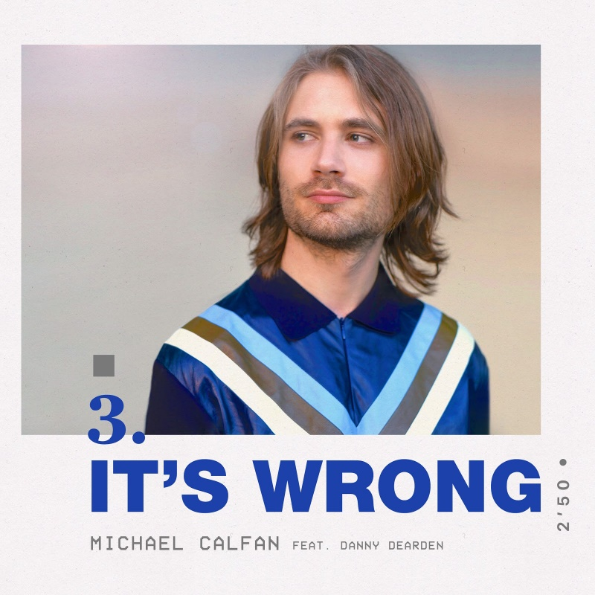

French producer Michael Calfan is respected worldwide for his kaleidoscopic House productions; he’s had many previous successes including landmark releases ‘Treasured Soul’ and ‘Nobody Does It Better’. With a staggering 100 million combined streams on Spotify to his name (aided by his recent genre bending productions ‘On You’ and ‘Got You’,) he is achieving critical acclaim and coming back to the forefront of Electronic Dance music. His next release ‘It’s Wrong’ ft. Danny Dearden showcases his ever-changing sound and style. Listen HERE!

Delivering ‘It’s Wrong’ via Big Beat Records, Michael Calfan returns to the classic influences of the French Touch sound. His new track omits nothing but good vibes, alongside big disco loops and a summer feeling. Retaining a classic, soulful and beautifully textured vocal in addition to the sophisticated house production, the record has the makings of an instant classic.

With previous records gaining support from the international DJ community, streaming sites and radio stations such as BBC Radio 1, Triple J, Slam!, Virgin Radio, P3 and Sirius XM; ‘It’s Wrong’ is perfectly positioned to become a summer breakthrough track.

The original radio edit now comes fully equipped with an extended version firmly designed for the dance floor with further remixes to be announced.

Michael’s huge 2015 single, ‘Treasured Soul’, reached #17 in the UK charts, clocking up a combined 50 million streams and 1.3 million Shazams. 2016’s ‘Nobody Does It Better’ picked up another 50 Million streams, marking an overall 100 million combined streams on Spotify. ‘Resurrection’, the Frenchman’s breakout single with Axwell back in 2011, received heavy rotation in clubs worldwide. Michael has also exercised his production talent with remixes for the likes of Duke Dumont and Major Lazer – further ascertaining his distinctive house sound.

Previous support for Michael has come from the likes of BBC Radio 1’s Pete Tong and Annie Mac as well as fellow artists David Guetta, Avicii and The Magician. The French producer/DJ has also established himself as a huge figure on the touring circuit, playing alongside acts including Martin Solveig, Kygo and MK.

Connect with Michael Calfan:
Soundcloud | Facebook | Twitter | Press Site

For “Micahel Calfan” press inquiries:
Lindsay Herr: Publicity, The Wanderlvst
Lindsay@thewanderlvst.com

For Big Beat Records inquiries:
Jordan Frazes: Head of Publicity, Big Beat Records
Jordan.Frazes@atlanticrecords.com

