MATOMA & BECKY HILL PREMIERE HUGE NEW SINGLE ‘FALSE ALARM’ + REVEAL NORTH AMERICAN
BUS TOUR DATES

https://soundcloud.com/matoma-official/false-alarm
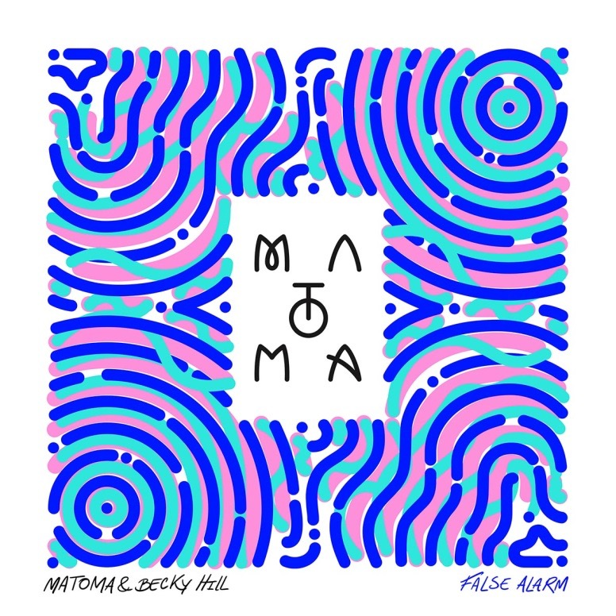

From the album ‘Hakuna Matoma’:
(Big Beat Records/Parlophone)
Spotify | Apple Music | iTunes | SoundCloud | YouTube

Norwegian electronic music star Matoma’s innovative ‘Hakuna Matoma’ album project – available via Big Beat Records/Parlophone - continues to go from strength-to-strength as it expands and evolves over time on streaming media platforms. With 280 million streams to date and 7.5 million regular monthly listeners on Spotify, Matoma is proving that his unconventional approach is paying dividends.

The latest track to be added to the album, and arguably the biggest, has now been unleashed with ‘False Alarm’ - a collaboration with British singer /songwriter Becky Hill who topped the charts as vocalist and co-writer of Oliver Heldens’ ‘Gecko (Overdrive)’ and has collaborated with the likes of Rudimental and Wilkinson.

The blissful ‘False Alarm’ captures the shimmering, summery side of Matoma’s sound, which presents an immediately captivating hook with his uplifting brand of dance music. The strength of Becky Hill’s impassioned vocal creates a soaring and classic topline which only furthers the track’s infectious style.
“For me I'm just so inspired by incredible vocals, and I think Becky has one of the most special voices I've ever heard, it's such an honor to collaborate with her on this track. When I heard her first demo vocal I got goosebumps, it was so good we ended up keeping it! I'm so excited about this song coming out and being the soundtrack to my summer.” says Matoma.
‘False Alarm’ follows Matoma’s recent track ‘Paradise’ which featured Sean Paul and KStewart and was launched during Matoma’s set at Coachella, where Sean Paul was on hand to reprise his performance on the track, and special guests Akon and Ja Rule surprised the beyond capacity tent with unannounced appearances.

‘Hakuna Matoma’ demonstrates Matoma’s ability to reach beyond the confines of house with elements of urban, dance, pop and Caribbean sounds within its palette. In addition to ‘False Alarm’ and ‘Paradise’, the album’s highlights include guest appearances from Washington D.C. rapper Wale and Jamaican dancehall artist Popcaan on the feel-good ‘Feeling Right (Everything Is Nice)’; ‘Try Me’, a collaboration with global superstars Jason Derulo and Jennifer Lopez; the jubilant ‘Wonderful Life’ as featured on the Angry Birds soundtrack; Matoma’s inspired reimagining of Coldplay’s ‘Adventure of a Lifetime’; the HypeM #1 ‘Knives’; and the gorgeous ‘Running Out’ with MTV Music Europe Award winner Astrid S.

To coincide with the release of ‘False Alarm’, Matoma announces a huge bus tour of North America this fall. With support from buzzing electronic trio Cheat Codes, guests Steve Void and BAYNK on select dates, and additional support artists soon to be announced, the tour will see Matoma bring his impressive new production and spread the love from coast to coast.

Matoma “Party At Your Place” National Fall Tour
w/ special guests Cheat Codes*, Steve Void, Baynk and more TBC
09-14 Mainstage Morgantown - Morgantown, WV*
09-15 Coda - Philadelphia, PA*
09-16 Kaaboo - Del Mar, CA*
09-17 A.I. - Washington, DC*
09-18 Kabana - Richmond, VA*
09-21 Intersection - Grand Rapids, MI*
09-22 Populux - Detroit, MI
09-23 UNIUN Nightclub - Toronto, ON
09-24 London Music Hall - London, ON
09-25 Anthology - Rochester, NY
09-28 Park Street Saloon - Columbus, OH
09-29 Diesel Night Club - Pittsburgh, PA
09-30 Canopy Club - Urbana, IL
10-03 Blue Note - Columbia, MO
10-04 Majestic - Madison, WI
10-05 Mill City Nights - Minneapolis, MN
10-06 TBA - St. Louis, MO
10-08 Boulder Theater - Boulder, CO
10-09 The Complex - Salt Lake City, UT
10-12 District 30 - Sacramento, CA
10-13 Catalyst - Santa Cruz, CA
10-14 Regency - San Francisco, CA
10-15 Exchange LA - Los Angeles, CA
10-16 EOS Lounge - Santa Barbara, CA
10-20 Euphoria - Portland, OR
10-21 Crocodile - Seattle, WA
10-22 Celebrities - Vancouver, BC
- Support Acts TBC

Connect:
http://hakunamatoma.com
https://facebook.com/matomaofficial
https://instagram.com/matomaofficial
https://twitter.com/matomaofficial
http://press.wearebigbeat.com/artists/matoma/
https://www.facebook.com/Beckyhillofficial/
https://www.instagram.com/beckyhill/
https://twitter.com/BeckyHill

For more information please contact:
Jordan Frazes (National): jordan.frazes@atlanticrecords.com
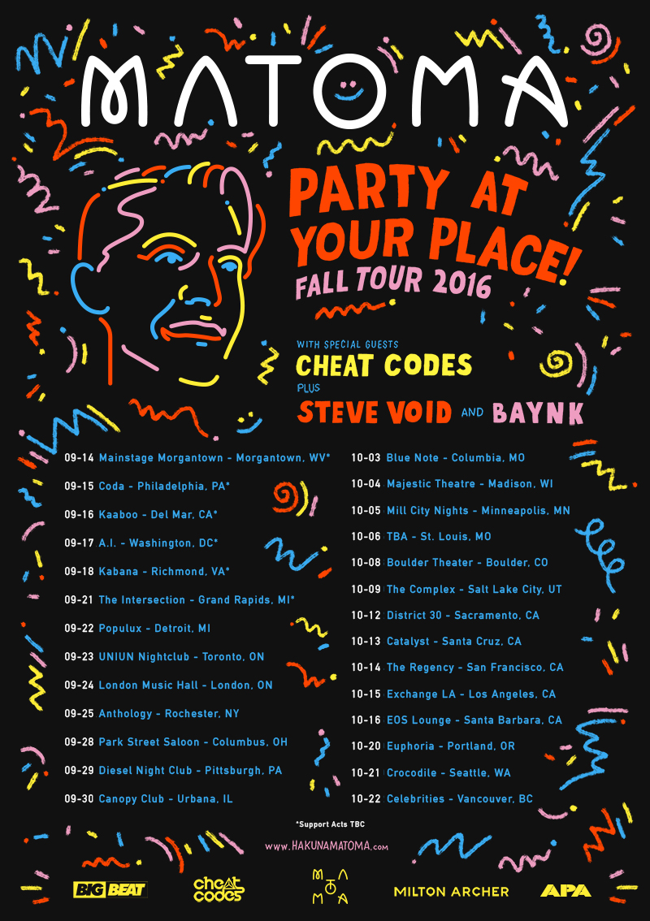
Lindsay Herr (Tour/Online): lindsay@thewanderlvst.com

