**Matoma surprises with debut album "Hakuna Matoma" and industry-changing release strategy – out now!**

**Subscribe to the album ‘Hakuna Matoma’ here-- first-of-its-kind digital format:**

[Spotify](http://smarturl.it/sHakunaMatoma) | [Apple Music](http://smarturl.it/amHakunaMatoma) | [iTunes](http://smarturl.it/iHankunaMatoma) | [SoundCloud](http://smarturl.it/scHakunaMatoma) | [YouTube](http://smarturl.it/ytHakunaMatoma)

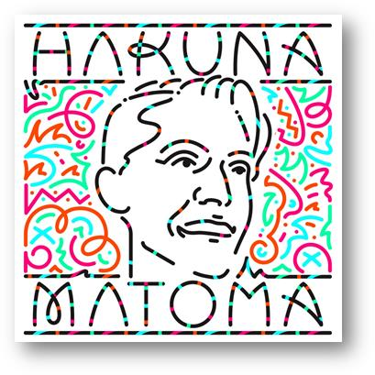

“Hakuna Matoma is very different. It's not a static album, but what Matoma and his crew call an “organic” one. It won't stand as a single work of art forever in its place, unchanging. It's more like an infinite playlist instantly accessible to fans today through Spotify and Soundcloud, and Matoma says it's better this way.” –[Billboard](http://www.billboard.com/articles/columns/pop-shop/6762292/matoma-spotify-debut-lp-listen)

As **Matoma**, 24 year old Norwegian tropical house producer **Tom Lagergren** helped define the sound of 2015 with his contributions to the musical landscape. In just one year his releases have amassed over a quarter of a billion streams, earned him an incredible and ever-growing fanbase, and cast a spotlight on what he does next. Since March’s official release of the undeniable throwback jam ***‘Old Thing Back’***, Lagergren has signed with **Parlophone**/**Big Beat Records** and has been busy touring the world while writing and producing the makings of his debut album.

That album ***‘Hakuna Matoma’*** is revealed now. The title sweetly sums up the Matoma ethos: spreading the love and good vibes. And while albums are often released in a flurry of hype only to disappear in a flash, ‘*Hakuna Matoma’* is being released in a totally unique way - using the playlist format to see the album expand and evolve over time. **Available on every download and streaming platform now***,* this first-of-its-kind format will allow the album to grow as more tracks are added. Listeners can subscribe to **‘*Hakuna Matoma’*** or the Matoma profile to hear the music and stay up to date with upcoming additions via notifications or feed updates, and be a part of his album campaign as it unfolds.

Along with the current feel-good smash **‘Feeling Right (Everything Is Nice)’** featuring **Wale** and Jamaican dancehall singer **Popcaan,** the release includes four brand new tracks, showcasing Matoma’s versatility and far outreaching the genre of ‘tropical house’ to include flavors of Caribbean, urban, dance and pop. In addition to these **five new originals**, *‘Hakuna Matoma’* will see the inclusion of some fan favorites. Along with *‘Old Thing Back’* the album also launches with ***‘Try Me’***, a collaboration with superstars **Jason Derulo** and **Jennifer Lopez**, Matoma’s gorgeous remix of compatriot **Astrid S**’ ***‘2AM’***, and his massive new re-imagination of **One Direction**’s *‘****Perfect’***. New music will constantly be added to ‘*Hakuna Matoma’* every few weeks through to early next year, making it a truly unique approach to the album cycle.

*“When I was releasing music by myself I could just put up my songs whenever I liked and engage with my fans all the time, and I think that's how I really developed my sound and made my name. When I signed with the label, I really wanted to do an album, but I didn't want to lose that vibe. ‘Hakuna Matoma’ is my living album that will continue growing as I grow with you guys. Many songs are finished, and also some of it will be written as I go, but I want my fans to come along with me on that journey because you are my inspiration and heart!”* – **Tom Lagergren** (aka Matoma)

*“Just releasing a string of singles can feel aimless. Attention is spiked and lost, and nothing really cements it all together in a meaningful way. Albums are great at that! They galvanize media and fanbase attention. They create a chapter in an artist's musical story that we all like to belong to and I believe is important. The idea of unfolding an album in playlist format is just a minor technical tweak, but allows us to release music with the best of both worlds —constant engagement with fans under a unifying campaign.”* – Matoma’s manager **Andrew Jackson**

***‘Hakuna Matoma’* is available worldwide on all platforms.**

**Subscribe to Hakuna Matoma here:**

[Spotify](http://smarturl.it/sHakunaMatoma) | [Apple Music](http://smarturl.it/amHakunaMatoma) | [iTunes](http://smarturl.it/iHankunaMatoma) | [SoundCloud](http://smarturl.it/scHakunaMatoma) | [YouTube](http://smarturl.it/ytHakunaMatoma)



For more information:

<http://matomamusic.com/>

<https://soundcloud.com/matoma-official>

<https://www.facebook.com/artistmatoma>

<https://twitter.com/MatomaOfficial>

To download press tools: <http://press.wearebigbeat.com/artists/matoma>

National requests: **Jordan Danielle Frazes** @[Jordan.Frazes@atlanticrecords.com](mailto:Jordan.Frazes@atlanticrecords.com)

Tour/Regional requests: **Lindsay Herr** @[Lindsay@thewanderlvst.com](mailto:Lindsay@thewanderlvst.com)