ANONYMOUS MASKED PRODUCER MURCI RETURNS WITH “DISCO JUICE”

FOLLOW UP TO DEBUT SINGLE “THREE SIX FIVE”

LISTEN/WATCH HERE: https://murci.lnk.to/DscoJcePR

OUT TODAY VIA PARAMETRIC RECORDS

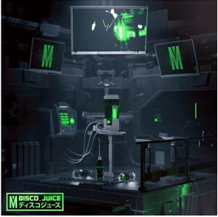
DOWNLOAD ARTWORK HERE

Following his debut single “Three Six Five” released earlier this year, Murci has returned with his latest bouncing single “Disco Juice.” Out today through Parametric Records, the tech house banger will have you yearning for the dance floor. Watch the disco juice in action in the accompanying music video HERE.

Murci crash landed on Earth with their 2019 bootleg ‘Deep Inside’ that was supported by Skrillex, Dillon Francis, Tiesto, and more. Following success in the bootleg arena, Murci released their debut single ‘Three Six Five’ with APG/Atlantic’s new dance imprint, Parametric Records. With sights now set on taking their talents to the world, Murci is set to release ‘Disco Juice’ featuring rising Australian sensation, Stace Cadet. Murci has arrived to bring you into his unique sonic space, one that is most definitely not of this world.

ABOUT PARAMETRIC RECORDS:
Parametric Records is Atlantic's newest label imprint, conceptualized as a home for groundbreaking electronic music. Parametric's releases have been played at the world's biggest dance music festivals by the world's biggest DJ's - Skrillex, Tiesto, Dillon Francis and Oliver Heldens are just a few of the many supporting the music. As a new label, Parametric is focused on taking chances and providing a platform for up and coming artists to succeed and be heard. The label's artists have garnered tens of millions of streams and gone on to play festivals like EDC, Electric Zoo and Coachella. Parametric is proud to constantly push the envelope sonically and empower the next generation of dance music superstars!

FOR MORE INFORMATION:
Paige Rosoff – Atlantic/Big Beat Records
Paige.Rosoff@atlanticrecords.com

