DUTCH DUO LUCAS & STEVE
SHARE INVIGORATING CLUB TUNE ‘I COULD BE WRONG’ WITH FAMED R&B SINGER BRANDY!

OUT TODAY ON BIG BEAT RECORDS

BRINGING BACK BRANDY’S DEBUT HIT SINGLE “I WANNA BE DOWN”

BUY/STREAM: https://BigBeat.lnk.to/ICBWPR

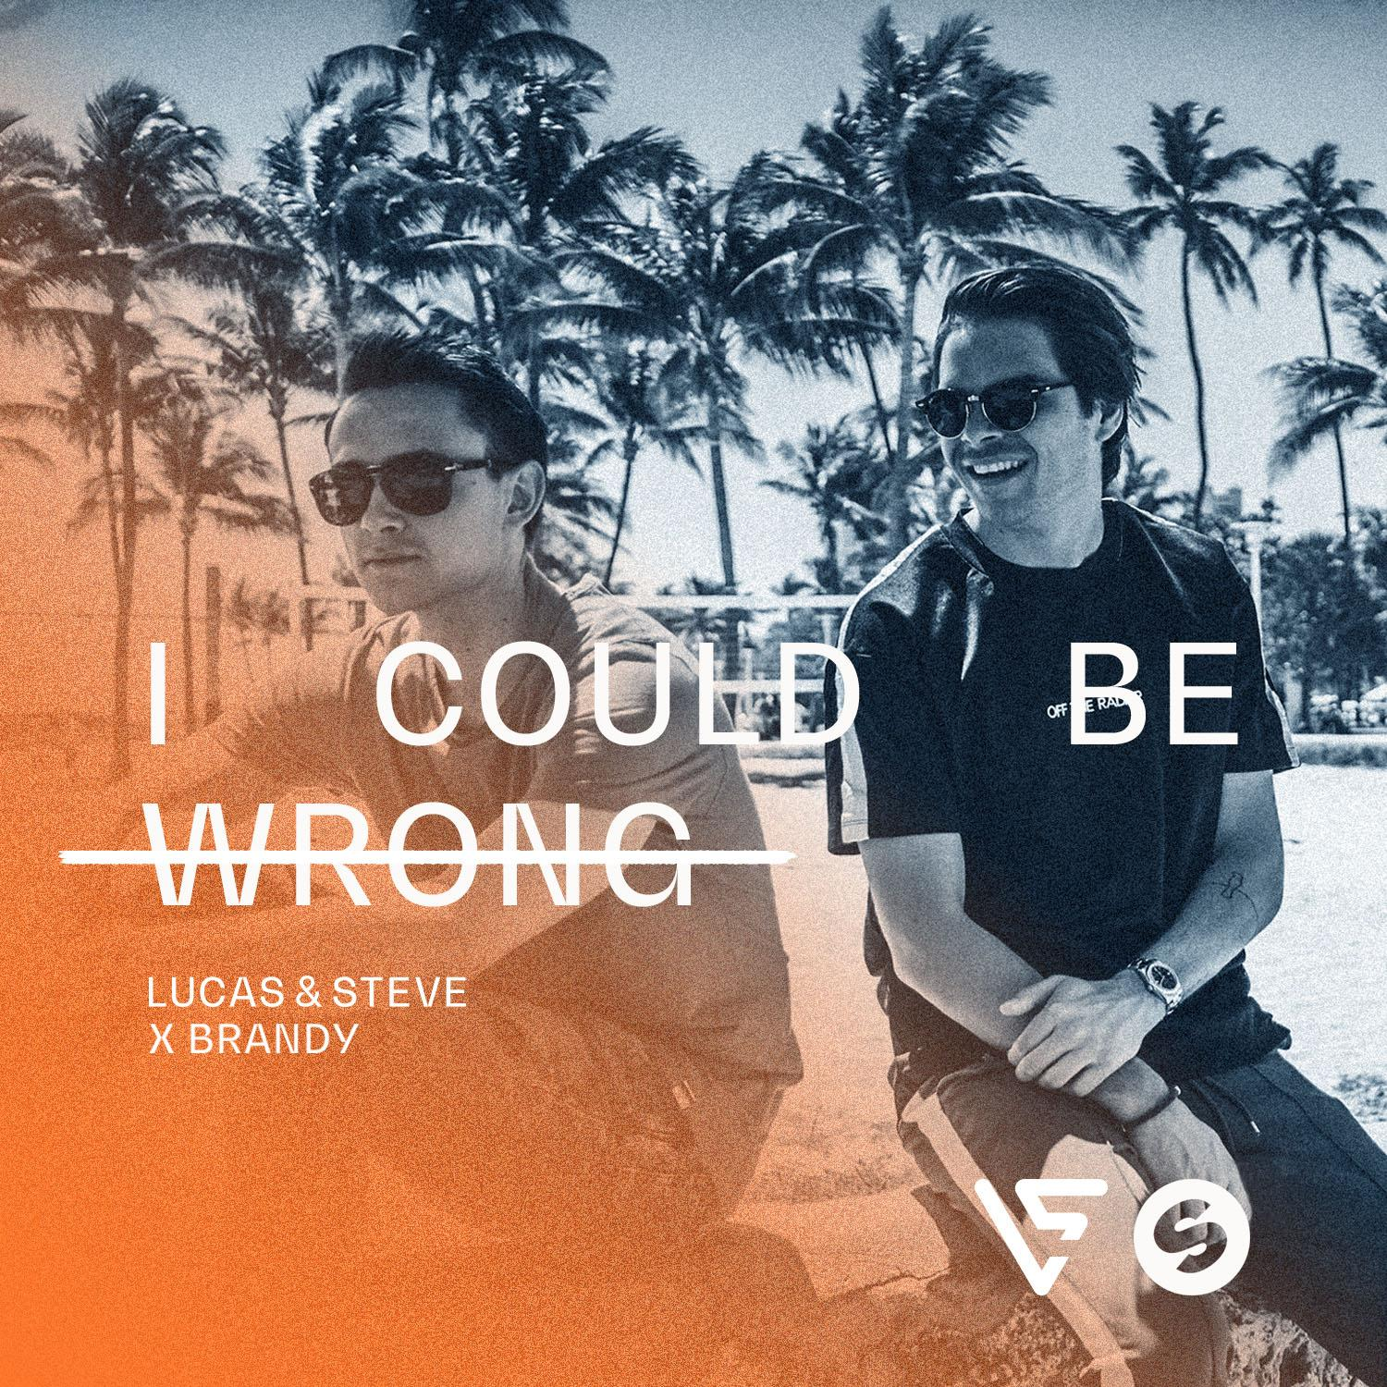

"We've been a fan of Brandy for so long! Her voice is amazing, and it already caught our attention when our parents played her songs, back in the 90's. So of course it was a huge honor for us to be asked to work on one of her records. Our goal was to create an upbeat summer track, with the positive sound people are used from us, but also perfectly fitting Brandy's unique R&B voice. We feel we nailed it, and hope 'I Could Be Wrong' will turn into a summer soundtrack for many people!" - Lucas & Steve

Dutch duo Lucas & Steve have been leaving their mark on the scene for a while already. Being responsible for quite some festival crowd pleasers the guys made it big with last year's single 'Up Till Dawn (On The Move)', turning into one of summer 2017 most favored tunes, counting over 27 million streams by now.

Meanwhile, they hit their most successful summer season ever in 2017 (including performances on Tomorrowland's mainstage, Creamfields (China), Amsterdam Music Festival, Sensation (Jakarta), Ministry Of Sound (UK) and World Club Dome (Germany) and got asked by none other than Hardwell and KSHMR to remix their recent hit record 'Power'.

Well, this season, the guys will take things up a notch! Recently, they were already shining bright during the Miami Music Week, performing to an enthused, sold out Spinnin' Hotel. Early 2018 also saw them drop their much acclaimed collab with singer-songwriter Janieck, the club favorite 'You Don't Have To Like It', as well as the feel good house track 'Source' - both receiving widespread DJ support.

And now, Lucas & Steve return for their definitive 2018 festival anthem, 'I Could Be Wrong'. For this, the guys are working with famed US singer Brandy, known from her internationally acclaimed hit singles 'The Boy Is Mine', 'Right Here' and 'Put It Down'.

As the track builds on her 1994 debut single, worldwide hit 'I Wanna Be Down' is stripped from its chilled groove, while staying true to Brandy's wonderful vocals.

This time round, the sultry R&B rhythms are reworked into a fresh 21st century dance production, featuring uplifting vibe and feelgood chords. The result is an uptempo crowdpleaser, touching on contemporary vocal house and festival vibe, made for enthused DJ support, giving the original Brandy song an unexpected twist into the new dance era.

DJ support is already widespread, ranging from enthused support by BBC's Mistajam to artists like Martin Garrix, Dimitri Vegas & Like Mike, Afrojack, Bob Sinclar, Robin Schulz, Don Diablo, Lost Frequencies, Felix Jaehn and many more.

***
Connect with LUCAS X STEVE:
Soundcloud | Facebook | Instagram | Twitter | YouTube | Spotify

For Press Assets: http://press.wearebigbeat.com/singles/i-could-be-wrong-lucas-steve-x-brandy/

For more information:
For “Lucas & Steve” press inquiries:
Lindsay Herr: Publicity, The Wanderlvst
Lindsay@thewanderlvst.com

For Big Beat Records inquiries:
Jordan Frazes: Head of Publicity, Big Beat Records
Jordan.Frazes@atlanticrecords.com

