LITTLE BIG “GO BANANAS” IN LATEST VIDEO, OUT NOW VIA BIG BEAT RECORDS
OFF THEIR EP GO BANANAS
WATCH HERE: https://youtu.be/ADlGkXAz1D0
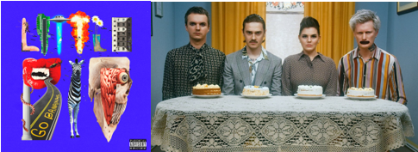
DL art here

Little Big, a Russian alt pop rave band that is taking the world by storm, have released a zany official music video for track “GO BANANAS” off their new EP with the same name. Watch the video HERE!
The “GO BANANAS” EP is an electrifying 5-track mix of rave, pop and punk. Little Big also released a video for “Rock-Paper-Scissors” off the EP in October, which reached more than 6 million YouTube views in the first week.
This fall the band brought their live show to Europe, CIS countries and Russia, spanning 53 different cities. It was the biggest tour of the band's history.
With their catchy tunes, eccentric image and quirky videos Little Big have become one of the most popular artists in Russia. The band achieved viral success in 2018 with the “Skibidi” video that sparked a dance craze all over the world and gained over 300 million views! The song was later included in the Just Dance 2020 video game.
Little Big have also recently collaborated with British trio Clean Bandit on “Arriba”, German band Eskimo Callboy and Estonian musician Tommy Cash. The group has received three Berlin Music Video Awards, Ketnet Awards (Belgium) and Global Film Festival Awards (USA).
CONNECT WITH LITTLE BIG:
Facebook YouTube Instagram Press site
Press contact: gabrielle.reese@atlanticrecords.com

