KYDUS RELEASES NEW SINGLE “AFTERMATH” OUT NOW ON BIG BEAT RECORDS!
LISTEN/SHARE: https://youtu.be/9OACLtE_0iE
STREAM/BUY: https://BigBeat.lnk.to/AftermathPR

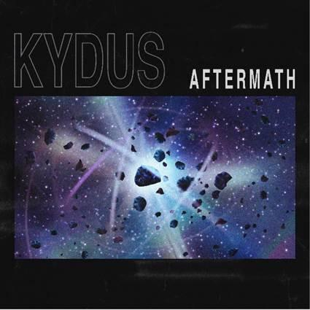
Download Artwork + Press Photos HERE

The shrewdest industry eyes are now focused upon Kydus as this modest, consistent young talent who is building his own path in dance music society. Today the up-and-coming producer unleashes his new record “Aftermath” via Big Beat Records - LISTEN HERE.

Kydus’ music makes bold moves in the tech, and progressive house world, enticing support from some of the biggest names like Eats Everything, Patrick Topping, Carl Cox, Nicole Moudaber, Luciano, Yousef, Hot Since 82, Joris Voorn, Sofi Tukker, Hardwell, Sam Feldt, and Kryder, just to name a few.

“Aftermath” is reminiscent of the classic dance music records, like those we’d hear from Above & Beyond, W&W, Deadmau5, Eric Prydz, and other electronic pioneers, who crafted melodic musical journeys with their forward thinking production palates and progressive house records.

Kydus has a true understanding of his craft, fusing his unashamedly honest experience and emotion with intricate technical studio skills and extensive djing experience. In the last 3 years Kydus has perfected his own brand of infectious, driving, flawless house and techno. Aligning a series of exciting originals and collaborations with some of the world’s most revered labels such as Toolroom, Saved, Knee Deep in Sound, Stereo & his spiritual home Circus Recordings. The last few years have seen Kydus achieve unparalleled support from industry heavyweights and noteable labels alike. Kydus makes his next impressive debut with Big Beat Records today with “Aftermath”.

Facebook I Spotify | Soundcloud | Twitter

Press tools available for download: http://press.wearebigbeat.com/singles/aftermath-kydus/

For more information:
KYDUS press inquiries:
Lindsay Herr: Publicity, The Wanderlvst
Lindsay@thewanderlvst.com

Paige Rosoff - Big Beat Records
Paige.Rosoff@atlanticrecords.com

