KRYSTAL KLEAR RETURNS WITH HIS INTERSTELLAR NU-DISCO WEAPON, THE ‘EUPHORIC DREAMS/MIYOKI’ EP

OUT TODAY ON RUNNING BACK/BIG BEAT RECORDS

LISTEN/SHARE: https://youtu.be/KDcRZJNBux0
BUY/STREAM: https://BigBeat.lnk.to/KEDMPR

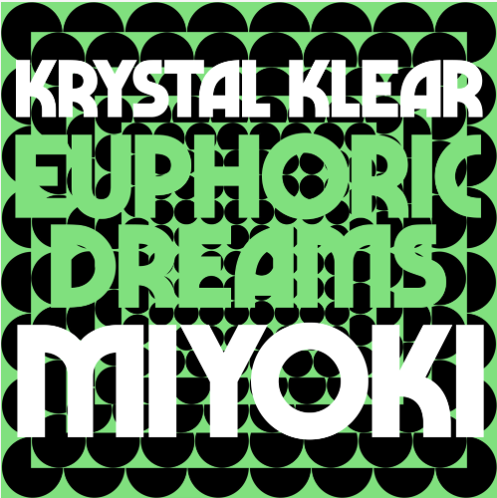
DOWNLOAD PHOTO HERE
Having cracked the DNA code of dance music with the biggest underground track last year, ‘Neutron Dance’ which amassed over 9 million worldwide streams, Irish DJ/producer Krystal Klear enters 2019 with a head start. Today Krystal Klear delivers a two-piece follow up to last year’s ‘The Division’ EP, the ‘Euphoric Dreams/Miyoki’ EP, out via Running Back/Big Beat Records. Once again, Declan Lennon showcases his knack for crafting assured dance floor weapons. Lead track ‘Euphoric Dreams’ is the musical incarnation of an Alexander Shulgin chemical formula, delivering a spine-tingling nu-disco utopia. ‘Miyoki’ lands in more sinister territories featuring a relentless bassline and deadly snare – LISTEN HERE!

Both in and out of the studio, Krystal Klear has now become one of dance music’s most recognizable names through his unmistakable hooks and infectious euphoric feels. Krystal Klear was hailed by Mixmag as a ‘Star Of The Year’, sharing top billing on clubs and festival lineups around the world, highlighted by a career defining performance at Radio’s 1 Ibiza Takeover at Café Mambo. Dominating European radio waves and streaming playlists, merits and kudos came quickly with an accolade from BBC Radio 1’s Pete Tong as ‘Essential New Tune’ along with Annie Mac’s ‘Hottest Record in the World’. Alongside this latest musical offering, 2019 will see him embark on a jam-packed touring schedule, with appearances already locked in for Hideout Festival, Primavera Sound and more.

Connect with KRYSTAL KLEAR:
Facebook | Instagram | Twitter | YouTube | Press Assets

For more information please contact Big Beat Records:

Jordan Danielle Frazes - Jordan.Frazes@atlanticrecords.com
Paige Rosoff - Paige.rosoff@atlanticrecords.com

