NORWEGIAN PRODUCTION DUO KREAM RELEASE FIRST SINGLE OF 2021, “ROADS,” FEATURING PLATINUM SINGER/SONGWRITER DAN CAPLEN

LISTEN HERE: https://KREAM.lnk.to/RoadsID

OUT TODAY VIA BIG BEAT RECORDS

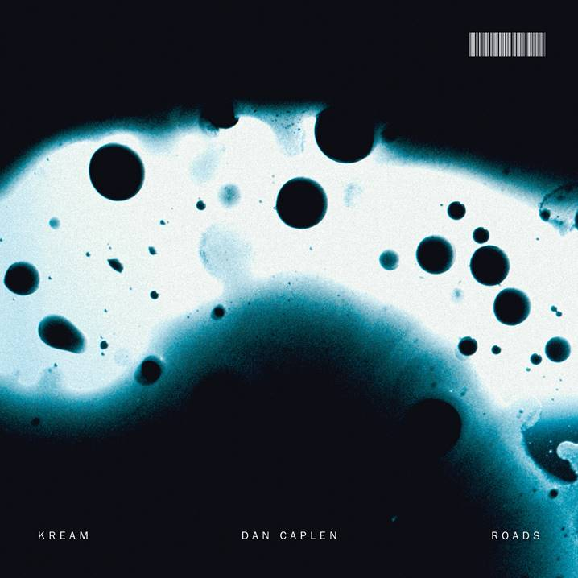
DL art here

Norwegian dance production duo KREAM steps into 2021 after a wildly productive 2020 with “Roads,” featuring powerful vocals from the UK Platinum selling singer/songwriter Dan Caplen. Listen HERE

Last month, KREAM released another live DJ set as part of their LIQUID : LAB mix series, which premiered via DJ mag. Filmed at a waterfall in Norway, the footage combines their DJ set with gorgeous drone footage of the falls and surrounding landscape. Watch HERE!

Electronic production duo KREAM, composed of brothers Daniel and Markus Slettebakken, churn out energetic dance music with an emphasis on classic songwriting and musicianship. Their use of pianos, elastic basslines and live percussion are a hallmark of their sound.

Initially discovered on SoundCloud through their remixes, the duo signed with Big Beat/Atlantic Records in 2016. Soon after, they delivered hit single "Taped Up Heart" featuring Swedish vocalist Clara Mae, which peaked at #21 on Billboard's Dance/Electronic chart and has racked up 100+ Million global streams.

The duo had a wildly productive 2020, eclipsing the 400 million career stream milestone with releases such as “L I E S” featuring DJ/producer luminary Steve Aoki, “Water,” a collaboration with Israeli experimental pop star ZOHARA, “Choices” featuring the budding DJ (and Diplo/Jessie J collaborator) Imanos, and “Jack,” featuring the American electronic duo Black Caviar.. The duo also continues to produce official remixes for major artists such as Dua Lipa, Kyle & Kehlani, Tove Lo, Anne Marie, Bazzi, Zara Larsson, Matoma, and Jess Glynne.

On the live front, 2019 saw KREAM embark on their first US tour with Lost Kings, accompany Matoma on a Europe tour, and play Electric Zoo’s mainstage. In 2020, the duo virtually opened for EDM titan Tiesto’s Red Rocks livestream concert.

Singer, songwriter and multi-instrumentalist Dan Caplen is an artist with an already enviable CV. Best known for his writing and performance on the triple platinum, Ivor Novello winning and Brit nominated single ‘These Days’, with Rudimental, which to date has racked up a staggering 825 million streams on Spotify. In addition to this, the past 2 years have seen him feature on tracks with Macklemore, Seeb and Lily Moore and well as co-writing ‘One Second’ on Stormzy’s No. One album ‘Heavy Is The Head’ and the most recent chart hit ‘Paradise’ by Meduza featuring Dermot Kennedy. Currently Dan is working towards the release of his next EP, due Sept 2021.

With KREAM’s glowing press coverage from outlets such as Billboard, Dancing Astronaut, DJ Times, EDM Sauce, and YourEDM, their sterling hit-making track record and prolific rate at which they work, it’s safe to say that it won’t be long before we hear more from the magnetic duo.

CONNECT WITH KREAM:
Instagram | Facebook | Twitter | Spotify

PRESS ASSETS: https://press.wearebigbeat.com/artists/kream/

FOR MORE INFORMATION:
Paige.Rosoff@atlanticrecords.com
Big Beat Records | Atlantic Records

