KREAM SHARE NEW SINGLE “GO SOMEWHERE” WITH RANI + STEP OUT OF SHADOWS BY APPEARING IN MUSIC VIDEO

LISTEN HERE: https://BigBeat.lnk.to/gosomewherePR

OUT TODAY VIA BIG BEAT RECORDS!

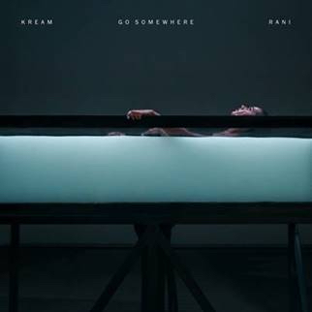
DOWNLOAD ARTWORK HERE

The chart-topping Norwegian duo KREAM has been on a roll so far in 2019 and is showing no sign of slowing down anytime soon. Today, the pop-leaning duo comprised of brothers Daniel and Markus Slettebakken are releasing a compelling new single called “Go Somewhere” with the rising UK-based R&B singer-songwriter RANI. “Go Somewhere” is out now through Big Beat Records along with its official music video, which marks KREAM’s debut appearance in a proper music video! The video features a flawless RANI being brought to life as she sings the melody and KREAM play out the music. They do so in seemingly comfortable fashion, performing live on a soundstage with their gorgeous custom studio arsenal in tow. LISTEN/WATCH HERE!

“Go Somewhere” was co-written by UK singer-songwriter Karen Harding who’s best known for her single “Say Something” that was a UK Top 10 single and is also known for her high-profile collabs with Blonde, Le Youth, Giorgio Moroder, Alex Newell, Felix Jaehn, and directed by Michael Baldwin (NOTD, The Vamps, Olly Murs). Vocalist RANI was recently featured on Sam Feldt’s latest single “Post Malone” that’s garnered over 50M streams, is currently in Spotify’s biggest playlist Today’s Top Hits, and is now being worked at US Pop radio.

“Go Somewhere” follows KREAM’s collaboration with Eden Prince “Ain’t Thinkin Bout You (feat. Louisa),” which is currently #12 at US Dance Radio and streaming in Spotify & Amazon’s biggest dance playlists, mint and Nectar. KREAM also just cut a stripped-down acoustic version of “Ain’t Thinkin Bout You” that was filmed in London with all artists – WATCH HERE! The single has received strong support/feedback from BBC Radio 1’s Friday and Saturday Dance Anthems show, MistaJam, KISS Fresh, Madison Mars, Vice, Hardwell, The Magician, CID, Sagan, Joe Maz, Just Kiddin, and more.

KREAM’s FIRST US FESTIVAL PERFORMANCE will be Main Stage @ NYC’s Electric Zoo on August 31st!

CONNECT WITH KREAM:
Soundcloud | Facebook | Instagram | Twitter | YouTube | Spotify

KREAM PRESS ASSETS: https://press.wearebigbeat.com/

FOR MORE INFORMATION:
Paige Rosoff – Big Beat Records
Paige.Rosoff@atlanticrecords.com

