JOEL CORRY & JAX JONES JOIN FORCES
WITH CHARLI XCX & SAWEETIE
ON NEW SINGLE ‘OUT OUT’

JOEL’S FIRST EVER US TOUR KICKS OFF IN SEPT

LISTEN HERE

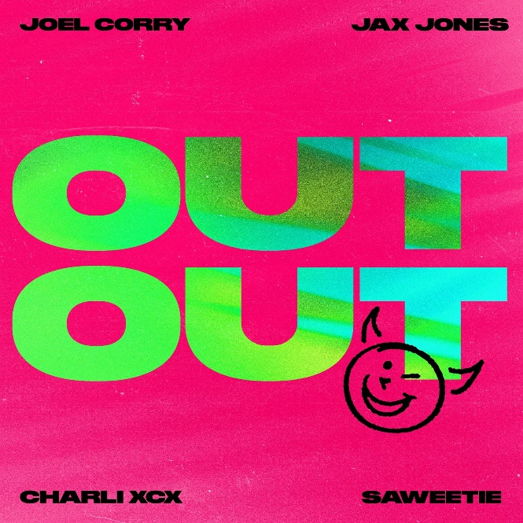
Joel Corry and Jax Jones are back with powerhouse new single ‘OUT OUT’, featuring inimitable pop trailblazer, Charli XCX, and breakout Cali rapper, Saweetie – listen HERE.
As two of the UK’s leading dance producers of the last two years – Joel boasted 2020’s longest-running consecutive UK #1 with ‘Head & Heart’ ft. MNEK and Jax’s debut album ‘Snacks’ was the UK’s best selling dance record of 2019 – the pair have been instrumental in shaping the UK’s contemporary electronic landscape, and show no signs of letting up on ‘OUT OUT’.
Lifting a sample from Stromae’s late ‘00s dance classic ‘Alors On Danse’ and re-booting it fresh for 2021, ‘OUT OUT’ is party music at its very best; fun, carefree and totally addictive. Complete with iconic guest features from none other than Charli XCX and Saweetie – who was recently nominated for Top Rap Female Artist at the 2021 Billboard Music Awards alongside Cardi B and Megan Thee Stallion – ‘OUT OUT’ feels every bit a 24-carat summer anthem in waiting.
“I’m buzzing to collaborate with my bro Jax Jones and the amazing Charli XCX and Saweetie”, says Joel Corry. “I’m a huge fan of Stromae’s classic ‘Alors On Danse’ and wanted to put a fun spin on it for summer 2021. Now we can party again, I want everyone to let their hair down and go OUT OUT!”
“I met Joel a few years ago and love his energy, focus and ambition, so a collaboration felt natural”, says Jax Jones. “OUT OUT feels like a proper party starter and is the perfect blend of our different sounds. I’m a big fan of Charli and Saweetie, having them on the song makes it feel like a moment with real synergy – at just the right time. I can’t wait to see this record drop and watch the reaction on the dance floor.”

Joel’s first ever American tour begins September 17th in Los Angeles and ends October 3rd in Las Vegas. Tickets and more info HERE
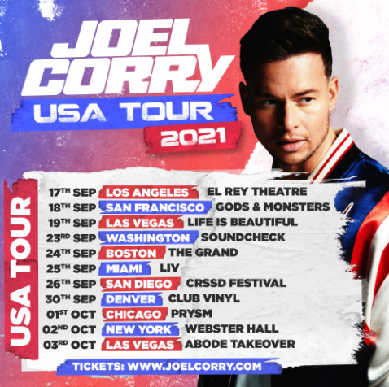
About Joel Corry
Multi-BRIT Award nominated DJ/producer Joel Corry has become one of the UK’s most prolific dance hit-makers since first breaking through with 2019’s ‘Sorry’ – a thumping re-work of Monsta Boy’s UKG classic of the same name that spent 10 weeks in the UK Top 10, peaking at #6, and broke Shazam’s all-time daily record in the UK after receiving over 41,000 tags in one 24-hour period. He has since released three consecutive UK Top 5 records including ‘Lonely’ (#4), latest single ‘BED’ with David Guetta & RAYE (#3) and 2020’s multi-platinum ‘Head & Heart’ ft. MNEK – the year’s longest-running consecutive UK #1 single, and the first of Joel’s career.

About Jax Jones
Ivor Novello, Grammy and BRIT-nominated DJ, producer and multi-instrumentalist Jax Jones has racked up over three million single sales and 4 billion streams during his career so far. Working with the likes of Mabel, Years and Years, Martin Solveig, RAYE, Stefflon Don, MNEK and Madison Beer, his last record ‘Snacks’ was named the best selling dance album of 2019 in the UK. Jax has since become a mainstay in modern British music and he continues to create genre-defying music for both the charts and the specialist dance world.

About Charli XCX
Charli XCX is an iconic figure in the arts, having helped expand the landscape of popular music over the last decade by seamlessly traversing the underground and the mainstream with her artistic output. Charli’s innovative approach has opened up new possibilities within the pop sphere for both her own career and those of the rising artists she has supported over the years. She recently won the Variety Hitmakers award for ‘Innovator of Pop’ and was Mercury Prize ‘Album of the Year’ shortlisted for the release of her album, ‘how I’m feeling now’, which she created from scratch in five weeks from her home in Los Angeles during the 2020 COVID-19 lockdown. Charli XCX will release her new single ‘Good Ones’ on September 3rd, the first single from her fifth studio album which will release early 2022.

About Saweetie
Flaunting nineties rhyme reverence, fashion-forward fire, and endless charisma, Saweetie —born Diamonté Harper — can go bar-for-bar with the best of ‘em. Drawing on a passion for poetry and numerous years of rapping in the car, she turned her love for words into vivid verses during 2018 on the High Maintenance EP with her smash hit ‘ICY GRL’ earning her first RIAA platinum certification in the US. 2019 saw the release of Saweetie's ICY EP, spawning double-platinum viral sensation ‘My Type’, as well as a 2020 BET Awards nomination for ‘Best Female Hip Hop Artist’ and a 2021 Billboard Music Awards nomination for ‘Top Rap Female Artist’. As a businesswoman, she has launched her sold-out ICY jewelry line and partnered with PrettyLittleThing for a 50-piece capsule collection and as an artist, has also been enlisted by everyone from Gwen Stefani to David Guetta, Dua Lipa to Wiz Khalifa, and Mulatto to G-Eazy for guest features.

CONNECT WITH JOEL CORRY:
FB / TWITTER / INSTAGRAM / YOUTUBE / WEBSITE

CONNECT WITH JAX JONES:
FB / TWITTER / INSTAGRAM / YOUTUBE / WEBSITE

CONNECT WITH CHARLI XCX:
FB / TWITTER / INSTAGRAM / YOUTUBE

CONNECT WITH SAWEETIE:
FB / TWITTER / INSTAGRAM / YOUTUBE

US press contact: gabrielle.reese@atlanticrecords.com

