HERCULES & LOVE AFFAIR RELEASE NEW SINGLE “REJOICE” OFF FORTHCOMING ALBUM OMNION!

LISTEN/POST: HERE
BUY/STREAM: HERE

“It’s at once exultant and ominous, a thumping industrial-tinged gospel-dance banger.”
– Stereogum

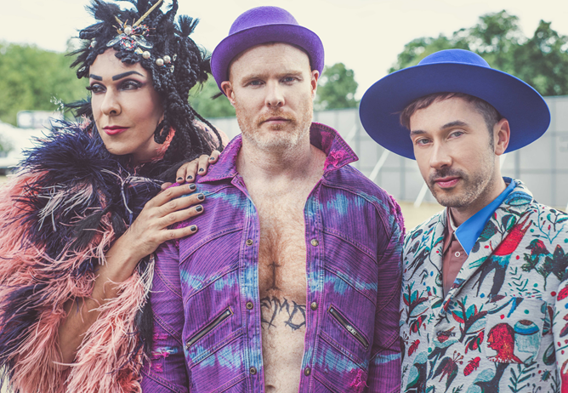

With forthcoming album Omnion garnering widespread critical acclaim and two singles playlisted at 6music, Hercules & Love Affair today reveal new single and disco stomper “Rejoice,” premiered yesterday via Stereogum.

“Rejoice” does exactly that. Taking things back to the dancefloor, this celebratory song marks four years of sobriety for Butler after years of serious drug addiction. Hercules regular Rouge Mary “a gender non-conformist” of Algerian heritage takes on vocals – a fitting choice given Rouge once found shelter in a church, finding his/her musical voice there, and given how, after Andy’s life was shattered by drugs, Rouge played a key role in helping him rebuild his life.

Rouge Mary explains - “The lyrics to ‘Rejoice’ were written in a day. It's so obvious when you look around, that we all have so many reasons to be sad and we are so used to complaining about sticky situations. So much that we forget the ancient secret. ‘Rejoice’ highlights the importance of gratitude and the power of positive thoughts. ‘Smile though your heart is aching,’ Charlie Chaplin once said. I interpret it in a very powerful way, to symbolize the urgency of the message. I feel this song is like a solution to face problems of all kind. It truly is an ode to positivity.”

Butler echoes much of the same sentiment: "As with this entire record, ‘Rejoice’ was born out of taking detours from a traditional ‘vocal house’ record. I picked up the tempo and stumbled onto a bass line that evoked my fave early industrial tracks from Front 242 or Cabaret Voltaire. The stomp is one of exuberance, and was begging for ‘vamping’ or ‘riffing’ from a singer – something Rouge Mary is so great at. The exuberance just pointed me to the word ‘Rejoice,’ so I asked her to bring that message to the song. It's a message she brings every day to her life, so it was exciting to watch her once again share ‘the keys to the kingdom!’”

Helping Butler interpret Omnion’s message of faith and tolerance on H&LA’s fourth studio album are a world class act of singers including The Horrors’ Faris Badwan, Lebanese rockers Mashrou’ Leila, New York singer-songwriter Sharon Van Etten on single and title track “Omnion,” and Icelandic sister act Sísý Ey, alongside regular collaborators Rouge Mary and Gustaph.

Born in Denver and cutting his teeth as a teenage DJ, Butler escaped to New York and invented Hercules & Love Affair as an outlet for his songs. From the retro-futurist Paradise Garage grooves of Hercules & Love Affair’s eponymous 2008 debut – with longtime friend ANOHNI on the classic, “Blind” – via the thoughtful elegiac songwriting of 2011’s Blue Songs, to the bumping, grittier pulse of 2014’s The Feast of the Broken Heart, Butler has nailed a body of work that bridges the dance floor and home listening.

Omnion moves his game up a notch and reflects his current “hypersensitivity” to all that is going on. “Sometimes the dance floor represents a decision to avoid dialogue with the wider world, to commune with people but not really talk,” Butler explains. “But humans need to challenge themselves and step it up. Not that everything has to be so serious but this Hercules record is.”

Set to be released on September 1st, Omnion is picking up plaudits across music, dance, and gay press – including being named “Album Of The Month” by DJ Mag and Gay Times – and garnering strong support at radio, including BBC 6music playlisting, and a live session on Lauren Laverne’s show.

Summer shows:

AUGUST:
25th - Rock en Seine, Paris (France)
27th - Stephenson Works, Newcastle (UK)

SEPTEMBER:
1st - Into the Great Wide Open, Vlieland (Netherlands)
9th - Festival No. 6, Portmeirion (Wales)
16th - Kutxa Kultur Festival, San Sebastian (Spain)

OCTOBER:
19th - ADE at Paradiso, Amsterdam (Netherlands)

Omnion European Tour:

NOVEMBER:
10th - Metropop Festival, Lausanne, Switzerland
15th - Sala But, MADRID, Spain
16th - Sala Apolo, Barcelona, Spain
17th - Lux Fragil, Lisbon, Portugal
25th - Smolna, Warsaw, Poland
30th - Kesslehaus, Berlin, Germany

DECEMBER:
1st - Trix, Antwerp, Belgium
6th - Santeria, Milan, Italy
7th - Locomotiv, Bologna, Italy
8th - Shepherds Bush Empire, London

CONNECT:
http://herculesandloveaffair.net/
https://www.facebook.com/herculesandloveaffair/
https://twitter.com/HerculesLA
https://www.youtube.com/user/HerculesALA
https://www.instagram.com/herculesandloveaffair/
Download assets: http://press.wearebigbeat.com/artists/herculesandloveaffair/

PRESS CONTACT:
Jordan Danielle Frazes
Head of Publicity, Big Beat Records
Jordan.Frazes@atlanticrecords.com

