HERCULES & LOVE AFFAIR RELEASE MUCH-ANTICIPATED NEW ALBUM OMNION – OUT TODAY!

WATCH/POST: HERE
BUY/STREAM: HERE

“Omnion continues tipping the scales in modernity's favor and disorienting the script… Contrast these progressive notes with Butler's ongoing desire to communicate through beat-wise pop songs, interpreted by nuanced, boldface voices.”
– NPR (FIRST LISTEN)

“…a broader, gentler and more thoughtful side to Hercules & Love Affair… Still present, however, are some of those catchy, deviant-disco grooves that Butler crafts so well”
– DJ MAG (ALBUM OF THE MONTH)

“Omnion is a serious, grown up dance record for serious times. Let’s dance”
– MIX MAG 8/10

“This whole album has an absolute fucking snap to it. Butler has always combined his all-out bangers with gooier, more introspective tracks… But on Omnion, even the more expansive tracks still have a bounce to them”
– STEREOGUM (ALBUM OF THE WEEK)

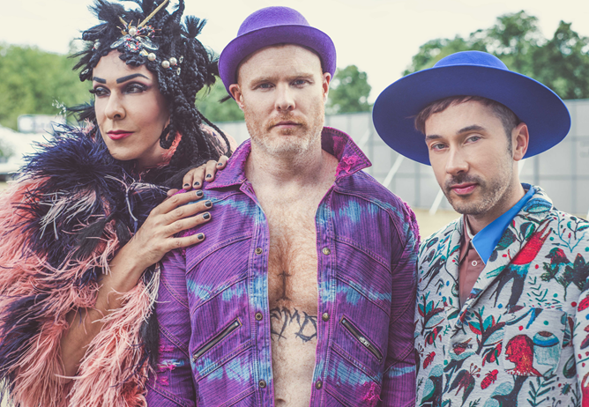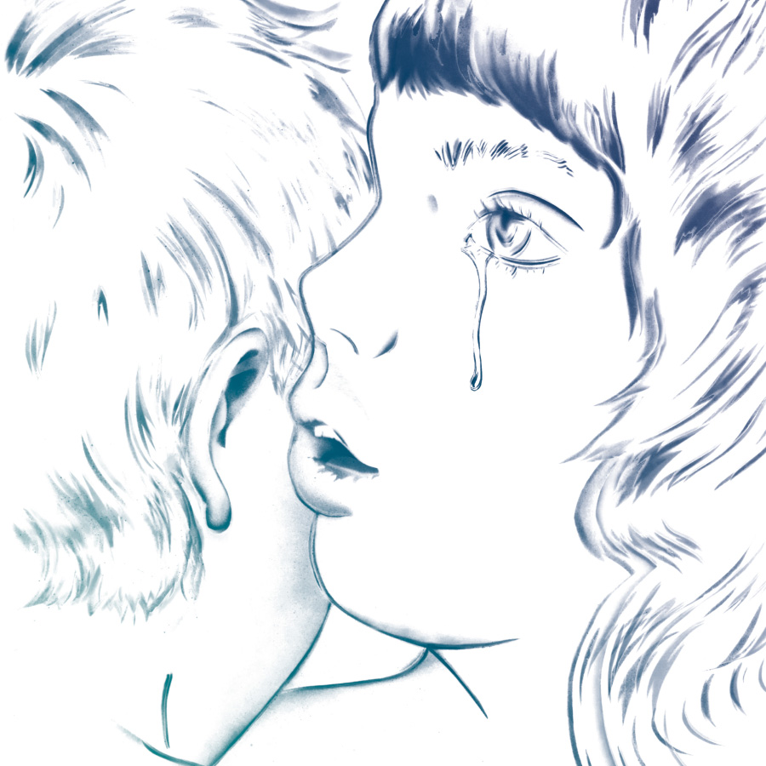

The recipients of widespread critical acclaim, including two playlisted singles at BBC 6music, DJ Mag’s Album of the Month, and the coveted “Album Of The Month” slot at Rough Trade, Hercules & Love Affair release their fourth studio album Omnion today – out via Big Beat Records (LISTEN HERE).

Renowned for their exuberant stage show and Andy Butler's knack for elegant and timely productions, Hercules & Love Affair have - unconsciously - hit the zeitgeist with their latest album - eleven songs sparkling with faith and tolerance in response to our troubling times.

“Sometimes songs are born out of an intense moment that has nothing to do with club music,” explains Hercules main man Andy Butler. “…I’m not just a ‘head’ (read techno-head, house-head, disco-head)….I’m touched just as much by, say, Sinead O’Connor accompanied only by a guitar, singing an intensely spirited message.”

Singles to date – “Controller” feat. The Horrors’ Faris Badwan, title track “Omnion” feat. Sharon Van Etten, and the latest “Rejoice” with HALA regular Rouge Mary on vocals – show that whilst it is rooted in Butler’s recovery from drug addiction, Omnion is an album of both reflective moments and joyful celebration.

In addition to Badwan and Van Etten, Butler is joined on Omnion by Lebanese rockers Mashrou’ Leila and Icelandic sister act Sísý Ey, as well as regular collaborators Rouge Mary and Gustaph.

From the retro-futurist Paradise Garage grooves of Hercules & Love Affair’s eponymous 2008 debut – with longtime friend ANOHNI on the classic, “Blind” – via the thoughtful elegiac songwriting of 2011’s Blue Songs, to the bumping, grittier pulse of 2014’s The Feast of the Broken Heart, Butler has nailed a body of work that bridges the dance floor and home listening.

Omnion moves his game up a notch and reflects his current “hypersensitivity” to all that is going on. “Sometimes the dance floor represents a decision to avoid dialogue with the wider world, to commune with people but not really talk,” Butler explains. “But humans need to challenge themselves and step it up. Not that everything has to be so serious but this Hercules record is.”

Following festival appearances this summer, Hercules & Love Affair bring their visually spectacular stage show – “A Feast for the Eyes” Creative Review – to venues across Europe this fall. Tickets are available now HERE.

Summer shows:

SEPTEMBER:
1st - Into the Great Wide Open, Vlieland (Netherlands)
7 th - Rough Trade East (UK)
9th - Festival No. 6, Portmeirion (Wales)
16th - Kutxa Kultur Festival, San Sebastian (Spain)

OCTOBER:
19th - ADE at Paradiso, Amsterdam (Netherlands)

Omnion European Tour:

NOVEMBER:
10th - Metropop Festival, Lausanne, Switzerland
15th - Sala But, MADRID, Spain
16th - Sala Apolo, Barcelona, Spain
17th - Lux Fragil, Lisbon, Portugal
25th - Smolna, Warsaw, Poland
30th - Kesslehaus, Berlin, Germany

DECEMBER:
1st - Trix, Antwerp, Belgium
6th - Santeria, Milan, Italy
7th - Locomotiv, Bologna, Italy
8th - Shepherds Bush Empire, London

CONNECT:
http://herculesandloveaffair.net/
https://www.facebook.com/herculesandloveaffair/
https://twitter.com/HerculesLA
https://www.youtube.com/user/HerculesALA
https://www.instagram.com/herculesandloveaffair/
Download assets: http://press.wearebigbeat.com/artists/herculesandloveaffair/

PRESS CONTACT:
Jordan Danielle Frazes
Head of Publicity, Big Beat Records
Jordan.Frazes@atlanticrecords.com

