HERCULES & LOVE AFFAIR RETURNS WITH NEW SINGLE “CONTROLLER” FEATURING FARIS BADWAN!

LISTEN/POST: https://soundcloud.com/hercules-and-love-affair/controller-faris-badwan/s-rrRoY
STREAM/BUY: https://BigBeat.lnk.to/controllerPR

“Hercules & Love Affair last released an album in 2014, with the emotional The Feast of the Broken Heart. Today, the project has returned with The Horrors's singer Faris Badwan for the steamy ‘Controller.’” – The FADER

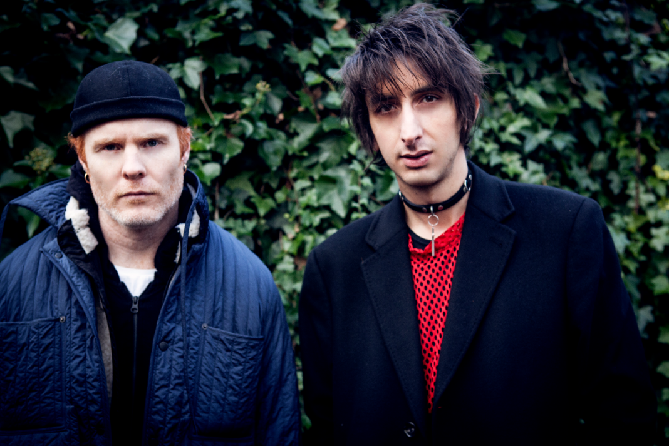
Photo credit: William Worrell | Download HiRes HERE.

Hercules & Love Affair return to the fray with “Controller”, a pulsing, propulsive new song that signals the first salvo from their long-awaited new album. Featuring The Horrors’ Faris Badwan on vocals, it takes the Hercules’ disco-house heritage and fuses it with starker post-punk stylings.

“Recently I’ve been aesthetically interested in the raw experimentation of early 80s electronic dance outside the glossier new wave pop music we know from the time,” admits head honcho Andy Butler, “Cabaret Voltaire, lots of noisier older music. It's funny that I ended up in Belgium, considering all of the music that came from here – Front 242, Telex, and so on.”

“When I became aware of music, aged around 12, I was listening to the Jesus & Mary Chain, Cocteau Twins, Ministry, “ he recalls, “That was my formative music, the college album charts, what became alt-rock. I found I could relate to this outsider music, stuff that wasn’t pop- I already had a love for Yazoo and Depeche Mode which got me into synthesizers. It was a rebellious, angst-ridden period and I was an industrial goth kid, stockings and make-up, which then dovetailed into the whole grindcore extreme stuff. But at 15 I heard LFO’s ‘Frequencies’ and was like whoa-- I walked away from vocal music initially, walked away from that aggression towards psychedelic utopia and acid house…”

With ‘Controller’ he’s reconnected. He knew he wanted a male voice for the song "a vocalist who flirted with the darkness, someone who had a touch of an Ian Astbury or Andrew Eldritch about them, or even of Ian Curtis.”

In London, working with fashion designer James Long, Andy came across The Horrors’ live version of Frankie Knuckles & Jamie Principle’s seminal Chicago house cut ‘Your Love’. He realized he’d found his voice, a rock artist willing to engage with dance culture's history.

“Controller” is the result, a contagious song containing a hint of seamy ‘80s electro-pop underbelly, but also recalling edgy early house records by the likes of Lil Louis and Bam Bam. And then there’s the whole sub-dom, master-and-servant thing going on in the lyrics…

“That’s a fair assessment,” Andy laughs, “but actually the new album is a lot about spirituality. Faris was happy to engage with that. He went into the recording booth, would come out with something, and I’d say, “Did you just sing, ‘I love what you’re making me do’?” He’d say, “No, but that sounds cool.” That’s how the song was made, it unfolded out of an unconscious process. It’s about being used by a higher entity but there’s this second layer which is a play on intense sub-dom sexual roleplay!”

As raunchy and contentious as it is catchy, ‘Controller’ is the first single from Hercules’s fourth album on which they consolidate this sonic palette yet further, while never losing sight of their following on the dance floor. Details to be announced soon…..

Connect with Hercules & Love Affair:
http://herculesandloveaffair.net/
https://www.facebook.com/herculesandloveaffair/
https://twitter.com/HerculesLA
https://www.youtube.com/user/HerculesALA
https://www.instagram.com/herculesandloveaffair/
Download assets: http://press.wearebigbeat.com/artists/herculesandloveaffair/

Press Contact:
Jordan Danielle Frazes
Head of Publicity, Big Beat Records
Jordan.Frazes@atlanticrecords.com

