GOLDEN FEATURES SHARES NEW SINGLE "WORSHIP"

AHEAD OF NATIONAL TOUR & DEBUT ALBUM

+ REVEALS TRACKLIST

SECT OUT JULY 27

LISTEN/POST/BUY/STREAM: https://BigBeat.lnk.to/WorshipPR
PREORDER SECT: https://wma.lnk.to/sectPR

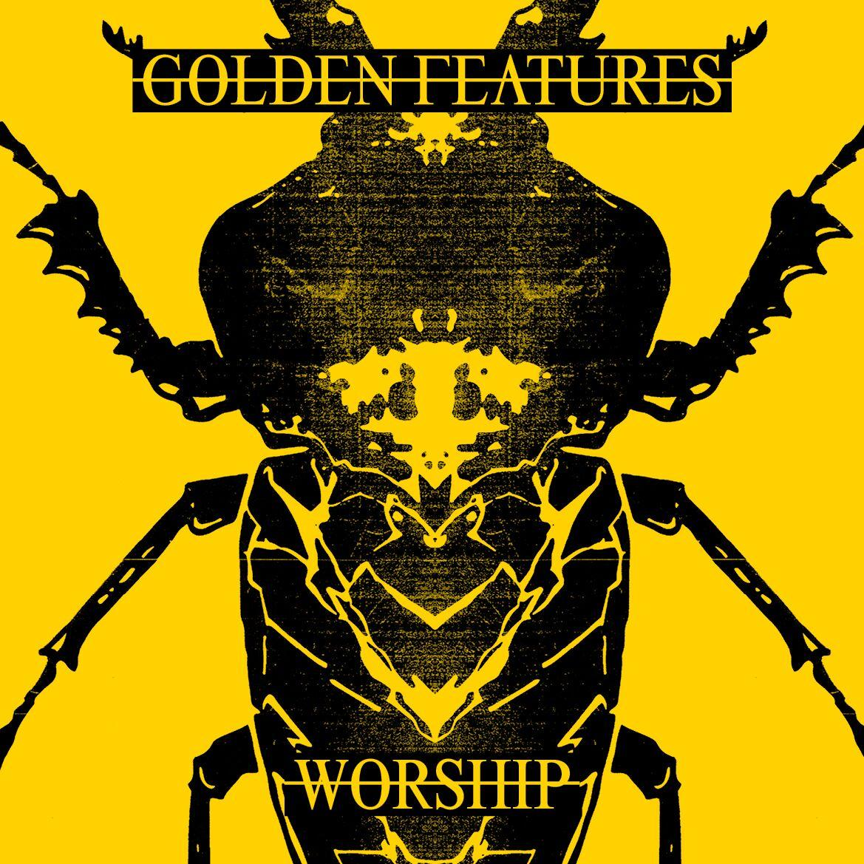

Wildly acclaimed Sydney producer Golden Features aka Tom Stell, gifts fans with an intoxicating new single "Worship", ahead of his forthcoming album SECT out July 27 via Warner Music Australia/Big Beat Records, and upcoming national tour to sold out crowds. In addition, Stell today also reveals the SECT track list.

Rich with glorious sonic depth, “Worship” provides an alluring taste of what’s to come from Golden Features' forthcoming record, SECT. A momentum driven by thumping beats and spine-tingling synths soon explodes into the mesmeric vocals of a luscious dark techno chorus, unleashed via a return of the heart pounding drop and signature bass fans have been craving.

"Worship is a song about what feelings of isolation can drive us to,” says Tom Stell.

Echoing the body-encompassing production behind Stell’s earlier classics, “Worship” offers a fitting follow up to his latest triumph “Falling Out”, which was swiftly added to triple j and has seen over 1.7 million streams. The single and its dynamic video marked the illustrious producer’s first release since 2016 in anticipation for his debut album, SECT. A full-length result of tireless hours spent in the studio refining his sound, the ten-track project is a creative journey and defining statement from Golden Features that fans will soon hear.

"Worship" arrives ahead of Golden Features' long awaited Australian tour, which features support from electronic powerhouses Big Wild and Nyxen and a sold-out show in Melbourne. Stell will traverse the nation from August 11 with a performance in his hometown at Sydney's Hordern Pavilion. He next visits Brisbane’s Eatons Hill on August 15, before crossing coast lines for Perth’s HBF Stadium on August 17. The following weekend, he’ll play to Adelaide’s Thebarton Theatre on August 24, before closing out an epic run with a sold-out show at Melbourne’s The Forum on August 25 and a second date added on August 26.

Following the success of Golden Features’ self-titled debut EP in 2014, follow-up XXIV EP in 2015 and the atmospheric and infectious double a-side in 2016, Stell has risen to the top of Australia’s electronic music scene and become one of our most innovative producers. In the live arena, after selling out his Australian headline tour in 2015 and playing to leading US festivals like HARD Summer and Holy Ship, alongside joining Alison Wonderland on her US tour - Golden Features made groundbreaking festival appearances at Splendour in the Grass in 2017 and Field Day earlier this year.

Having already cemented his reputation for delivering a magnified audio-visual experience of his all encompassing productions, and with a debut album on the way - Golden Features next prepares to play his biggest shows to date this August, pushing his creative vision one step further. Be sure to catch the latest jaw-dropping single from one of Australia’s brightest artists, out now.

GOLDEN FEATURES
WEBSITE I SOUNDCLOUD I FACEBOOK I TWITTER | INSTAGRAM | YOUTUBE | PRESS SITE

SECT Tracklist

1. Always
2. Medicate
3. Runner
4. Falling Out
5. Woodcut
6. Pyre
7. Renewal
8. Worship
9. Everything
10. 1991

Press assets: http://press.wearebigbeat.com/singles/worship-golden-features/

For press inquiries:
Jordan Danielle Frazes
Head of Publicity, Big Beat Records
Jordan.Frazes@atlanticrecords.com

Lindsay Herr
Lindsay@thewanderlvst.com

