FOR IMMEDIATE RELEASE
APRIL 24, 2020

Galantis & Wrabel release “The Lake”

reflective new single arrives today via Big Beat Records

Internationally acclaimed duo’s third album Church available now

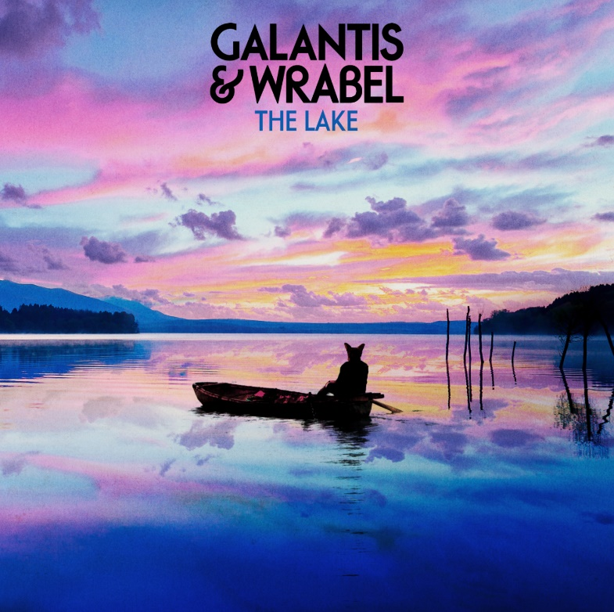
DOWNLOAD HIGH-RES IMAGES/ARTWORK

STREAM “THE LAKE”: https://galantis.lnk.to/TheLakePR

Internationally-acclaimed duo Galantis have teamed up with singer-songwriter Wrabel for an introspective new collaborative single, “The Lake” – available now via Big Beat Records. A musical departure that showcases a new side of Galantis, the track pairs earnest harmonies with nostalgia-tinged lyrics that strive to provide a sonic escape.

“During this time of social distancing, we’re trying to keep creative and find inspiration for new music. ‘The Lake’ is a bit different than our usual Galantis songs. We wrote it with our friend Wrabel as a reflection of what we’re all experiencing around the world right now. As we are all seeking peace of mind and hoping for a better tomorrow, we hope everyone out there can find a ‘lake’ of their own. Stay safe.”
– GALANTIS

“‘The Lake’ is about an escape. From a day or from a feeling. Remembering there’s always somewhere to go, to pause and to reflect, even if it’s a lake in our mind.”
– WRABEL

Galantis released their highly anticipated third studio album Church earlier this year, taking listeners on a euphoric sonic journey. The duo’s first new album in three years, the 14-track collection features Galantis’ explosive single “Faith” with country music icon Dolly Parton featuring Dutch singer-songwriter Mr. Probz. Praised as “a life-affirming dancefloor jam” by Entertainment Weekly upon release, “Faith” saw a #1 debut on Billboard’s Dance/Electronic Chart before quickly reaching #1 on the Dance/Mix Show Airplay Chart where it remained for 5 weeks – in tandem with an outpouring of support from Rolling Stone, Good Morning America, Entertainment Tonight, NPR, Huffington Post & more. The track listing also includes the duo’s blockbuster collaborations with OneRepublic (“Bones”), Passion Pit (“I Found U”) and Yellow Claw (“We Can Get High”), among new standout tracks “Never Felt A Love Like This” with Hook N Sling featuring Dotan and “Hurricane” with John Newman.

In February, Galantis teamed up with WaveXR for a live virtual concert that was shared globally via YouTube. A stunning VR experience, the show transformed the duo into real-time custom avatars while fans joined the audience remotely from around the world. The performance will be rebroadcast as part of the OneWave Benefit Concert Series on Monday, April 30th at 3p PST, with proceeds going directly to MusiCares and the AdCouncil. For more information visit https://wavexr.com/.

***

Setting a new standard for songwriting in dance music, Galantis is a collaborative project between Christian Karlsson (aka Bloodshy, one-third of Miike Snow) and Linus Eklöw (aka Style of Eye). Their debut album Pharmacy reached No. 1 on the Billboard Dance album chart on the strength of RIAA gold certified single “Peanut Butter Jelly” and platinum certified smash “Runaway (U & I)” – the latter of which earned GRAMMY nominations for “Best Dance Recording” and “Best Remixed Recording” – while their 2017 sophomore album The Aviary (featuring platinum certified single “No Money”) saw a top 10 debut in 23 countries and 2020 album Church features their chart-topping single “Faith” with country music icon Dolly Parton featuring Dutch singer-songwriter Mr. Probz. The duo have received over 3 billion cumulative worldwide streams, and over 1 billion video views to date.

The story of Galantis started back in 2009. Working as Bloodshy, Karlsson’s songwriting collaborations have included Madonna, Kylie Minogue, Katy Perry and Britney Spears (whose “Toxic” earned a GRAMMY for “Best Dance Recording”). After reaching out to Eklöw (who produced Icona Pop’s hit single “I Love It” as Style of Eye) to remix Miike Snow’s “Animal,” the two continued to collaborate until ultimately Galantis was born. Following their blockbuster performance debut at 2014’s Coachella Valley Music and Arts Festival, the duo quickly rose to become one of dance music’s most dynamic and in-demand live performers.

CONNECT:
WeAreGalantis.com | Twitter | Facebook | YouTube | Instagram | Press Assets

CONTACT:
Ted Sullivan | Ted.Sullivan@atlanticrecords.com

