FOR IMMEDIATE RELEASE
JUNE 16, 2020

Galantis, Ship Wrek & Pink Sweat$ bring “Only A Fool” to life

Animated music video for Sensational new collaborative single out now

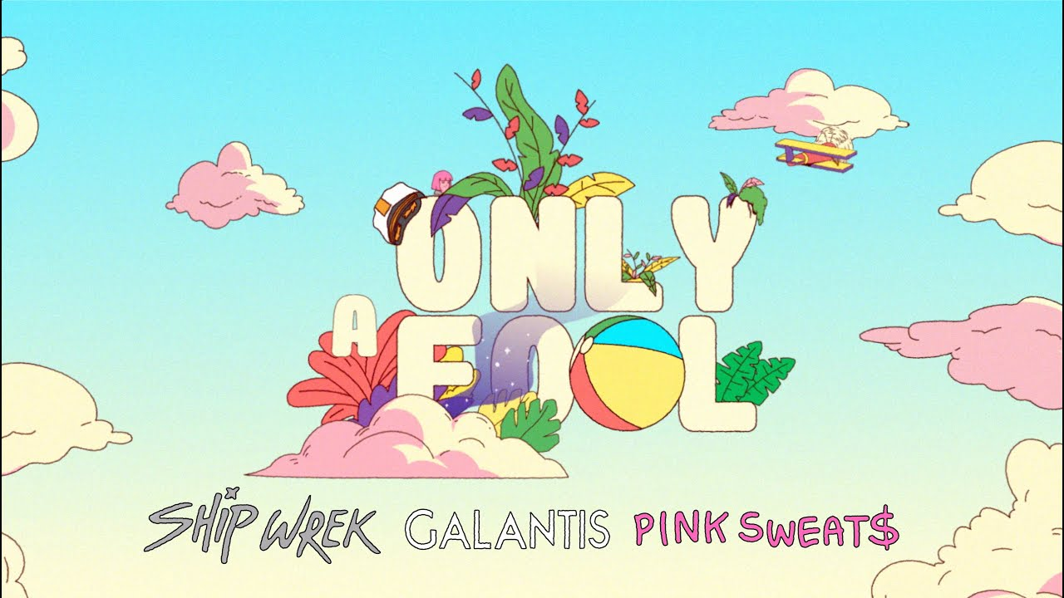
DOWNLOAD HIGH-RES IMAGES/ARTWORK

WATCH/STREAM “ONLY A FOOL”: https://lnk.to/OnlyAFoolPR/youtube

Internationally-acclaimed duo Galantis and prolific rising producer/DJs Ship Wrek have joined forces with singer-songwriter-producer Pink Sweat$ for a sensational new collaborative single, “Only A Fool” – brought to life today via a gleeful Mero Estudio-directed animated music video.

“Only A Fool” (available via Big Beat Records) pairs silky-soulful vocals with an effervescent beat that perfectly ushers in summer months ahead. The lively track was deemed an “infectious pop-tinged gem” by DJ Times upon release, while Dancing Astronaut echoed “its cheery melody is an uplifting tune.”

“Quarantine has allowed us to work in the studio non-stop, and it was great to work with label mates Pink Sweat$ and Ship Wrek on a collab that brings some good vibes." – GALANTIS

“There's really something special about this record that just feels right –the R&B mixed with house music is something that we hadn’t explored until this song and we put every ounce of our lives for a good while into making sure it was perfect.” – SHIP WREK

““Only A Fool’ is about a person that you’re deeply into but they’re not doing the right things. At the same time, you’re not perfect but you realize with love you can master imperfection. You’re not trying to fix everything wrong about someone but you’re able to acknowledge those things. Being able to tell them, I don’t like this part about you but I love this part about you and I’d be a fool to let those things that I don’t like keep me from falling deeply in love with the person.” – PINK SWEAT$

***

ABOUT GALANTIS:
Setting a new standard for songwriting in dance music, Galantis is a collaborative project between Christian Karlsson (aka Bloodshy, one-third of Miike Snow) and Linus Eklöw (aka Style of Eye). Their debut album Pharmacy reached No. 1 on the Billboard Dance album chart on the strength of RIAA gold certified single “Peanut Butter Jelly” and platinum certified smash “Runaway (U & I)” – the latter of which earned GRAMMY nominations for “Best Dance Recording” and “Best Remixed Recording” – while their 2017 sophomore album The Aviary (featuring platinum certified single “No Money”) saw a top 10 debut in 23 countries. Most recently, their third album Church features their chart-topping single “Faith” with country music icon Dolly Parton featuring Dutch singer-songwriter Mr. Probz, which saw a #1 debut on Billboard’s Dance/Electronic Chart before quickly reaching #1 on the Dance/Mix Show Airplay Chart where it remained for 5 weeks. The duo have received over 3 billion cumulative worldwide streams, and over 1 billion video views to date.

“Only A Fool” marks the third new release from Galantis over the last month, following their introspective collaborative single “The Lake” with Wrabel and their soundtrack contribution to SCOOB! The Album, “I Fly” featuring Faouzia. This past February, the duo also teamed up with WaveXR to transform into real-time custom avatars for a live virtual reality concert special. The performance, which re-aired last month as part of the OneWave Benefit Concert Series benefitting MusiCares and the AdCouncil, has amassed over 1 million collective views.

The story of Galantis started back in 2009. Working as Bloodshy, Karlsson’s songwriting collaborations have included Madonna, Kylie Minogue, Katy Perry and Britney Spears (whose “Toxic” earned a GRAMMY for “Best Dance Recording”). After reaching out to Eklöw (who produced Icona Pop’s hit single “I Love It” as Style of Eye) to remix Miike Snow’s “Animal,” the two continued to collaborate until ultimately Galantis was born. Following their blockbuster performance debut at 2014’s Coachella Valley Music and Arts Festival, the duo quickly rose to become one of dance music’s most dynamic and in-demand live performers.

ABOUT SHIP WREK:
Los Angeles-based duo Ship Wrek, comprised of Tripp Churchill and Collin Maguire, originally connected in 2019 to form the current iteration of Ship Wrek and quickly became one of the most prolific production teams in the electronic scene. The duo has released remixes and originals that have caught the attention of music fans, press, and industry heavyweights alike. Artists including Skrillex, Dillon Francis, Diplo, Jauz, The Chainsmokers, Chris Lake, Zedd, and Tiesto have all played out Ship Wrek’s music, and the list of collaborators and fans just keeps on growing.

Ship Wrek’s unique signature sound has quickly turned them into music producers’ favorite producers having been commissioned for official remixes for DJ Snake and A R I Z O N A, and receiving massive praise for recent releases “Obsession” with Valentino Khan and their debut EP Mirror Mirror, which included “It’s My House” with Dillon Francis. With support already rooted firmly in place from the dance music community, the sky’s the limit for Ship Wrek, and the future is looking brighter and brighter.

ABOUT PINK SWEAT$:
Hailed by ROLLING STONE as “An artist you need to know,” Philadelphia-native singer-songwriter-producer Pink Sweat$ has drawn international applause for his utterly unique brand of genre-smashing contemporary soul, marked by lyrical complexity, melodic power, and true vocal majesty. He began making music at the age of 19, cutting demo vocals at Philly’s legendary Sigma Sounds Studios. There he began his career as a songwriter and producer, teaming with a wide range of artists spanning Tierra Whack to Florida Georgia Line. In 2018, Pink Sweat$ fully stepped into the spotlight with his extraordinary debut EP, VOLUME 1, which began accruing major attention in an array of top media outlets around the world. “(Pink Sweat$) is taking a new approach to creating genre-bending music,” declared Ones To Watch. “Though Pink’s music is rooted in R&B and soul, he carefully strips back the typical genre-specific production to leave room for his stunning melodies and memorable lyrics.” DJ Booth applauded VOLUME 1 as “tender, affecting, and plush,” while Billboard personally praised Pink Sweat$ for his “indomitable pen-skills and soothing vocals.” In 2019, the rising artist celebrated the release of VOLUME 1 with the Pink Beginnings Tour, which was later followed by the introduction of its highly-anticipated follow up, VOLUME 2. Shortly after the release of VOLUME 2, Pink Sweat$ went on to support the EP by headlining his Pink Beginnings Tour – Part 2 during the summer.

2019 saw a number of successes for the talented artist, including being named Apple Music’s “Up Next” artist, ranked among Billboard‘s “11 Hip-Hop & R&B Artists to Watch in 2019” and making his high profile network TV debut on ABC’s Jimmy Kimmel Live!. As if that weren’t enough, the break-through star was nominated for “Best New Artist” at the 2019 Soul Train Awards, in addition to having performed at the show in Las Vegas, NV. Pink Sweat$ was also recently named BET's Amplified Artist of the Month for January 2020.

CONTACT:
GALANTIS: Ted Sullivan | Ted.Sullivan@atlanticrecords.com
SHIP WREK: Paige Rosoff | Paige.Rosoff@atlanticrecords.com
PINK SWEAT$: Ariana White | Ariana.White@atlanticrecords.com

